**Microsoft Azure Fundamentals**

Lucia Harcekova

DISCLAIMER: THE CONTENT WAS TAKEN FROM THE MS LEARNING PATH FOR THE CERTIFICATE ON THE MS PAGE. THEREAFTER IT WAS EDITED AND FORMED TO THIS DOCUMENT.

Contents_Toc92134378

Introduction to Azure fundamentals 11

Preparation for Exam AZ-900 11

Cloud computing 11

Why is cloud computing typically cheaper to use? 11

Why should I move to the cloud? 11

Azure 12

What does Azure offer? 12

What can I do with Azure? 12

What is the Azure portal? 12

What is Azure Marketplace? 13

Tour of Azure services 13

Azure services 13

Get started with Azure accounts 19

Discuss Azure fundamental concepts 20

Discuss different types of cloud models 20

Describe cloud benefits and considerations 20

Describe different cloud services 21

What are cloud service models? 21

Cloud service model comparison 24

What is serverless computing? 24

Describe core Azure architectural components 24

Overview of Azure subscriptions, management groups, and resources 24

Azure regions, availability zones, and region pairs 25

Use availability zones in your apps 26

Azure resources and Azure Resource Manager 27

Azure resource groups 27

Azure Resource Manager 28

Azure subscriptions and management groups 29

Azure subscriptions 29

Azure management groups 30

Azure terminology and concepts 31

What is App Service? 31

What is Azure Marketplace? 31

Create resources in Azure 32

Azure Fundamentals part 2: Describe core Azure services 33

Explore Azure compute services 33

Virtual machine scale sets 33

Containers and Kubernetes 33

App Service 33

Functions 34

Decide when to use Azure Virtual Machines 34

Move to the cloud with VMs 34

Scale VMs in Azure 35

What are virtual machine scale sets? 35

What is Azure Batch? 35

Decide when to use Azure App Service 35

Azure App Service costs 35

Types of app services 36

Web apps 36

API apps 36

WebJobs 36

Mobile apps 36

Decide when to use Azure Container Instances or Azure Kubernetes Service 37

What are containers? 37

Manage containers 37

What is Kubernetes? 37

Use containers in your solutions 37

What is a microservice? 38

Decide when to use Azure Functions 38

Serverless computing in Azure 39

Azure Functions 39

Azure Logic Apps 39

Functions vs. Logic Apps 40

Decide when to use Azure Virtual Desktop 40

What is Azure Virtual Desktop? 41

Why should you use Azure Virtual Desktop? 41

What are some key features of Azure Virtual Desktop? 41

How can you reduce costs with Azure Virtual Desktop? 42

Explore Azure networking services 42

What is Azure virtual networking? 42

Network configurations for virtual machines 43

Connect virtual networks 44

Azure Virtual Network settings 44

Create a virtual network 44

Configure virtual networks 46

Azure ExpressRoute fundamentals 46

Features and benefits of ExpressRoute 47

ExpressRoute connectivity models 48

Explore Azure Storage services 49

Azure Storage account fundamentals 49

Disk storage fundamentals 49

Azure Blob storage fundamentals 49

Azure Files fundamentals 50

Understand Blob access tiers 51

Explore Azure database and analytics services 52

Explore Azure Cosmos DB 52

Explore Azure SQL Database 52

Exercise - Create a SQL database 53

Task 1: Create the database 53

Task 2: Test the database 54

Explore Azure database for MySQL 55

Explore Azure Database for PostgreSQL 56

Explore Azure SQL Managed Instance 57

Explore big data and analytics 57

Azure Fundamentals part 3: Describe core solutions and management tools on Azure 58

Choose the best Azure IoT service for your application 58

Identify the product options 59

Analyse the decision criteria 60

Use IoT Hub 61

Use IoT Central 62

Use Azure Sphere 63

Choose the best AI service for your needs 63

Identify the product options 63

Azure product options 64

Analyse the decision criteria 65

Use Machine Learning for decision support systems 65

Use Cognitive Services for data analysis 66

Use Bot Service for interactive chat experiences 67

Choose the best Azure serverless technology for your business scenario 67

Identify the product options 68

Analyse the decision criteria 69

Use Azure Functions 70

Use Azure Logic Apps 70

Choose the best tools to help organizations build better solutions 71

Understand your product options 71

Product options 72

Analyze the decision criteria 73

Use Azure DevOps to manage the application development lifecycle 74

Use GitHub to contribute to open-source software 74

Use Azure DevTest Labs to manage testing environments 75

Choose the best tools for managing and configuring your Azure environment 75

Azure Resource Manager 75

Identify the product options 76

Your product options 76

Analyze the decision criteria 77

Use the Azure portal to visually understand and manage your cloud environment 78

Use Azure PowerShell for one-off administrative tasks 79

Use the Azure CLI for one-off administrative tasks 79

Use the Azure mobile app to manage Azure on the go 80

Use ARM templates to deploy an entire cloud infrastructure 80

Choose the best monitoring service for visibility, insight, and outage mitigation 81

Identify your product options 81

The product options 81

Analyse the decision criteria 83

Use Azure Advisor 83

Use Azure Monitor 84

Use Azure Service Health 84

Azure Fundamentals part 4: Describe general security and network security features 85

Protect against security threats by using Azure Security Centre 85

What's Azure Security Center? 85

Understand your security posture 85

What's secure score? 86

Protect against threats 86

Respond to security alerts 87

Detect and respond to security threats by using Azure Sentinel 87

Connect your data sources 87

Detect threats 87

Investigate and respond 88

Store and manage secrets by using Azure Key Vault 88

What can Azure Key Vault do? 89

What are the benefits of Azure Key Vault? 89

Exercise - Manage a password in Azure Key Vault 89

Create a key vault 90

Add a password to the key vault 90

Show the password 90

Clean up 90

Host your Azure virtual machines on dedicated physical servers by using Azure Dedicated Host 90

What are the benefits of Azure Dedicated Host? 91

Availability considerations for Dedicated Host 91

Pricing considerations 91

Secure network connectivity on Azure 91

What is defense in depth? 91

Layers of defense in depth 92

Security posture 93

Protect virtual networks by using Azure Firewall 94

What's Azure Firewall? 94

What can I configure with Azure Firewall? 94

Protect from DDoS attacks by using Azure DDoS Protection 95

What are DDoS attacks? 95

What is Azure DDoS Protection? 95

What service tiers are available to DDoS Protection? 95

What kinds of attacks can DDoS Protection help prevent? 96

Filter network traffic by using network security groups 97

What are network security groups? 97

How do I specify NSG rules? 97

Exercise - Configure network access to a VM by using a network security group 97

Create a Linux virtual machine and install Nginx 97

Access your web server 98

List the current network security group rules 99

Create the network security rule 100

Access your web server again 100

Clean up 100

Combine Azure services to create a complete network security solution 101

Secure the perimeter layer 101

Secure the network layer 101

Combine services 101

Summary 102

Azure Fundamentals part 5: Describe identity, governance, privacy, and compliance features 102

Secure access to your applications by using Azure identity services 102

How will Tailwind Traders secure access to its cloud applications? 102

Compare authentication and authorization 102

What is Azure Active Directory? 103

How does Azure AD compare to Active Directory? 103

Who uses Azure AD? 104

What services does Azure AD provide? 104

What kinds of resources can Azure AD help secure? 104

What's single sign-on? 105

How can I connect Active Directory with Azure AD? 105

What are multifactor authentication and Conditional Access? 105

What's multifactor authentication? 105

What's Azure AD Multi-Factor Authentication? 106

What's Conditional Access? 106

When can I use Conditional Access? 107

Where is Conditional Access available? 107

Summary 107

Build a cloud governance strategy on Azure 108

How will Tailwind Traders improve agility while maintaining control? 108

Control access to cloud resources by using Azure role-based access control 108

How is role-based access control applied to resources? 108

When should I use Azure RBAC? 109

How is Azure RBAC enforced? 109

Who does Azure RBAC apply to? 109

How do I manage Azure RBAC permissions? 109

Prevent accidental changes by using resource locks 110

How do I manage resource locks? 110

What levels of locking are available? 110

How do I delete or change a locked resource? 110

Combine resource locks with Azure Blueprints 111

Exercise - Protect a storage account from accidental deletion by using a resource lock 111

Create the resource group 111

Add a lock to the resource group 111

Verify that the resource group is protected from deletion 111

Protect a storage account from accidental deletion 112

Delete the resource group and the storage account 112

Organize your Azure resources by using tags 113

How do I manage resource tags? 113

An example tagging structure 113

Control and audit your resources by using Azure Policy 114

How does Azure Policy define policies? 114

Azure Policy in action 114

What are Azure Policy initiatives? 115

How do I define an initiative? 116

How do I assign an initiative? 116

Exercise - Restrict deployments to a specific location by using Azure Policy 116

Explore predefined policies 117

Configure the location policy 117

Verify the location policy 118

Delete the policy assignment 118

Delete the resource group 118

Govern multiple subscriptions by using Azure Blueprints 118

Azure Blueprints in action 119

What are blueprint artifacts? 119

How will Tailwind Traders use Azure Blueprints for ISO 27001 compliance? 119

Accelerate your cloud adoption journey by using the Cloud Adoption Framework for Azure 120

What's in the Cloud Adoption Framework? 120

Define your strategy 120

Make a plan 121

Ready your organization 121

Adopt the cloud 121

Govern and manage your cloud environments 122

Create a subscription governance strategy 122

Billing 123

Access control 123

Subscription limits 123

Summary 123

Examine privacy, compliance, and data protection standards on Azure 123

How will Tailwind Traders protect its data in the cloud and stay compliant? 124

Explore compliance terms and requirements 124

Which compliance categories are available on Azure? 124

Criminal Justice Information Service 124

Cloud Security Alliance STAR Certification 125

European Union Model Clauses 125

Health Insurance Portability and Accountability Act 125

International Organization of Standards/International Electrotechnical Commission 27018 125

Multi-Tier Cloud Security Singapore 125

Service Organization Controls 1, 2, and 3 125

National Institute of Standards and Technology Cybersecurity Framework 126

United Kingdom Government G-Cloud 126

Access the Microsoft Privacy Statement, the Online Services Terms, and the Data Protection Addendum 126

What's in the Microsoft Privacy Statement? 126

What's in the Online Services Terms? 126

What is the Data Protection Addendum? 126

Explore the Trust Center 127

Explore the Trust Center 127

Access Azure compliance documentation 128

What is the Azure compliance documentation? 128

Examine PCI DSS compliance 128

Access additional compliance resources 129

What is Azure Government? 129

What is Azure China 21Vianet? 129

Azure products and services available in China 130

Azure Fundamentals part 6: Describe Azure cost management and service level agreements 130

Compare costs by using the Total Cost of Ownership Calculator 130

What's the TCO Calculator? 130

How does the TCO Calculator work? 131

Exercise - Compare sample workload costs by using the TCO Calculator 132

Define your workloads 132

Adjust assumptions 133

View the report 134

Purchase Azure services 134

What types of Azure subscriptions can I use? 134

How do I purchase Azure services? 135

What factors affect cost? 135

Does location or network traffic affect cost? 136

How can I estimate the total cost? 137

Exercise - Estimate workload cost by using the Pricing calculator 138

Define your requirements 138

Explore the Pricing calculator 139

Estimate your solution 139

Add services to the estimate 139

Configure services to match your requirements 139

Review, share, and save your estimate 140

Manage and minimize total cost on Azure 140

Understand estimated costs before you deploy 140

Use Azure Advisor to monitor your usage 140

Use spending limits to restrict your spending 141

Use Azure Reservations to prepay 141

Choose low-cost locations and regions 141

Research available cost-saving offers 141

Use Azure Cost Management + Billing to control spending 141

Apply tags to identify cost owners 142

Resize underutilized virtual machines 142

Deallocate virtual machines during off hours 143

Delete unused resources 143

Migrate from IaaS to PaaS services 143

Save on licensing costs 143

Choose cost-effective operating systems 143

Use Azure Hybrid Benefit to repurpose software licenses on Azure 144

Summary 144

Choose the right Azure services by examining SLAs and service lifecycle 144

How will moving to the cloud affect availability agreements? 144

What are service-level agreements (SLAs)? 144

Why are SLAs important? 145

Where can I access SLAs for Azure services? 145

What's in a typical SLA? 145

How do percentages relate to total downtime? 145

What are service credits? 146

What's the SLA for free services? 146

How do I know when there's an outage? 146

How can I request a service credit from Microsoft? 147

Define your application SLA 147

What does the team decide? 147

Design your application to meet your SLA 148

Identify your workloads 148

Combine SLAs to compute the composite SLA 148

What happens when the composite SLA doesn't meet your needs? 149

Very high performance is difficult to achieve 150

Access preview services and preview features 150

What is the service lifecycle? 150

What terms and conditions can I expect? 151

How can I access preview services? 151

How can I access new features for an existing service? 151

How can I access preview features for the Azure portal? 151

How can I provide feedback on the Azure portal? 151

How can I stay updated on the latest announcements? 152

Summary 152

# Introduction to Azure fundamentals

Azure is a cloud computing platform with an ever-expanding set of services to help you build solutions to meet your business goals. Azure services range from simple web services for hosting your business presence in the cloud to running fully virtualized computers for you to run custom software solutions. Azure provides a wealth of cloud-based services like remote storage, database hosting, and centralized account management. Azure offers new capabilities like AI and IoT.

## ****Preparation for Exam AZ-900****

The Azure fundamentals learning path can help you prepare for [Exam AZ-900: Microsoft Azure Fundamentals](https://docs.microsoft.com/en-us/learn/certifications/exams/az-900). This exam includes six knowledge domain areas:

* Describe cloud concepts: 20-25%
* Describe core Azure services: 15-20%
* Describe core solutions and management tools on Azure: 10-15%
* Describe general security and network security features: 10-15%
* Describe identity, governance, privacy, and compliance features: 20-25%
* Describe Azure cost management and Service Level Agreements: 10-15%

## Cloud computing

It's the delivery of computing services over the internet, which is otherwise known as the cloud. These services include servers, storage, databases, networking, software, analytics, and intelligence. Cloud computing offers faster innovation, flexible resources, and economies of scale.

### Why is cloud computing typically cheaper to use?

Cloud computing is the delivery of computing services over the internet by using a pay-as-you-go pricing model. You typically pay only for the cloud services you use, which helps you:

* Lower your operating costs.
* Run your infrastructure more efficiently.
* Scale as your business needs change.

To put it another way, cloud computing is a way to rent compute power and storage from someone else's datacenter. You can treat cloud resources like you would resources in your own datacenter. When you're done using them, you give them back. You're billed only for what you use.

Instead of maintaining CPUs and storage in your datacenter, you rent them for the time that you need them. Cloud provider takes care of maintaining the underlying infrastructure for you. The cloud enables you to quickly solve toughest business challenges, and bring cutting-edge solutions to users.

### Why should I move to the cloud?

The cloud helps you move faster and innovate in ways that were once nearly impossible. In our ever-changing digital world, two trends emerge:

* Teams deliver new features to their users at record speeds.
* Users expect an increasingly rich and immersive experience with their devices and with software.

Software releases were once scheduled in terms of months or even years. Today, teams release features in smaller batches that are often scheduled in days or weeks. Some teams even deliver software updates continuously, sometimes with multiple releases within the same day.

Think of all the ways you interact with devices that you couldn't do a few years ago. Many devices can recognize your face and respond to voice commands. Augmented reality changes the way you interact with the physical world. Household appliances are even beginning to act intelligently. These technologies are only a few examples, and many of them are powered by the cloud.

To power your services and deliver innovative and novel user experiences more quickly, the cloud provides on-demand access to:

* A nearly limitless pool of raw compute, storage, and networking components.
* Speech recognition and other cognitive services that help make your application stand out.
* Analytics services that deliver telemetry data from your software and devices.

## Azure

Azure is a continually expanding set of cloud services that help your organization meet your current and future business challenges. Azure gives you the freedom to build, manage, and deploy applications on a massive global network using your favourite tools and frameworks.

### What does Azure offer?

**Be ready for the future:** Continuous innovation from Microsoft supports your development today and your product visions for tomorrow.

**Build on your terms:** You have choices. With a commitment to open source, and support for all languages and frameworks, you can build how you want and deploy where you want to.

**Operate hybrid seamlessly:** On-premises, in the cloud, and at the edge--we'll meet you where you are. Integrate and manage your envs with tools and services designed for a hybrid cloud solution.

**Trust your cloud:** Get security from the ground up, backed by a team of experts, and proactive compliance trusted by enterprises, governments, and startups.

### What can I do with Azure?

Azure provides more than 100 services that enable you to do everything from running your existing apps on VMs, to exploring new software paradigms, such as intelligent bots and mixed reality.

Many teams start exploring the cloud by moving their existing applications to virtual machines that run in Azure. Migrating your existing apps to virtual machines is a good start, but the cloud is much more than a different place to run your virtual machines.

Ex. Azure provides AI and ML services that can naturally communicate with your users through vision, hearing, and speech. It also provides storage solutions that dynamically grow to massive amounts of data. Azure services enable solutions that aren't feasible without the power of the cloud.

### What is the Azure portal?

The Azure portal is a web-based, unified console that provides an alternative to command-line tools. With the Azure portal, you can manage your Azure subscription by using a graphical UI. You can:

* Build, manage, and monitor everything from simple web apps to complex cloud deployments.
* Create custom dashboards for an organized view of resources.
* Configure accessibility options for an optimal experience.

The Azure portal is designed for resiliency and continuous availability. It maintains a presence in every Azure datacenter. This configuration makes the Azure portal resilient to individual datacenter failures and avoids network slowdowns by being close to users. The Azure portal updates continuously and requires no downtime for maintenance activities.

### What is Azure Marketplace?

[Azure Marketplace](https://azuremarketplace.microsoft.com/) helps connect users with Microsoft partners, independent software vendors, and startups that are offering their solutions and services, which are optimized to run on Azure. Azure Marketplace customers can find, try, purchase, and provision applications and services from hundreds of leading service providers. All solutions and services are certified to run on Azure.

Solution catalogue spans several industry categories such as open-source container platforms, virtual machine images, databases, application build and deployment SW, developer tools, threat detection, and blockchain. Using Azure Marketplace, you can provision end-to-end solutions quickly and reliably, hosted in your Azure env. At the time of writing, there are more than 8,000 listings.

Azure Marketplace is designed for IT pros and cloud developers interested in commercial and IT software. Microsoft partners also use it as a launch point for all joint go-to-market activities.

## Tour of Azure services

Azure can help you tackle tough business challenges. You bring your requirements, creativity, and favourite software development tools. Azure brings a massive global infrastructure that's always available for you to build your applications on.

### Azure services

Let's take a closer look at the most commonly used categories: Compute, Networking, Storage, Mobile,Databases, Web, Internet of Things (IoT), Big data, AI, DevOps.

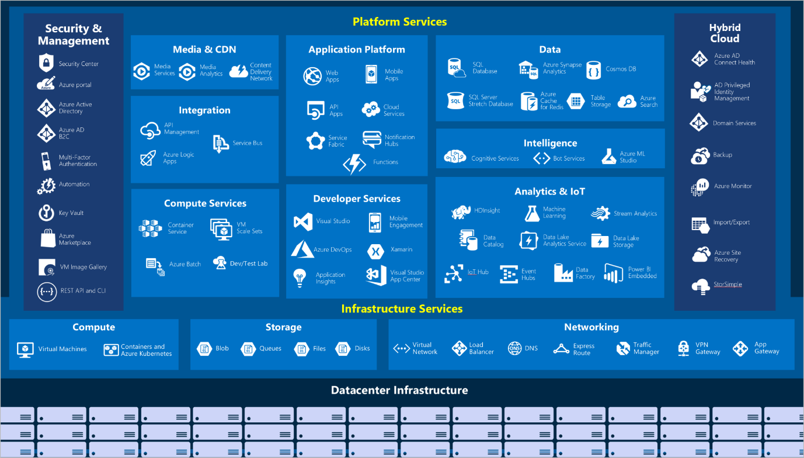

#### Compute

Compute services are often one of the primary reasons why companies move to the Azure platform. Azure provides a range of options for hosting applications and services. Here are some examples of compute services in Azure.

|  |  |
| --- | --- |
| **Service name** | **Service function** |
| Azure Virtual Machines | Windows or Linux virtual machines (VMs) hosted in Azure. |
| Azure Virtual Machine Scale Sets | Scaling for Windows or Linux VMs hosted in Azure. |
| Azure Kubernetes Service | Cluster management for VMs that run containerized services. |
| Azure Service Fabric | Distributed systems platform that runs in Azure or on-premises. |
| Azure Batch | Managed service for parallel and high-performance computing applications. |
| Azure Container Instances | Containerized apps run on Azure without provisioning servers or VMs. |
| Azure Functions | An event-driven, serverless compute service. |

#### Networking

Linking compute resources and providing access to applications is the key function of Azure networking. Networking functionality in Azure includes a range of options to connect the outside world to services and features in the global Azure datacenters.

|  |  |
| --- | --- |
| **Service name** | **Service function** |
| Azure Virtual Network | Connects VMs to incoming virtual private network (VPN) connections. |
| Azure Load Balancer | Balances inbound and outbound connections to applications or service endpoints. |
| Azure Application Gateway | Optimizes app server farm delivery while increasing application security. |
| Azure VPN Gateway | Accesses Azure Virtual Networks through high-performance VPN gateways. |
| Azure DNS | Provides ultra-fast DNS responses and ultra-high domain availability. |
| Azure Content Delivery Network | Delivers high-bandwidth content to customers globally. |
| Azure DDoS Protection | Protects Azure-hosted applications from distributed denial of service (DDOS) attacks. |
| Azure Traffic Manager | Distributes network traffic across Azure regions worldwide. |
| Azure ExpressRoute | Connects to Azure over high-bandwidth dedicated secure connections. |
| Azure Network Watcher | Monitors and diagnoses network issues by using scenario-based analysis. |
| Azure Firewall | Implements high-security, high-availability firewall with unlimited scalability. |
| Azure Virtual WAN | Creates a unified wide area network (WAN) that connects local and remote sites. |

#### Storage

Azure provides four main types of storage services.

|  |  |
| --- | --- |
| **Service name** | **Service function** |
| Azure Blob storage | Storage service for very large objects, such as video files or bitmaps. |
| Azure File storage | File shares that can be accessed and managed like a file server. |
| Azure Queue storage | A data store for queuing and reliably delivering messages between applications. |
| Azure Table storage | Table storage is a service that stores non-relational structured data (also known as structured NoSQL data) in the cloud, providing a key/attribute store with a schemaless design. |

These services all share several common characteristics:

* **Durable** and highly available with redundancy and replication.
* **Secure** through automatic encryption and role-based access control.
* **Scalable** with virtually unlimited storage.
* **Managed**, handling maintenance and any critical problems for you.
* **Accessible** from anywhere in the world over HTTP or HTTPS.

#### Mobile

With Azure, developers can create mobile back-end services for iOS, Android, and Windows apps quickly and easily. Features that used to take time and increase project risks, such as adding corporate sign-in and then connecting to on-premises resources such as SAP, Oracle, SQL Server, and SharePoint, are now simple to include.

Other features of this service include:

* Offline data synchronization.
* Connectivity to on-premises data.
* Broadcasting push notifications.
* Autoscaling to match business needs.

#### Databases

Azure provides multiple database services to store a wide variety of data types and volumes. And with global connectivity, this data is available to users instantly.

|  |  |
| --- | --- |
| **Service name** | **Service function** |
| Azure Cosmos DB | Globally distributed database that supports NoSQL options. |
| Azure SQL Database | Fully managed relational database with auto-scale, integral intelligence, and robust security. |
| Azure Database for MySQL | Fully managed and scalable MySQL relational database with high availability and security. |
| Azure Database for PostgreSQL | Fully managed and scalable PostgreSQL relational database with high availability and security. |
| SQL Server on Azure Virtual Machines | Service that hosts enterprise SQL Server apps in the cloud. |
| Azure Synapse Analytics | Fully managed data warehouse with integral security at every level of scale at no extra cost. |
| Azure Database Migration Service | Service that migrates databases to the cloud with no application code changes. |
| Azure Cache for Redis | Fully managed service caches frequently used and static data to reduce data and application latency. |
| Azure Database for MariaDB | Fully managed and scalable MariaDB relational database with high availability and security. |

#### Web

Having a great web experience is critical in today's business world. Azure includes first-class support to build and host web apps and HTTP-based web services. The following Azure services are focused on web hosting.

|  |  |
| --- | --- |
| **Service name** | **Description** |
| Azure App Service | Quickly create powerful cloud web-based apps. |
| Azure Notification Hubs | Send push notifications to any platform from any back end. |
| Azure API Management | Publish APIs to developers, partners, and employees securely and at scale. |
| Azure Cognitive Search | Deploy this fully managed search as a service. |
| Web Apps feature of Azure App Service | Create and deploy mission-critical web apps at scale. |
| Azure SignalR Service | Add real-time web functionalities easily. |

#### IoT

People are able to access more information than ever before. Personal digital assistants led to smartphones, and now there are smart watches, smart thermostats, and even smart refrigerators. Personal computers used to be the norm. Now the internet allows any item that's online-capable to access valuable information. This ability for devices to garner and then relay information for data analysis is referred to as IoT.

Many services can assist and drive end-to-end solutions for IoT on Azure.

|  |  |
| --- | --- |
| **Service name** | **Description** |
| IoT Central | Fully managed global IoT software as a service (SaaS) solution that makes it easy to connect, monitor, and manage IoT assets at scale. |
| Azure IoT Hub | Messaging hub that provides secure communications between and monitoring of millions of IoT devices. |
| IoT Edge | Fully managed service that allows data analysis models to be pushed directly onto IoT devices, which allows them to react quickly to state changes without needing to consult cloud-based AI models. |

#### Big data

Data comes in all formats and sizes. When we talk about big data, we're referring to *large* volumes of data. Data from weather systems, communications systems, imaging platforms, and many other scenarios generate hundreds of gigabytes of data. This amount of data makes it hard to analyze and make decisions. It's often so large that traditional forms of processing and analysis are no longer appropriate. Open-source cluster technologies have been developed to deal with large data sets. Azure supports a broad range of technologies and services to provide big data and analytic solutions.

|  |  |
| --- | --- |
| **Service name** | **Description** |
| Azure Synapse Analytics | Run analytics at a massive scale by using a cloud-based enterprise data warehouse that takes advantage of massively parallel processing to run complex queries quickly across petabytes of data. |
| Azure HDInsight | Process massive amounts of data with managed clusters of Hadoop clusters in the cloud. |
| Azure Databricks | Integrate this collaborative Apache Spark-based analytics service with other big data services in Azure. |

#### AI

AI, in the context of cloud computing, is based around a broad range of services, the core of which is ML. ML is a data science technique that allows computers to use existing data to forecast future behaviors, outcomes, and trends. Using ML, computers learn without being explicitly programmed.

Forecasts or predictions from machine learning can make apps and devices smarter. Here are some of the most common AI and machine learning service types in Azure.

|  |  |
| --- | --- |
| **Service name** | **Description** |
| Azure Machine Learning Service | Cloud-based environment you can use to develop, train, test, deploy, manage, and track machine learning models. It can auto-generate a model and auto-tune it for you. It will let you start training on your local machine, and then scale out to the cloud. |
| Azure ML Studio | Collaborative visual workspace where you can build, test, and deploy machine learning solutions by using prebuilt machine learning algorithms and data-handling modules. |

A closely related set of products are the *cognitive services*. You can use these prebuilt APIs in your applications to solve complex problems.

|  |  |
| --- | --- |
| **Service name** | **Description** |
| Vision | Use image-processing algorithms to smartly identify, caption, index, and moderate your pictures and videos. |
| Speech | Convert spoken audio into text, use voice for verification, or add speaker recognition to your app. |
| Knowledge mapping | Map complex information and data to solve tasks such as intelligent recommendations and semantic search. |
| Bing Search | Add Bing Search APIs to your apps and harness the ability to comb billions of webpages, images, videos, and news with a single API call. |
| Natural Language processing | Allow your apps to process natural language with prebuilt scripts, evaluate sentiment, and learn how to recognize what users want. |

#### DevOps

DevOps brings together people, processes, and technology by automating sw delivery to provide continuous value to users. With Azure DevOps, you can create e-build and release pipelines that provide continuous integration, delivery, and deployment for your apps. You can integrate repositories and application tests, perform application monitoring, and work with build artifacts. You can also work with and backlog items for tracking, automate infrastructure deployment, and integrate a range of third-party tools and services such as Jenkins and Chef.

|  |  |
| --- | --- |
| **Service name** | **Description** |
| Azure DevOps | Use development collaboration tools such as high-performance pipelines, free private Git repositories, configurable Kanban boards, and extensive automated and cloud-based load testing. Formerly known as Visual Studio Team Services. |
| Azure DevTest Labs | Quickly create on-demand Windows and Linux environments to test or demo applications directly from deployment pipelines. |

## Get started with Azure accounts

To create and use Azure services, you need an Azure subscription. When you're working with your own applications and business needs, you need to create an Azure account, and a subscription will be created for you. After you've created an Azure account, you're free to create additional subscriptions. For example, your company might use a single Azure account for your business and separate subscriptions for development, marketing, and sales departments. After you've created an Azure subscription, you can start creating Azure resources within each subscription.

If you're new to Azure, you can sign up for a free account on the Azure website to start exploring at no cost to you. When you're ready, you can choose to upgrade your free account. You can create a new subscription that enables you to start paying for Azure services you need to use that are beyond the limits of a free account.

#### Create an Azure account

You can purchase Azure access directly from Microsoft by signing up on the [Azure website](https://azure.microsoft.com/) or through a Microsoft representative. You can also purchase Azure access through a Microsoft partner. Cloud Solution Provider partners offer a range of complete managed-cloud solutions for Azure.

#### What is the Azure free account?

The Azure free account includes:

* Free access to popular Azure products for 12 months.
* A credit to spend for the first 30 days.
* Access to more than 25 products that are always free.

The Azure free account is an excellent way for new users to get started and explore. To sign up, you need phone number, credit card, and a MS or GitHub account. The credit card inf is used for identity verification only. You won't be charged for any services until you upgrade to a paid subscription.

#### What is the Azure free student account?

The [Azure free student account](https://azure.microsoft.com/free/students/) is an offer for students that gives $100 credit and free developer tools. Also, you can sign up without a credit card. The Azure free student account offer includes:

* Free access to certain Azure services for 12 months.
* A credit to use in the first 12 months.
* Free access to certain software developer tools.

#### What is the Learn sandbox?

Technology called the sandbox, which creates a temporary subscription that's added to your Azure account. Learn automatically cleans up the temporary resources for you after completed module.

## Discuss Azure fundamental concepts

### Discuss different types of cloud models

There are three deployment models for cloud computing. Each deployment model has different aspects that you should consider as you migrate to the cloud.

**Public cloud -** Services are offered over the public internet and available to anyone who wants to purchase them. Cloud resources, such as servers and storage, are owned and operated by a third-party cloud service provider, and delivered over the internet.

**Private cloud -** A private cloud consists of computing resources used exclusively by users from one business or organization. A private cloud can be physically located at your organization's on-site (on-premises) datacenter, or it can be hosted by a third-party service provider.

**Hybrid cloud -** A hybrid cloud is a computing environment that combines a public cloud and a private cloud by allowing data and applications to be shared between them.

#### Cloud model comparison

**Public cloud**

* No capital expenditures to scale up.
* Applications can be quickly provisioned and deprovisioned.
* Organizations pay only for what they use.

**Private cloud**

* Hardware must be purchased for start-up and maintenance.
* Organizations have complete control over resources and security.
* Organizations are responsible for hardware maintenance and updates.

**Hybrid cloud**

* Provides the most flexibility.
* Organizations determine where to run their applications.
* Organizations control security, compliance, or legal requirements.

### Describe cloud benefits and considerations

There are several advantages that a cloud env has over a physical env that can be used for migration to Azure.

* **High availability**: Depending on the service-level agreement (SLA) that you choose, your cloud-based apps can provide a continuous user experience with no apparent downtime, even when things go wrong.
* **Scalability**: Apps in the cloud can scale vertically and horizontally:
  + Scale vertically to increase compute capacity by adding RAM or CPUs to a vVM.
  + Scaling horizontally increases compute capacity by adding instances of resources, such as adding VMs to the configuration.
* **Elasticity**: You can configure cloud-based apps to take advantage of autoscaling, so your apps always have the resources they need.
* **Agility**: Deploy and configure cloud-based resources quickly as app requirements change.
* **Geo-distribution**: You can deploy apps and data to regional datacenters around the globe, thereby ensuring that your customers always have the best performance in their region.
* **Disaster recovery**: By taking advantage of cloud-based backup services, data replication, and geo-distribution, you can deploy your apps with the confidence that comes from knowing that your data is safe in the event of disaster.

#### Capital expenses vs. operating expenses

* **Capital Expenditure (CapEx)** is the up-front spending of money on physical infrastructure, and then deducting that up-front expense over time. The up-front cost from CapEx has a value that reduces over time.
* **Operational Expenditure (OpEx)** is spending money on services or products now, and being billed for them now. You can deduct this expense in the same year you spend it. There is no up-front cost, as you pay for a service or product as you use it.

In other words, when Tailwind owns its infrastructure, it buys equipment that goes onto its balance sheets as assets. Because a capital investment was made, accountants categorize this transaction as a CapEx. Over time, to account for the assets' limited useful lifespan, assets are depreciated or amortized.

Cloud services, on the other hand, are categorized as an OpEx, because of their consumption model. There's no asset for Tailwind Traders to amortize, and its cloud service provider (Azure) manages the costs that are associated with the purchase and lifespan of the physical equipment. As a result, OpEx has a direct impact on net profit, taxable income, and the associated expenses on the balance sheet.

To summarize, CapEx requires significant up-front financial costs, as well as ongoing maintenance and support expenditures. By contrast, OpEx is a consumption-based model, so Tailwind Traders is only responsible for the cost of the computing resources that it uses.

#### Cloud computing is a consumption-based model

Cloud service providers operate on a consumption-based model, which means that end users only pay for the resources that they use. Whatever they use is what they pay for.

A consumption-based model has many benefits, including:

* No upfront costs.
* No need to purchase and manage costly infrastructure that users might not use to its fullest.
* The ability to pay for additional resources when they are needed.
* The ability to stop paying for resources that are no longer needed.

## Describe different cloud services

### What are cloud service models?

If you've been around cloud computing for a while, you've probably seen the PaaS, IaaS, and SaaS acronyms for the different cloud service models. These models define the different levels of shared responsibility that a cloud provider and cloud tenant are responsible for.

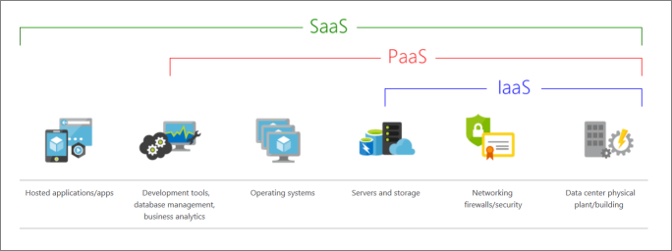

#### **IaaS (**Infrastructure-as-a-Service)

This cloud service model is the closest to managing physical servers; a cloud provider will keep the hardware up-to-date, but operating system maintenance and network configuration is up to you as the cloud tenant. For example, Azure virtual machines are fully operational virtual compute devices running in Microsoft datacenters. An advantage of this cloud service model is rapid deployment of new compute devices. Setting up a new virtual machine is considerably faster than procuring, installing, and configuring a physical server.

IaaS is the most flexible category of cloud services. It aims to give you complete control over the hardware that runs your application. Instead of buying hardware, with IaaS, you rent it.

Advantages

**No CapEx**. Users have no up-front costs.

**Agility**. Applications can be made accessible quickly, and deprovisioned whenever needed.

**Management**. The shared responsibility model applies; the user manages and maintains the services they have provisioned, and the cloud provider manages and maintains the cloud infrastructure.

**Consumption-based model**. Organizations pay only for what they use and operate under an Operational Expenditure (OpEx) model.

**Skills**. No deep technical skills are required to deploy, use, and gain the benefits of a public cloud. Organizations can use the skills and expertise of the cloud provider to ensure workloads are secure, safe, and highly available.

**Cloud benefits**. Organizations can use the skills and expertise of the cloud provider to ensure workloads are made secure and highly available.

**Flexibility**. IaaS is the most flexible cloud service because you have control to configure and manage the hardware running your application.

#### **PaaS (**Platform-as-a-Service)

This cloud service model is a managed hosting environment. The cloud provider manages the virtual machines and networking resources, and the cloud tenant deploys their applications into the managed hosting environment. For example, Azure App Services provides a managed hosting environment where developers can upload their web applications, without having to worry about the physical hardware and software requirements.

PaaS provides the same benefits and considerations as IaaS, but there are some additional benefits to be aware of.

**Advantages**

**No CapEx**. Users have no up-front costs.

**Agility**. PaaS is more agile than IaaS, and users don't need to configure servers for running applications.

**Consumption-based model**. Users pay only for what they use, and operate under an OpEx.

**Skills**. No deep technical skills are required to deploy, use, and gain the benefits of PaaS.

**Cloud benefits**. Users can take advantage of the skills and expertise of the cloud provider to ensure that their workloads are made secure and highly available. In addition, users can gain access to more cutting-edge development tools. They can then apply these tools across an application's lifecycle.

**Productivity**. Users can focus on application development only, because the cloud provider handles all platform management. Working with distributed teams as services is easier because the platform is accessed over the internet. You can make the platform available globally more easily.

**Disadvantage**

**Platform limitations**. There can be some limitations to a cloud platform that might affect how an application runs. When you're evaluating which PaaS platform is best suited for a workload, be sure to consider any limitations in this area.

#### **SaaS (**Software-as-a-Service)

In this cloud service model, the cloud provider manages all aspects of the application environment, such as virtual machines, networking resources, data storage, and applications. The cloud tenant only needs to provide their data to the application managed by the cloud provider. For example, Microsoft Office 365 provides a fully working version of Microsoft Office that runs in the cloud. All you need to do is create your content, and Office 365 takes care of everything else.

SaaS is software that's centrally hosted and managed for you and your users or customers. Usually one version of the application is used for all customers, and it's licensed through a monthly or annual subscription. SaaS provides the same benefits as IaaS, but again there are some additional benefits .

**Advantages**

**No CapEx**. Users have no up-front costs.

**Agility**. Users can provide staff with access to the latest software quickly and easily.

**Pay-as-you-go pricing model**. Users pay for the software they use on a subscription model, typically monthly or yearly, regardless of how much they use the software.

**Skills**. No deep technical skills are required to deploy, use, and gain the benefits of SaaS.

**Flexibility**. Users can access the same application data from anywhere.

**Disadvantage**

**Software limitations**. There can be some limitations to a software application that might affect how users work. Because you're using as-is software, you don't have direct control of features. When you're evaluating which SaaS platform is best suited for a workload, be sure to consider any business needs and software limitations.

### Cloud service model comparison

The chart illustrates the various levels of responsibility between a cloud provider and a cloud tenant.

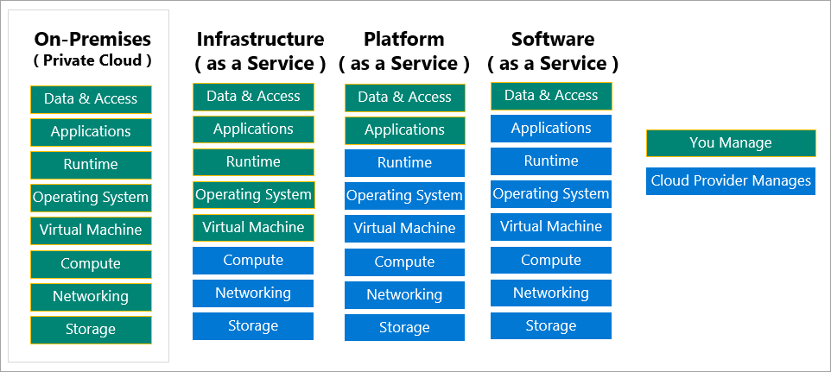

### What is serverless computing?

Like PaaS, serverless computing enables developers to build applications faster by eliminating the need for them to manage infrastructure. With serverless applications, the cloud service provider automatically provisions, scales, and manages the infrastructure required to run the code. Serverless architectures are highly scalable and event-driven, only using resources when a specific function or trigger occurs.

It's important to note that servers are still running the code. The "serverless" name comes from the fact that the tasks associated with infrastructure provisioning and management are invisible to the developer. This approach enables developers to increase their focus on the business logic, and deliver more value to the core of the business. Serverless computing helps teams increase their productivity and bring products to market faster, and it allows organizations to better optimize resources and stay focused on innovation.

## Describe core Azure architectural components

Let's say that you work as a developer for a successful hardware manufacturing company. Your company's Chief Officer recently decided to adopt Azure as the cloud computing platform. You're currently in the planning stages for the migration. Before you begin the migration process, you decide to study Azure concepts, resources, and terminology to ensure migration is a success.

### Overview of Azure subscriptions, management groups, and resources

As part of your research, you need to learn the organizing structure for resources in Azure, which has four levels: management groups, subscriptions, resource groups, and resources.

* **Resources**: Resources are instances of services you create, ex. vms, storage, SQL dbs, …
* **Resource groups**: Resources are combined into resource groups, which act as a logical container into which Azure resources like web apps, databases, and storage accounts are deployed and managed.
* **Subscriptions**: A subscription groups together user accounts and the resources that have been created by those user accounts. For each subscription, there are limits or quotas on the amount of resources that you can create and use. Organizations can use subscriptions to manage costs and the resources that are created by users, teams, or projects.
* **Management groups**: These groups help you manage access, policy, and compliance for multiple subscriptions. All subscriptions in a management group automatically inherit the conditions applied to the management group.

### Azure regions, availability zones, and region pairs

Resources are created in regions, which are different geographical locations around the globe that contain Azure datacenters. Azure is made up of datacenters located around the globe. When you use a service or create a resource such as a SQL database or VM, you're using physical equipment in one or more of these locations. These specific datacenters aren't exposed to users directly. Instead, Azure organizes them into regions. As you'll see later in this unit, some of these regions offer availability zones, which are different Azure datacenters within that region.

#### Azure regions

A region is a geographical area on the planet that contains at least one but potentially multiple datacenters that are nearby and networked together with a low-latency network. Azure intelligently assigns and controls resources within each region to ensure workloads are appropriately balanced.

When you deploy a resource in Azure, you'll often need to choose the region where you want your resource deployed.

**Important:** Some services or VM features are only available in certain regions, such as specific VM sizes or storage types. There are also some global Azure services that don't require you to select a particular region, such as Azure Active Directory, Azure Traffic Manager, and Azure DNS.

A few examples of regions are West US, Canada Central, West Europe, Australia East, and Japan West. Here's a view of all the available regions as of June 2020.

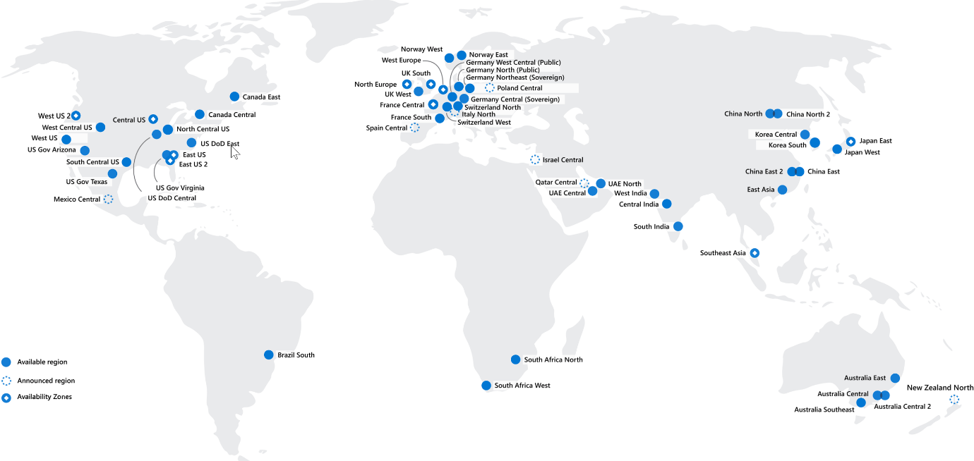

Azure has more global regions than any other cloud provider. These regions give you the flexibility to bring applications closer to your users no matter where they are. Global regions provide better scalability and redundancy. They also preserve data residency for your services.

#### Special Azure regions

Azure has specialized regions that you might want to use when you build out your applications for compliance or legal purposes. A few examples include:

* **US DoD Central, US Gov Virginia, US Gov Iowa and more:** These regions are physical and logical network-isolated instances of Azure for U.S. government agencies and partners. These datacenters are operated by screened U.S. personnel and include additional compliance certifications.
* **China East, China North, …:** These regions are available through a unique partnership between MS and 21Vianet, whereby MS doesn't directly maintain the datacenters.

Regions are what you use to identify the location for your resources. There are two other terms you should also be aware of: geographies and availability zones.

#### Azure availability zones

You want to ensure your services and data are redundant so you can protect your information in case of failure. When you host your infrastructure, setting up your own redundancy requires that you create duplicate hardware environments. Azure can help make your app highly available through availability zones.

Availability zones are physically separate datacenters within an Azure region. Each AZ is made up of one or more datacenters equipped with independent power, cooling, and networking. An availability zone is set up to be an isolation boundary. If one zone goes down, the other continues working. Availability zones are connected through high-speed, private fiber-optic networks. Not every region has support for availability zones.

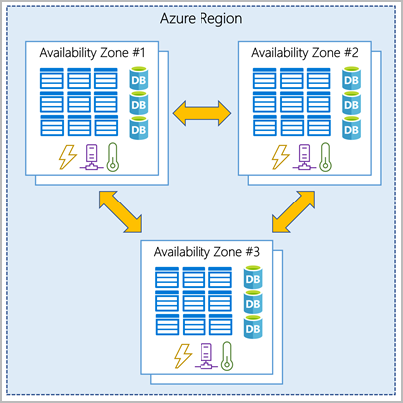

### Use availability zones in your apps

You can use availability zones to run mission-critical applications and build high-availability into your application architecture by co-locating your compute, storage, networking, and data resources within a zone and replicating in other zones. Keep in mind that there could be a cost to duplicating your services and transferring data between zones.

Availability zones are primarily for VMs, managed disks, load balancers, and SQL databases. Azure services that support availability zones fall into three categories:

* **Zonal services**: You pin the resource to a specific zone (for example, VMs, managed disks, IP addresses).
* **Zone-redundant services**: The platform replicates automatically across zones (for example, zone-redundant storage, SQL Database).
* **Non-regional services**: Services are always available from Azure geographies and are resilient to zone-wide outages as well as region-wide outages.

#### Azure region pairs

Availability zones are created by using one or more datacenters. There's a minimum of three zones within a single region. It's possible that a large disaster could cause an outage big enough to affect even two datacenters. That's why Azure also creates region pairs.

Each Azure region is always paired with another region within the same geography (such as US, Europe, or Asia) at least 300 miles away. This approach allows for the replication of resources (such as VM storage) across a geography that helps reduce the likelihood of interruptions because of events such as natural disasters, civil unrest, power outages, or physical network outages that affect both regions at once. If a region in a pair was affected by a natural disaster, for instance, services would automatically failover to the other region in its region pair.

Ex. of region pairs in Azure are West US paired with East US and SouthEast Asia paired with East Asia.

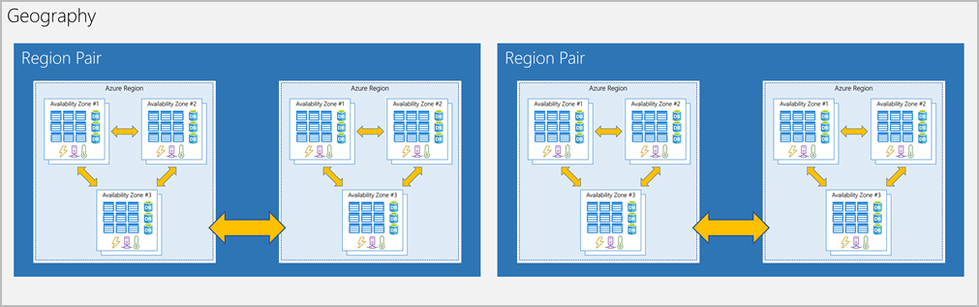

Because the pair of regions is directly connected and far enough apart to be isolated from regional disasters, you can use them to provide reliable services and data redundancy. Some services offer automatic geo-redundant storage by using region pairs.

Additional advantages of region pairs:

* If an extensive Azure outage occurs, one region out of every pair is prioritized to make sure at least one is restored as quickly as possible for applications hosted in that region pair.
* Planned Azure updates are rolled out to paired regions one region at a time to minimize downtime and risk of application outage.
* Data continues to reside within the same geography as its pair (except for Brazil South) for tax- and law-enforcement jurisdiction purposes.

Having broadly distributed set of datacenters allows Azure to provide high guarantee of availability.

## Azure resources and Azure Resource Manager

Before you create a subscriptio, you will need to be ready to start creating resources and storing them in resource groups. With that in mind, it's important to define those terms:

* **Resource**: A manageable item that's available through Azure. Virtual machines (VMs), storage accounts, web apps, databases, and virtual networks are examples of resources.
* **Resource group**: A container that holds related resources for an Azure solution. The resource group includes resources that you want to manage as a group. You decide which resources belong in a rg based on what makes the most sense for your organization.

### Azure resource groups

Resource groups are a fundamental element of the Azure platform. A resource group is a logical container for resources deployed on Azure. These resources are anything you create in an Azure subscription like VMs, Azure Application Gateway instances, and Azure Cosmos DB instances. All resources must be in a resource group, and a resource can only be a member of a single resource group. Many resources can be moved between resource groups with some services having specific limitations or requirements to move. Resource groups can't be nested. Before any resource can be provisioned, you need a resource group for it to be placed in.

#### Logical grouping

Resource groups exist to help manage and organize your Azure resources. By placing resources of similar usage, type, or location in a resource group, you can provide order and organization to resources you create in Azure. Logical grouping is the aspect that you're most interested in here, because there's a lot of disorder among our resources.

#### Life cycle

If you delete a resource group, all resources contained within it are also deleted. Organizing resources by life cycle can be useful in nonproduction environments, where you might try an experiment and then dispose of it. Resource groups make it easy to remove a set of resources all at once.

#### Authorization

Resource groups are also a scope for applying role-based access control (RBAC) permissions. By applying RBAC permissions to a resource group, you can ease administration and limit access to allow only what's needed.

### Azure Resource Manager

Azure Resource Manager is the deployment and management service for Azure. It provides a management layer that enables you to create, update, and delete resources in your Azure account. You use management features like access control, locks, and tags to secure and organize your resources after deployment.

When a user sends a request from any of the Azure tools, APIs, or SDKs, Resource Manager receives the request. It authenticates and authorizes the request. Resource Manager sends the request to the Azure service, which takes the requested action. Because all requests are handled through the same API, you see consistent results and capabilities in all the different tools.

The following image shows the role Resource Manager plays in handling Azure requests.

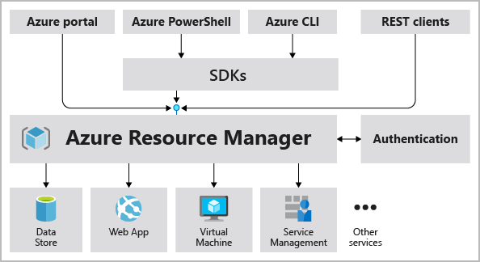

All capabilities that are available in the Azure portal are also available through PowerShell, the Azure CLI, REST APIs, and client SDKs. Functionality initially released through APIs will be represented in the portal within 180 days of initial release.

#### The benefits of using Resource Manager

* Manage your infrastructure through declarative templates rather than scripts. A Resource Manager template is a JSON file that defines what you want to deploy to Azure.
* Deploy, manage, and monitor all the resources for your solution as a group, rather than individually.
* Redeploy your solution throughout the development life cycle and have confidence your resources are deployed in a consistent state.
* Define the dependencies between resources so they're deployed in the correct order.
* Access control to all services because RBAC is natively integrated into the management platform.
* Apply tags to resources to logically organize all the resources in your subscription.
* Clarify organization's billing by viewing costs for group of resources that share same tag.

## Azure subscriptions and management groups

**Note:** An Azure resource is a manageable item that's available through Azure. Virtual machines (VMs), storage accounts, web apps, databases, and virtual networks are all examples of resources.

### Azure subscriptions

Using Azure requires an Azure subscription. A subscription provides you with authenticated and authorized access to Azure products and services. It also allows you to provision resources. An Azure subscription is a logical unit of Azure services that links to an Azure account, which is an identity in Azure Active Directory (Azure AD) or in a directory that Azure AD trusts.

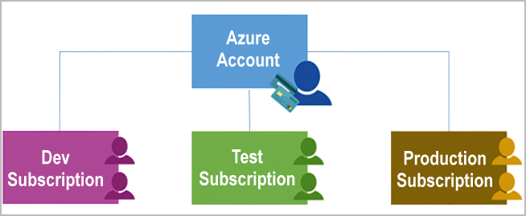

An account can have one subscription or multiple subscriptions that have different billing models and to which you apply different access-management policies. You can use Azure subscriptions to define boundaries around Azure products, services, and resources. There are two types of subscription boundaries that you can use:

* **Billing boundary**: This subscription type determines how an Azure account is billed for using Azure. You can create multiple subscriptions for different types of billing requirements. Azure generates separate billing reports and invoices for each subscription so that you can organize and manage costs.
* **Access control boundary**: Azure applies access-management policies at the subscription level, and you can create separate subscriptions to reflect different organizational structures. An example is that within a business, you have different departments to which you apply distinct Azure subscription policies. This billing model allows you to manage and control access to the resources that users provision with specific subscriptions.

#### Create additional Azure subscriptions

You might want to create additional subscriptions for resource or billing management purposes. For example, you might choose to create additional subscriptions to separate:

* **Environments:** When managing your resources, you can choose to create subscriptions to set up separate environments for development and testing, security, or to isolate data for compliance reasons. This design is particularly useful because resource access control occurs at the subscription level.
* **Organizational structures:** You can create subscriptions to reflect different organizational structures. For example, you could limit a team to lower-cost resources, while allowing the IT department a full range. This design allows you to manage and control access to the resources that users provision within each subscription.
* **Billing:** You might want to also create additional subscriptions for billing purposes. Because costs are first aggregated at the subscription level, you might want to create subscriptions to manage and track costs based on your needs. Ex you might want to create one subscription for production workloads and another subscription for development and testing workloads.

You might also need additional subscriptions because of:

* **Subscription limits:** Subscriptions are bound to some hard limitations. For example, the maximum number of Azure ExpressRoute circuits per subscription is 10. Those limits should be considered as you create subscriptions on your account. If there's a need to go over those limits in particular scenarios, you might need additional subscriptions.

#### Customize billing to meet your needs

If you have multiple subscriptions, you can organize them into invoice sections. Each invoice section is a line item on the invoice that shows the charges incurred that month. For example, you might need a single invoice for your organization but want to organize charges by team, or project.

Depending on your needs, you can set up multiple invoices within same billing account. To do this, create additional billing profiles. Each billing profile has its monthly invoice and payment method.

The diagram shows an overview of how billing is structured. If you've previously signed up for Azure or if your organization has an Enterprise Agreement, your billing might be set up differently.

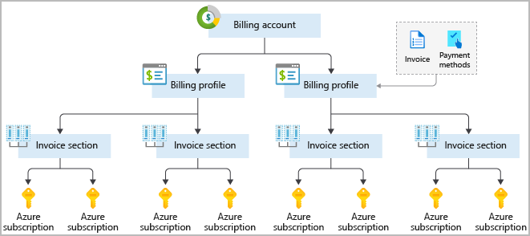

### Azure management groups

If your organization has many subscriptions, you might need a way to efficiently manage access, policies, and compliance for those subscriptions. Azure management groups provide a level of scope above subscriptions. You organize subscriptions into containers called management groups and apply your governance conditions to the management groups. All subscriptions within a management group automatically inherit the conditions applied to the management group. Management groups give you enterprise-grade management at a large scale no matter what type of subscriptions you might have. All subscriptions within a single management group must trust the same Azure AD tenant.

For example, you can apply policies to a management group that limits the regions available for VM creation. This policy would be applied to all management groups, subscriptions, and resources under that management group by only allowing VMs to be created in that region.

#### Hierarchy of management groups and subscriptions

You can build a flexible structure of management groups and subscriptions to organize your resources into a hierarchy for unified policy and access management. The following diagram shows an example of creating a hierarchy for governance by using management groups.

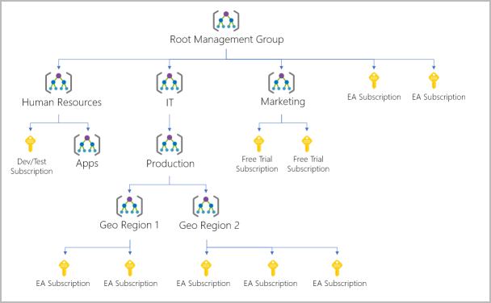

You can create a hierarchy that applies a policy. For example, you could limit VM locations to the US West Region in a group called Production. This policy will inherit onto all the Enterprise Agreement subscriptions that are descendants of that management group and will apply to all VMs under those subscriptions. This security policy can't be altered by the resource or subscription owner, which allows for improved governance.

Another scenario where you would use management groups is to provide user access to multiple subscriptions. By moving multiple subscriptions under that management group, you can create one role-based access control (RBAC) assignment on the management group, which will inherit that access to all the subscriptions. One assignment on the management group can enable users to have access to everything they need instead of scripting RBAC over different subscriptions.

Important facts about management groups

* 10,000 management groups can be supported in a single directory.
* A management group tree can support up to six levels of depth. This limit doesn't include the root level or the subscription level.
* Each management group and subscription can support only one parent.
* Each management group can have many children.
* All subscriptions and management groups are within a single hierarchy in each directory.

## Azure terminology and concepts

Before getting started, let's review and describe some basic terms and concepts that you'll need to know when you create your website.

### What is App Service?

App Service is an HTTP-based service that enables you to build and host many types of web-based solutions without managing infrastructure. For example, you can host web apps, mobile back ends, and RESTful APIs in several supported programming languages. Applications developed in .NET, .NET Core, Java, Ruby, Node.js, PHP, or Python can run in and scale with ease on both Windows-based and Linux-based environments.

### What is Azure Marketplace?

Azure Marketplace is an online store that hosts applications that are certified and optimized to run in Azure. Many types of applications are available, ranging from AI and machine learning to web applications. As you'll see in a couple of minutes, deployments from the store are done via the Azure portal by using a wizard-style user interface. This UI makes evaluating different solutions easy.

### Create resources in Azure

Typically, the first thing we'd do is to create a rg to hold all the things that we need to create. The rg enables us to administer all services, disks, network interfaces, and other elements that potentially make up our solution as a unit. We can use the Azure portal to create and manage our solution's resource groups. Keep in mind that you can also manage resources via a command line by using the Azure CLI. The Azure CLI is a useful option if you need to automate the process in the future.

#### Choose a location

The free sandbox allows you to create resources in a subset of the Azure global regions. Select a region from this list when you create resources:

* westus2, southcentralus, centralus, eastus, westeurope, southeastasia, japaneast, brazilsouth, australiasoutheast, centralindia

#### Create a WordPress website

* If you haven't done so already, verify that you've activated the sandbox. Activating the sandbox allocates the subscription and resource group you'll use in this exercise. This step is required for any Microsoft Learn exercises that use a sandbox.
* Sign in to the [Azure portal](https://portal.azure.com/learn.docs.microsoft.com) by using the same account you used to activate the sandbox.
* On the top left of the Azure portal pane, select **Create a resource**.

Azure Marketplace has many services, solutions, and resources available for you to use. We know that we want to install WordPress, so we can do a quick search for it. In the Search the Marketplace box with the listed application options, enter WordPress. Select the default WordPress option from the list of options available.

In the **WordPress** pane that appears, you'll typically find more information about the item you're about to install, such as the publisher, a brief description of the resource, and links to more information. Make sure to review this information. Select **Create** to begin the process to create a WordPress app. The **WordPress/Create** pane appears.

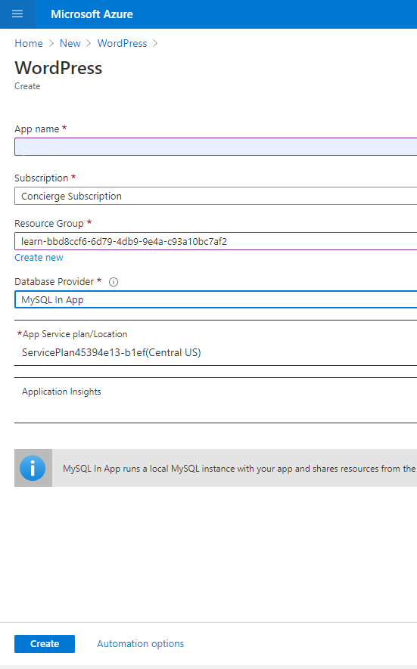

# Azure Fundamentals part 2: Describe core Azure services

## Explore Azure compute services

Azure compute is on-demand computing service for running cloud-based apps. It provides compu-ting resources such as disks, processors, memory, networking, and OSs. Resources are available on-demand and can typically be made available in minutes or seconds. You pay only for the resources you use, and only for as long as you're using them.

Azure supports a wide range of computing solutions for development and testing, running apps, and extending your datacenter. The service supports Linux, Windows Server, SQL Server, Oracle, IBM, and SAP. Azure also has many services that can run virtual machines (VMs). Each service provides different options depending on your requirements. Some of the most prominent services are:

* Azure Virtual Machines
* Azure Container Instances
* Azure App Service
* Azure Functions (or serverless computing)

**Virtual machines**

Virtual machines are software emulations of physical computers. They include a virtual processor, memory, storage, and networking resources. VMs host an operating system, and you can install and run software just like a physical computer. When using a remote desktop client, you can use and control the VM as if you were sitting in front of it.

With [Azure](https://azure.microsoft.com/services/virtual-machines/) VM, you can create and use VMs in the cloud. VM provides IaaS and can be used in different ways. When you need total control over an operating system and environment, VMs are an ideal choice. Just like a physical computer, you can customize all the software running on the VM. This ability is helpful when you're running custom software or custom hosting configurations.

### ****Virtual machine scale sets****

[They](https://azure.microsoft.com/services/virtual-machine-scale-sets) are Azure compute resource that you can use to deploy and manage set of identical VMs. With all VMs configured the same, vm scale sets are designed to support true autoscale. No preprovisio-ning of VMs is required.It's easier to build large-scale services targeting big compute, big data, and containerized workloads. As demand goes up, more VM instances can be added. As demand goes down, VM instances can be removed. Process can be manual, automated, or combination of both.

### ****Containers and Kubernetes****

[Container Instances](https://azure.microsoft.com/services/container-instances) and [Azure Kubernetes Service](https://azure.microsoft.com/services/kubernetes-service) are Azure compute resources that you can use to deploy and manage containers. Containers are lightweight, virtualized application environments. They're designed to be quickly created, scaled out, and stopped dynamically. You can run multiple instances of a containerized application on a single host machine.

### ****App Service****

With it, you can quickly build, deploy, and scale enterprise-grade web, mobile, and API apps running on any platform. You can meet rigorous performance, scalability, security, compliance requirements while using fully managed platform to perform infrastructure maintenance. App Service is a PaaS.

### ****Functions****

[Functions](https://azure.microsoft.com/services/functions) are ideal when you're concerned only about the code running your service and not the underlying platform or infrastructure. They're commonly used when you need to perform work in response to an event (often via a REST request), timer, or message from another Azure service, and when that work can be completed quickly, within seconds or less.

## Decide when to use Azure Virtual Machines

With Azure Virtual Machines, you can create and use VMs in the cloud. VMs provide IaaS in the form of a virtualized server and can be used in many ways. Just like a physical computer, you can customize all of the software running on the VM. VMs are an ideal choice when you need:

* Total control over the operating system (OS).
* The ability to run custom software.
* To use custom hosting configurations.

An Azure VM gives you the flexibility of virtualization without having to buy and maintain the physical hardware that runs the VM. You still need to configure, update, and maintain the software that runs on the VM.

You can create and provision a VM in minutes when you select a preconfigured VM image. Selecting an image is one of the most important decisions you'll make when you create a VM. An image is a template used to create a VM. These templates already include an OS and often other software, like development tools or web hosting environments.

**Examples of when to use VMs**

* **During testing and development.** VMs provide a quick and easy way to create different OS and application configurations. Test and development personnel can then easily delete the VMs when they no longer need them.
* **When running applications in the cloud.** The ability to run certain applications in the public cloud as opposed to creating a traditional infrastructure to run them can provide substantial economic benefits. Ex. an application might need to handle fluctuations in demand. Shutting down VMs when you don't need them or quickly starting them up to meet a sudden increase in demand means you pay only for the resources you use.
* **When extending your datacenter to the cloud.** An organization can extend the capabilities of its own on-premises network by creating a virtual network in Azure and adding VMs to that virtual network. Applications like SharePoint can then run on an Azure VM instead of running locally. This arrangement makes it easier or less expensive to deploy than in an on-premises environment.
* **During disaster recovery.** As with running certain types of applications in the cloud and extending an on-premises network to the cloud, you can get significant cost savings by using an IaaS-based approach to disaster recovery. If a primary datacenter fails, you can create VMs running on Azure to run your critical applications and then shut them down when the primary datacenter becomes operational again.

### Move to the cloud with VMs

VMs are excellent choice when you move from a physical server to the cloud (also known as lift and shift). You can create image of physical server and host it within a VM with little or no changes. Just like physical on-premises server, you must maintain VM. You update installed OS and the SW it runs.

### Scale VMs in Azure

You can run single VMs for testing, development, or minor tasks. Or you can group VMs together to provide high availability, scalability, and redundancy. No matter what your uptime requirements are, Azure has several features that can meet them. These features include: VM scale sets, Azure Batch.

### What are virtual machine scale sets?

VM scale sets let you create and manage a group of identical, load-balanced VMs. Imagine you're running a website that enables scientists to upload astronomy images that need to be processed. If you duplicated the VM, you'd normally need to configure an additional service to route requests between multiple instances of the website. Virtual machine scale sets could do that work for you.

Scale sets allow you to centrally manage, configure, and update a large number of VMs in minutes to provide highly available applications. The number of VM instances can automatically increase or decrease in response to demand or a defined schedule. With virtual machine scale sets, you can build large-scale services for areas such as compute, big data, and container workloads.

### What is Azure Batch?

Azure Batch enables large-scale parallel and high-performance computing batch jobs with the ability to scale to tens, or thousands of VMs. When you're ready to run job, Batch does following:

* Starts a pool of compute VMs for you.
* Installs applications and staging data.
* Runs jobs with as many tasks as you have.
* Identifies failures.
* Requeues work.
* Scales down the pool as work completes.

There might be situations in which you need raw computing power or supercomputer-level compute power. Azure provides these capabilities.

## Decide when to use Azure App Service

In your research for Tailwind Traders, you've looked at different ways that you can virtualize your application. Another alternative is to deploy your application's front-end websites to Azure App Service, which makes it easy to respond to application demand.

App Service enables you to build and host web apps, background jobs, mobile back-ends, RESTful APIs in the programming language of your choice without managing infrastructure. It offers automatic scaling and high availability. App Service supports WS and Linux and enables automated deployments from GitHub, Azure DevOps, or any Git repo to support continuous deployment model.

This platform as a service (PaaS) environment allows you to focus on the website and API logic while Azure handles the infrastructure to run and scale your web applications.

### Azure App Service costs

You pay for the Azure compute resources your app uses while it processes requests based on the App Service plan you choose. The App Service plan determines how much hardware is devoted to your host. For example, the plan determines whether it's dedicated or shared hardware and how much memory is reserved for it. There's even a free tier you can use to host small, low-traffic sites.

### Types of app services

With App Service, you can host most common app service styles like:

* Web apps
* API apps
* WebJobs
* Mobile apps

App Service handles most of the infrastructure decisions you deal with in hosting web-accessible apps:

* Deployment and management are integrated into the platform.
* Endpoints can be secured.
* Sites can be scaled quickly to handle high traffic loads.
* The built-in load balancing and traffic manager provide high availability.

All of these app styles are hosted in the same infrastructure and share these benefits. This flexibility makes App Service the ideal choice to host web-oriented applications.

### Web apps

App Service includes full support for hosting web apps by using ASP.NET, ASP.NET Core, Java, Ruby, Node.js, PHP, or Python. You can choose either Windows or Linux as the host operating system.

### API apps

Much like hosting a website, you can build REST-based web APIs by using your choice of language and framework. You get full Swagger support and the ability to package and publish your API in Azure Marketplace. The produced apps can be consumed from any HTTP- or HTTPS-based client.

### WebJobs

You can use the WebJobs feature to run a program (.exe, Java, PHP, Python, or Node.js) or script (.cmd, .bat, PowerShell, or Bash) in the same context as a web app, API app, or mobile app. They can be scheduled or run by a trigger. WebJobs are often used to run background tasks as part of your application logic.

### Mobile apps

Use the Mobile Apps feature of App Service to quickly build a back end for iOS and Android apps. With just a few clicks in the Azure portal, you can:

* Store mobile app data in a cloud-based SQL database.
* Authenticate customers against common social providers, such as MSA, Google, Twitter, and Facebook.
* Send push notifications.
* Execute custom back-end logic in C# or Node.js.

On the mobile app side, there's SDK support for native iOS and Android, Xamarin, and React native apps.

## Decide when to use Azure Container Instances or Azure Kubernetes Service

While vms are excellent way to reduce costs versus the investments that are necessary for physical hardware, they're still limited to a single operating system per virtual machine. If you want to run multiple instances of an application on a single host machine, containers are an excellent choice.

### What are containers?

Containers are a virtualization env. Much like running multiple virtual machines on a single physical host, you can run multiple containers on a single physical or virtual host. Unlike virtual machines, you don't manage the operating system for a container. Virtual machines appear to be an instance of an operating system that you can connect to and manage, but containers are lightweight and designed to be created, scaled out, and stopped dynamically. While it's possible to create and deploy virtual machines as application demand increases, containers are designed to allow you to respond to changes on demand. With containers, you can quickly restart in case of a crash or hardware interruption. One of the most popular container engines is Docker, which is supported by Azure.

### Manage containers

Containers are managed through a container orchestrator, which can start, stop, and scale out application instances as needed. There are two ways to manage both Docker and Microsoft-based containers in Azure: Azure Container Instances and Azure Kubernetes Service (AKS).

#### **Azure Container Instances**

[Azure Container Instances](https://azure.microsoft.com/services/container-instances) offers the fastest and simplest way to run a container in Azure without having to manage any virtual machines or adopt any additional services. It's a platform as a service (PaaS) offering that allows you to upload your containers, which it runs for you.

#### **Azure Kubernetes Service**

The task of automating, managing, and interacting with a large number of containers is known as orchestration. [Azure Kubernetes Service](https://azure.microsoft.com/services/kubernetes-service) is a complete orchestration service for containers with distributed architectures and large volumes of containers.

### What is Kubernetes?

[Kubernetes](https://kubernetes.io/docs/concepts/overview/what-is-kubernetes/), also known as K8s, is an open-source system for automating deployment, scaling, and management of containerized applications. It groups containers that make up an application into logical units for easy management and discovery.

### Use containers in your solutions

Containers are often used to create solutions by using a microservice architecture. This architecture is where you break solutions into smaller, independent pieces. For example, you might split a website into a container hosting your front end, another hosting your back end, and a third for storage. This split allows you to separate portions of your app into logical sections that can be maintained, scaled, or updated independently.

Imagine your website back-end has reached capacity but the front end and storage aren't being stressed. You could:

* Scale the back end separately to improve performance.
* Decide to use a different storage service.
* Replace the storage container without affecting the rest of the application.

### What is a microservice?

Microservices - also known as the microservice architecture - is an architectural style that structures an application as a collection of services that are

* Highly maintainable and testable
* Loosely coupled
* Independently deployable
* Organized around business capabilities
* Owned by a small team

The microservice architecture enables the rapid, frequent and reliable delivery of large, complex applications. It also enables an organization to evolve its technology stack.

## Decide when to use Azure Functions

After consulting with several of your fellow developers at Tailwind Traders, you've determined that some of your application logic is event driven. In other words, for a large amount of time, your application is waiting for a particular input before it performs any processing. To reduce your costs, you want to avoid having to pay for the time that your application is waiting for input.

Serverless computing is the abstraction of servers, infrastructure, and operating systems. With serverless computing, Azure takes care of managing the server infrastructure and the allocation and deallocation of resources based on demand. Infrastructure isn't your responsibility. Scaling and performance are handled automatically. You're billed only for the exact resources you use. There's no need to even reserve capacity.

Serverless computing includes the abstraction of servers, an event-driven scale, and micro-billing:

* **Abstraction of servers**: Serverless computing abstracts the servers you run on. You never explicitly reserve server instances. The platform manages that for you. Each function execution can run on a different compute instance. This execution context is transparent to the code. With serverless architecture, you deploy your code, which then runs with high availability.
* **Event-driven scale**: Serverless computing is an excellent fit for workloads that respond to incoming events. Events include triggers by:
  + Timers, for example, if a function needs to run every day at 10:00 AM UTC.
  + HTTP, for example, API and webhook scenarios.
  + Queues, for example, with order processing.
  + And much more.
* Instead of writing an entire application, the developer authors a function, which contains both code and metadata about its triggers and bindings. The platform automatically schedules the function to run and scales the number of compute instances based on the rate of incoming events. Triggers define how a function is invoked. Bindings provide a declarative way to connect to services from within the code.
* **Micro-billing**: Traditional computing bills for a block of time like paying a monthly or annual rate for website hosting. This method of billing is convenient but isn't always cost effective. Even if a customer's website gets only one hit a day, they still pay for a full day's worth of availability. With serverless computing, they pay only for the time their code runs. If no active function executions occur, they're not charged. For example, if the code runs once a day for two minutes, they're charged for one execution and two minutes of computing time.

### Serverless computing in Azure

Azure has two implementations of serverless compute:

* **Azure Functions**: Functions can execute code in almost any modern language.
* **Azure Logic Apps**: Logic apps are designed in a web-based designer and can execute logic triggered by Azure services without writing any code.

### Azure Functions

When you're concerned only about the code running your service, and not the underlying platform or infrastructure, using Azure Functions is ideal. Functions are commonly used when you need to perform work in response to an event (often via a REST request), timer, or message from another Azure service, and when that work can be completed quickly, within seconds or less.

Functions scale automatically based on demand, so they're a solid choice when demand is variable. For example, you might receive messages from an IoT solution that's used to monitor a fleet of delivery vehicles. You'll likely have more data arriving during business hours.

Using VM-based approach, you'd incur costs even when the virtual machine is idle. With functions, Azure runs your code when it's triggered and automatically deallocates resources when the function is finished. In this model, you're only charged for the CPU time used while your function runs.

Functions can be either stateless or stateful. When they're stateless (the default), they behave as if they're restarted every time they respond to an event. When they're stateful (called Durable Functions), a context is passed through the function to track prior activity.

Functions are a key component of serverless computing. They're also a general compute platform for running any type of code. If the needs of the developer's app change, you can deploy the project in an environment that isn't serverless. This flexibility allows you to manage scaling, run on virtual networks, and even completely isolate the functions.

### Azure Logic Apps

Logic apps are similar to functions. Both enable you to trigger logic based on an event. Where functions execute code, logic apps execute workflows that are designed to automate business scenarios and are built from predefined logic blocks.

Every Azure logic app workflow starts with a trigger, which fires when a specific event happens or when newly available data meets specific criteria. Many triggers include basic scheduling capabilities, so developers can specify how regularly their workloads will run. Each time the trigger fires, the Logic Apps engine creates a logic app instance that runs the actions in the workflow. These actions can also include data conversions and flow controls, such as conditional statements, switch statements, loops, and branching.

You create logic app workflows by using a visual designer on the Azure portal or in Visual Studio. The workflows are persisted as a JSON file with a known workflow schema.

Azure provides more than 200 different connectors and processing blocks to interact with different services. These resources include the most popular enterprise apps. You can also build custom connectors and workflow steps if the service you need to interact with isn't covered. You then use the visual designer to link connectors and blocks together. You pass data through the workflow to do custom processing, often all without writing any code.

As an example, let's say a ticket arrives in Zendesk. You could:

* Detect the intent of the message with cognitive services.
* Create an item in SharePoint to track the issue.
* Add the customer to your Dynamics 365 CRM system if they aren't already in your database.
* Send a follow-up email to acknowledge their request.

### Functions vs. Logic Apps

Functions and Logic Apps can both create complex orchestrations. An orchestration is a collection of functions or steps that are executed to accomplish a complex task.

* With Functions, you write code to complete each step.
* With Logic Apps, you use a GUI to define the actions and how they relate to one another.

You can mix and match services when you build an orchestration, calling functions from logic apps and calling logic apps from functions. Here are some common differences between the two.

|  |  |  |
| --- | --- | --- |
|  | **Functions** | **Logic Apps** |
| State | Normally stateless, but Durable Functions provide state | Stateful |
| Development | Code-first (imperative) | Designer-first (declarative) |
| Connectivity | About a dozen built-in binding types. Write code for custom bindings. | Large collection of connectors. Enterprise Integration Pack for B2B scenarios. Build custom connectors. |
| Actions | Each activity is an Azure function. Write code for activity functions | Large collection of ready-made actions |
| Monitoring | Azure Application Insights. | Azure portal, Log Analytics |
| Management | REST API, Visual Studio. | Azure portal, REST API, PowerShell, Visual Studio. |
| Execution context | Can run locally or in the cloud. | Runs only in the cloud. |

## Decide when to use Azure Virtual Desktop

In addition to the challenges that Tailwind Traders has been facing with application scale, your manager has asked you to put together a new development team of remote workers.

This task would normally require setting up several new PCs with all of the requisite development tools for your new team. Then you would need to ship them to the respective developers. The time to procure, set up, and ship each of these PCs would be costly. Also, all of your new developers have their own computing devices that are running a mixture of WS, Android, and macOS OSs.

### What is Azure Virtual Desktop?

AVD is a desktop and application virtualization service that runs on the cloud. It enables your users to use a cloud-hosted version of Windows from any location. Azure Virtual Desktop works across devices like Windows, Mac, iOS, Android, and Linux. It works with apps that you can use to access remote desktops and apps. You can also use most browsers to access AVD-hosted experiences.

### Why should you use Azure Virtual Desktop?

#### Provide the best user experience

Users have the freedom to connect to Azure Virtual Desktop with any device over the internet. They use a Azure Virtual Desktop client to connect to their published WS desktop and apps. This client could either be a native application on the device or the Azure Virtual Desktop HTML5 web client.

You can make sure your session host VMs run near apps and services that connect to your datacenter or the cloud. This way your users stay productive and don't encounter long load times.

User sign-in to Azure Virtual Desktop is fast because user profiles are containerized by using FSLogix. At sign-in, the user profile container is dynamically attached to the computing environment. The user profile is immediately available and appears in the system exactly like a native user profile.

You can provide individual ownership through personal (persistent) desktops. For example, you might want to provide personal remote desktops for members of an engineering team. Then they can add or remove programs without impacting other users on that remote desktop.

#### Enhance security

Azure Virtual Desktop provides centralized security management for users' desktops with Azure Active Directory (Azure AD). You can enable multifactor authentication to secure user sign-ins. You can also secure access to data by assigning granular role-based access controls (RBACs) to users.

With Azure Virtual Desktop, the data and apps are separated from the local hardware. Azure Virtual Desktop runs them instead on a remote server. The risk of confidential data being left on a personal device is reduced.

User sessions are isolated in both single and multi-session environments.

Azure Virtual Desktop also improves security by using reverse connect technology. This connection type is more secure than the Remote Desktop Protocol. We don't open inbound ports to the session host VMs.

### What are some key features of Azure Virtual Desktop?

#### Simplified management

Azure Virtual Desktop is an Azure service, so it will be familiar to Azure administrators. You use Azure AD and RBACs to manage access to resources. With Azure, you also get tools to automate VM deployments, manage VM updates, and provide disaster recovery. As with other Azure services, Azure Virtual Desktop uses Azure Monitor for monitoring and alerts. This standardization lets admins identify issues through a single interface.

#### Performance management

Azure Virtual Desktop gives you options to load balance users on your VM host pools. Host pools are collections of VMs with the same configuration assigned to multiple users. For the best performance, you can configure load balancing to occur as users sign in (breadth mode). With breadth mode, users are sequentially allocated across the host pool for your workload. To save costs, you can configure your VMs for depth mode load balancing where users are fully allocated on one VM before moving to the next. Azure Virtual Desktop provides tools to automatically provision additional VMs when incoming demand exceeds a specified threshold.

#### Multi-session Windows 10 deployment

Azure Virtual Desktop lets you use Windows 10 Enterprise multi-session, the only Windows client-based operating system that enables multiple concurrent users on a single VM. Azure Virtual Desktop also provides a more consistent experience with broader application support compared to Windows Server-based operating systems.

### How can you reduce costs with Azure Virtual Desktop?

#### Bring your own licenses

Azure Virtual Desktop is available to you at no additional cost if you have an eligible Microsoft 365 license. Just pay for the Azure resources used by Azure Virtual Desktop.

Bring your eligible Windows or Microsoft 365 license to get Windows 10 Enterprise and Windows 7 Enterprise desktops and apps at no additional cost.

If you're an eligible Microsoft Remote Desktop Services Client Access License customer, Windows Server Remote Desktop Services desktops and apps are available at no additional cost.

#### Save on compute costs

Buy one-year or three-year Azure Reserved Virtual Machine Instances to save you up to 72 percent versus pay-as-you-go pricing. You can pay for a reservation up front or monthly. Reservations provide a billing discount and don't affect the runtime state of your resources.

## Explore Azure networking services

To help save costs, you convince your team to move your website and several of your other networked resources to the cloud. With that in mind, you'll need to provide secure access to private company data for each of its branch locations. You want to know how Azure can help you manage your network more effectively. As it turns out, managing networks on Azure isn't entirely different from managing on-premises networks.

### What is Azure virtual networking?

Azure virtual networks enable Azure resources, such as VMs, web apps, and databases, to communicate with each other, with users on the internet, and with your on-premises client computers. You can think of an Azure network as a set of resources that links other Azure resources.

Azure virtual networks provide the following key networking capabilities:

* Isolation and segmentation
* Internet communications
* Communicate between Azure resources
* Communicate with on-premises resources
* Route network traffic
* Filter network traffic
* Connect virtual networks

### Network configurations for virtual machines

#### Isolation and segmentation

Virtual Network allows you to create multiple isolated virtual networks. When you set up a virtual network, you define a private IP address space by using either public or private IP address ranges. You can divide that IP address space into subnets and allocate part of the defined address space to each named subnet.

For name resolution, you can use the name resolution service that's built in to Azure. You also can configure the virtual network to use either an internal or an external DNS server.

#### Internet communications

A VM in Azure can connect to the internet by default. You can enable incoming connections from the internet by defining a public IP address or a public load balancer. For VM management, you can connect via the Azure CLI, Remote Desktop Protocol, or Secure Shell.

#### Communicate between Azure resources

You'll want to enable Azure resources to communicate securely with each other. You can do that in one of two ways:

**Virtual networks** Virtual networks can connect not only VMs but other Azure resources, such as the App Service Environment for Power Apps, Azure Kubernetes Service, and Azure virtual machine scale sets.

**Service endpoints** You can use service endpoints to connect to other Azure resource types, such as Azure SQL databases and storage accounts. This approach enables you to link multiple Azure resources to virtual networks to improve security and provide optimal routing between resources.

#### Communicate with on-premises resources

Azure virtual networks enable you to link resources together in your on-premises environment and within your Azure subscription. In effect, you can create a network that spans both your local and cloud environments. There are three mechanisms for you to achieve this connectivity:

**Point-to-site virtual private networks** The typical approach to a virtual private network (VPN) connection is from a computer outside your organization, back into your corporate network. In this case, the client computer initiates an encrypted VPN connection to connect that computer to the Azure virtual network.

**Site-to-site virtual private networks** A site-to-site VPN links your on-premises VPN device or gateway to the Azure VPN gateway in a virtual network. In effect, the devices in Azure can appear as being on the local network. The connection is encrypted and works over the internet.

**Azure ExpressRoute** For environments where you need greater bandwidth and even higher levels of security, Azure ExpressRoute is the best approach. ExpressRoute provides dedicated private connectivity to Azure that doesn't travel over the internet. (You'll learn more about ExpressRoute in a separate unit later in this module.)

#### Route network traffic

By default, Azure routes traffic between subnets on any connected virtual networks, on-premises networks, and the internet. You also can control routing and override those settings, as follows:

**Route tables** A route table allows you to define rules about how traffic should be directed. You can create custom route tables that control how packets are routed between subnets.

**Border Gateway Protocol** Border Gateway Protocol (BGP) works with Azure VPN gateways or ExpressRoute to propagate on-premises BGP routes to Azure virtual networks.

#### Filter network traffic

Azure virtual networks enable you to filter traffic between subnets by using the following:

**Network security groups** A network security group is an Azure resource that can contain multiple inbound and outbound security rules. You can define these rules to allow or block traffic, based on factors such as source and destination IP address, port, and protocol.

**Network virtual appliances** A network virtual appliance is a specialized VM that can be compared to a hardened network appliance. A network virtual appliance carries out a particular network function, such as running a firewall or performing wide area network (WAN) optimization.

### Connect virtual networks

You can link virtual networks together by using virtual network peering. Peering enables resources in each virtual network to communicate with each other. These virtual networks can be in separate regions, which allows you to create a global interconnected network through Azure.

UDR is user-defined Routing. UDR is a significant update to Azure’s Virtual Networks as this allows network admins to control the routing tables between subnets within a VNet, as well as between VNets, thereby allowing for greater control over network traffic flow.

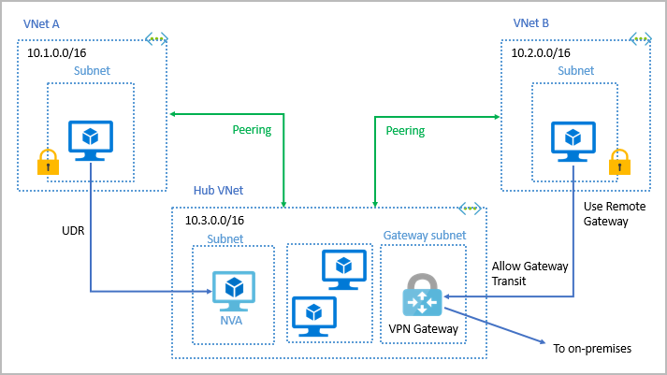

### Azure Virtual Network settings

You can create and configure Azure Virtual Network instances from the Azure portal, Azure PowerShell on your local computer, or Azure Cloud Shell.

### Create a virtual network

When you create an Azure virtual network, you configure a number of basic settings. You'll have the option to configure advanced settings, such as multiple subnets, distributed denial of service (DDoS) protection, and service endpoints.

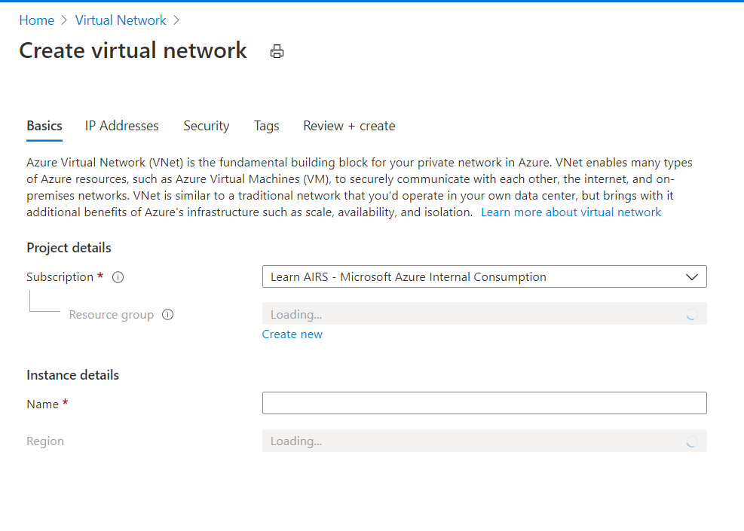

You'll configure the following settings for a basic virtual network:

* **Network name** The network name must be unique in your subscription, but it doesn't need to be globally unique. Make the name a descriptive one that's easy to remember and identified from other virtual networks.
* **Address space** When you set up a virtual network, you define the internal address space in Classless Interdomain Routing format. This address space needs to be unique within your subscription and any other networks that you connect to. Let's assume you choose an address space of 10.0.0.0/24 for your first virtual network. The addresses defined in this address space range from 10.0.0.1 to 10.0.0.254. You then create a second virtual network and choose an address space of 10.0.0.0/8. The addresses in this address space range from 10.0.0.1 to 10.255.255.254. Some of the addresses overlap and can't be used for the two virtual networks. But you can use 10.0.0.0/16, with addresses that range from 10.0.0.1 to 10.0.255.254, and 10.1.0.0/16, with addresses that range from 10.1.0.1 to 10.1.255.254. You can assign these address spaces to your virtual networks because there's no address overlap.

**Note:** You can add address spaces after you create the virtual network.

* **Subscription** This option only applies if you have multiple subscriptions to choose from.
* **Resource group** Like any other Azure resource, a virtual network needs to exist in a resource group. You can either select an existing resource group or create a new one.
* **Location** Select the location where you want the virtual network to exist.
* **Subnet** Within each virtual network address range, you can create one or more subnets that partition the virtual network's address space. Routing between subnets will then depend on the default traffic routes. You also can define custom routes. Alternatively, you can define one subnet that encompasses all the virtual networks' address ranges.

**Note:** Subnet names must begin with a letter or number and end with a letter, number, or underscore. They may contain only letters, numbers, underscores, periods, or hyphens.

* **DDoS protection** You can select either Basic or Standard DDoS protection. Standard DDoS protection is a premium service. For more information on Standard DDoS protection, see [Azure DDoS protection Standard overview](https://docs.microsoft.com/en-us/azure/virtual-network/ddos-protection-overview).
* **Service endpoints** Here, you enable service endpoints. Then you select from the list which Azure service endpoints you want to enable. Options include Azure Cosmos DB, Azure Service Bus, Azure Key Vault, and so on.

**Define additional settings**

After you create a virtual network, you can then define further settings. These include:

* **Network security group** have security rules that enable you to filter the type of network traffic that can flow in and out of virtual network subnets and network interfaces. You create the network security group separately. Then you associate it with the virtual network.
* **Route table** Azure automatically creates a route table for each subnet within an Azure virtual network and adds system default routes to the table. You can add custom route tables to modify traffic between virtual networks.

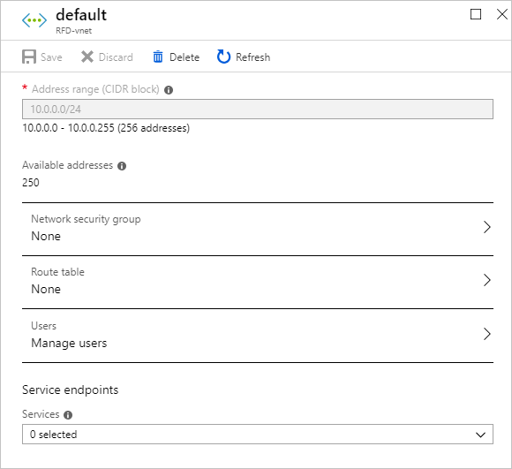

### Configure virtual networks

You can change any further settings on **Virtual network** pane in Azure portal. Or, you can use PowerShell commands or commands in Cloud Shell for changes. You can then review and change settings in further subpanes. Include:

* **Address spaces**: You can add additional address spaces to the initial definition.
* **Connected devices**: Use the virtual network to connect machines.
* **Subnets**: You can add additional subnets.
* **Peerings**: Link virtual networks in peering arrangements.

You can also monitor and troubleshoot virtual networks. Or, you can create an automation script to generate the current virtual network.

Virtual networks are powerful and highly configurable mechanisms for connecting entities in Azure. You can connect Azure resources to one another or to resources you have on-premises. You can isolate, filter, and route your network traffic.

## Azure ExpressRoute fundamentals

ExpressRoute lets you extend your on-premises networks into the Microsoft cloud over a private connection with the help of a connectivity provider. With ExpressRoute, you can establish connections to Microsoft cloud services, such as Microsoft Azure and Microsoft 365.

Connectivity can be from any-to-any (IP VPN) network, a point-to-point Ethernet network, or virtual cross-connection through a connectivity provider at a colocation facility. ExpressRoute connections don't go over the public Internet. This allows ExpressRoute connections to offer more reliability, faster speeds, consistent latencies, and higher security than typical connections over Internet. For inf on how to connect your network to MS using ExpressRoute, see ExpressRoute connectivity models.

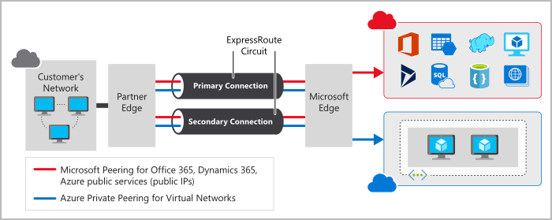

As part of your work for Tailwind Traders, you should understand what Azure ExpressRoute is and how it integrates with on-premises and Azure networks. In this unit, you'll learn about the benefits that ExpressRoute provides compared to other site-to-site connectivity options. As a result, you'll learn whether ExpressRoute can provide your company with the best possible network performance.

Two different layers of the Open Systems Interconnection (OSI) model:

* **Layer 2 (L2)**: This layer is the Data Link Layer, which provides node-to-node communication between two nodes on the same network.
* **Layer 3 (L3)**: This layer is the Network Layer, which provides addressing and routing between nodes on a multi-node network.

### Features and benefits of ExpressRoute

Benefits to using ExpressRoute as the connection service between Azure and on-premises networks.

* Layer 3 connectivity between your on-premises network and the Microsoft Cloud through a connectivity provider. Connectivity can be from an any-to-any (IPVPN) network, a point-to-point Ethernet connection, or through a virtual cross-connection via an Ethernet exchange.
* Connectivity to Microsoft cloud services across all regions in the geopolitical region.
* Global connectivity to MS services across all regions with the ExpressRoute premium add-on.
* Dynamic routing between your network and Microsoft via BGP.
* Built-in redundancy in every peering location for higher reliability.
* Connection uptime SLA.
* QoS support for Skype for Business.

#### Layer 3 connectivity

ExpressRoute provides Layer 3 (address-level) connectivity between your on-premises network and the Microsoft cloud through connectivity partners. These connections can be from a point-to-point or any-to-any network. They can also be virtual cross-connections through an exchange.

#### Built-in redundancy

Each connectivity provider uses redundant devices to ensure that connections established with Microsoft are highly available. You can configure multiple circuits to complement this feature. All redundant connections are configured with Layer 3 connectivity to meet service-level agreements.

#### Connectivity to Microsoft cloud services

ExpressRoute enables direct access to the following services in all regions:

* Microsoft Office 365
* Microsoft Dynamics 365
* Azure compute services, such as Azure Virtual Machines
* Azure cloud services, such as Azure Cosmos DB and Azure Storage

Office 365 was created to be accessed securely and reliably via the internet. For this reason, we recommend the use of ExpressRoute for specific scenarios. The "Learn more" section at the end of this module includes a link about using ExpressRoute to access Office 365.

#### Across on-premises connectivity with ExpressRoute Global Reach

You can enable ExpressRoute Global Reach to exchange data across your on-premises sites by connecting your ExpressRoute circuits. Ex. assume you have private datacenter in Bali connected to ExpressRoute in Valley. You have another private datacenter in Texas connected to ExpressRoute in Dallas. With ExpressRoute Global Reach, you can connect your private datacenters through two ExpressRoute circuits. Your cross-datacenter traffic will travel through MS network.

#### Dynamic routing

ExpressRoute uses the Border Gateway Protocol (BGP) routing protocol. BGP is used to exchange routes between on-premises networks and resources running in Azure. This protocol enables dynamic routing between your on-premises network and services running in the Microsoft cloud.

### ExpressRoute connectivity models

ExpressRoute supports three models that you can use to connect your on-premises network to the Microsoft cloud: CloudExchange colocation, Point-to-point Ethernet connection, and Any-to-any connection.

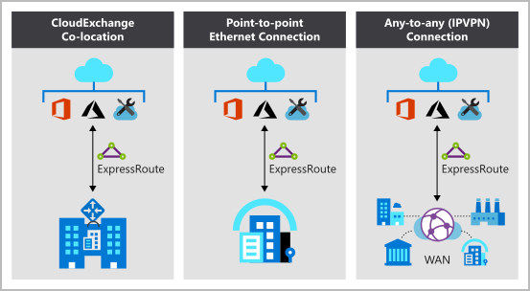

#### Colocation at a cloud exchange

Colocated providers can normally offer both Layer 2 and Layer 3 connections between your infrastructure, which might be located in the colocation facility, and the Microsoft cloud. For example, if your datacenter is colocated at a cloud exchange such as an ISP, you can request a virtual cross-connection to the Microsoft cloud.

#### Point-to-point Ethernet connection

Point-to-point connections provide Layer 2 and Layer 3 connectivity between your on-premises site and Azure. You can connect your offices or datacenters to Azure by using the point-to-point links.Ex. if you have an on-premises datacenter, you can use a point-to-point Ethernet link to connect to MS.

#### Any-to-any networks

With any-to-any connectivity, you can integrate your wide area network (WAN) with Azure by providing connections to your offices and datacenters. Azure integrates with your WAN connection to provide a connection like you would have between your datacenter and any branch offices.

With any-to-any connections, all WAN providers offer Layer 3 connectivity. For example, if you already use Multiprotocol Label Switching to connect to your branch offices or other sites in your organization, an ExpressRoute connection to Microsoft behaves like any other location on your private WAN.

#### Security considerations

With ExpressRoute, your data doesn't travel over the public internet, so it's not exposed to the potential risks associated with internet communications. ExpressRoute is a private connection from your on-premises infrastructure to your Azure infrastructure. Even if you have an ExpressRoute connection, DNS queries, certificate revocation list checking, and Azure Content Delivery Network requests are still sent over the public internet.

## Explore Azure Storage services

### Azure Storage account fundamentals

[Azure Storage](https://azure.microsoft.com/product-categories/storage) is a service that you can use to store files, messages, tables, and other types of information. Clients such as websites, mobile apps, desktop applications, and many other types of custom solutions can read data from and write data to Azure Storage. Azure Storage is also used by infrastructure as a service virtual machines, and platform as a service cloud services.

To begin using Azure Storage, you first create an Azure Storage account to store your data objects. You can create an Azure Storage account by using the Azure portal, PowerShell, or the Azure CLI. Your storage account will contain all of your Azure Storage data objects, such as blobs, files, and disks. A storage account provides a unique namespace for your Azure Storage data, that's accessible from anywhere in the world over HTTP or HTTPS. Data in this account is secure, highly available, durable, and massively scalable.

**Note:** Azure VMs use Azure Disk Storage to store virtual disks. However, you can't use Azure Disk Storage to store a disk outside of a virtual machine.

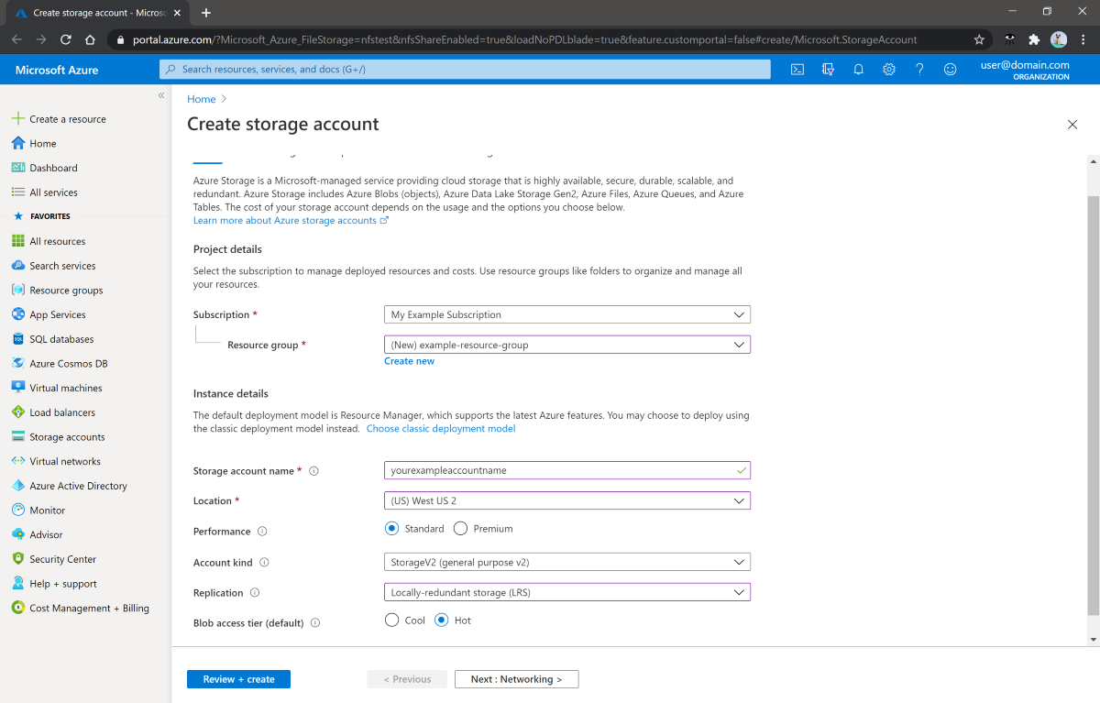

### Disk storage fundamentals

Disk Storage provides disks for Azure virtual machines. Applications and other services can access and use these disks as needed, similar to how they would in on-premises scenarios. Disk Storage allows data to be persistently stored and accessed from an attached virtual hard disk.

Disks come in many different sizes and performance levels, from solid-state drives (SSDs) to traditional spinning hard disk drives (HDDs), with varying performance tiers. You can use standard SSD and HDD disks for less critical workloads, premium SSD disks for mission-critical production applications, and ultra disks for data-intensive workloads such as SAP HANA, top tier databases, and transaction-heavy workloads. Azure has consistently delivered enterprise-grade durability for infrastructure as a service (Iaas) disks, with an industry-leading ZERO% annualized failure rate.

### Azure Blob storage fundamentals

Azure Blob Storage is an object storage solution for the cloud. It can store massive amounts of data, such as text or binary data. Azure Blob Storage is unstructured, meaning that there are no restrictions on the kinds of data it can hold. Blob Storage can manage thousands of simultaneous uploads, massive amounts of video data, constantly growing log files, and can be reached from anywhere with an internet connection.

Blobs aren't limited to common file formats. A blob could contain gigabytes of binary data streamed from a scientific instrument, an encrypted message for another app, or data in a custom format for an app you're developing. One advantage of blob storage over disk storage is that it does not require developers to think about or manage disks; data is uploaded as blobs, and Azure takes care of the physical storage needs. Blob Storage is ideal for:

* Serving images or documents directly to a browser.
* Storing files for distributed access.
* Streaming video and audio.
* Storing data for backup and restore, disaster recovery, and archiving.
* Storing data for analysis by an on-premises or Azure-hosted service.
* Storing up to 8 TB of data for virtual machines.

You store blobs in containers, which helps you organize your blobs depending on your business needs. The following diagram illustrates how you might use Azure accounts, containers, and blobs.

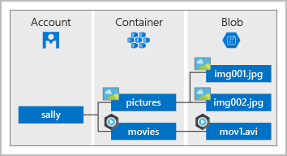

### Azure Files fundamentals

Azure Files offers fully managed file shares in cloud that are accessible via industry standard Server Message Block and Network File System protocols. Azure file shares can be mounted concurrently by cloud or on-premises deployments of Windows, Linux, and macOS. Apps running in Azure VMs or cloud services can mount file storage share to access file data, just as desktop app would mount typical SMB share. Any number of Azure VMs or roles can mount and access the file storage share simultaneously. Usage scenarios would be to share files anywhere in world, diagnostic data, ...

#### Use Azure Files for the following situations:

* Many on-premises applications use file shares. Azure Files makes it easier to migrate those applications that share data to Azure. If you mount the Azure file share to the same drive letter that the on-premises application uses, the part of your application that accesses the file share should work with minimal changes, if any.
* Store configuration files on a file share and access them from multiple VMs. Tools and utilities used by multiple developers in a group can be stored on a file share, ensuring that everybody can find them, and that they use the same version.
* Write data to a file share, and process or analyze the data later. For example, you might want to do this with diagnostic logs, metrics, and crash dumps.

The illustration shows Azure Files being used to share data between two geographical locations. Azure Files ensures data is encrypted at rest, and SMB protocol ensures data is encrypted in transit.

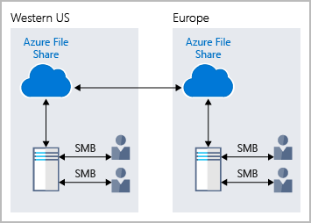

One thing that distinguishes Azure Files from files on a corporate file share is that you can access the files from anywhere in the world, by using a URL that points to the file. You can also use Shared Access Signature (SAS) tokens to allow access to a private asset for a specific amount of time.

Here's an example of a service SAS URI, showing the resource URI and the SAS token:

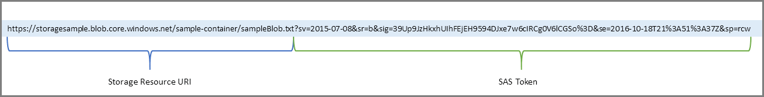

### Understand Blob access tiers

Data stored in the cloud can grow at an exponential pace. To manage costs for your expanding storage needs, it's helpful to organize your data based on attributes like frequency of access and planned retention period. Data stored in the cloud can be different based on how it's generated, processed, and accessed over its lifetime. Some data is actively accessed and modified throughout its lifetime. Some data is accessed frequently early in its lifetime, with access dropping drastically as the data ages. Some data remains idle in the cloud and is rarely, if ever, accessed after it's stored. To accommodate these different access needs, Azure provides several access tiers, which you can use to balance your storage costs with your access needs.

Azure Storage offers different access tiers for your blob storage, helping you store object data in the most cost-effective manner. The available access tiers include:

* **Hot access tier**: Optimized for storing data that is accessed frequently (ex. web image)
* **Cool access tier**: Optimized for data that is infrequently accessed and stored for at least 30 days (for example, invoices for your customers).
* **Archive access tier**: Appropriate for data that is rarely accessed and stored for at least 180 days, with flexible latency requirements (for example, long-term backups).

The following considerations apply to the different access tiers:

* Only the hot and cool access tiers can be set at the account level. The archive access tier isn't available at the account level.
* Hot, cool, and archive tiers can be set at the blob level, during upload or after upload.
* Data in the cool access tier can tolerate slightly lower availability, but still requires high durability, retrieval latency, and throughput characteristics similar to hot data. For cool data, a slightly lower availability service-level agreement (SLA) and higher access costs compared to hot data are acceptable trade-offs for lower storage costs.
* Archive storage stores data offline and offers the lowest storage costs, but also the highest costs to rehydrate and access data.

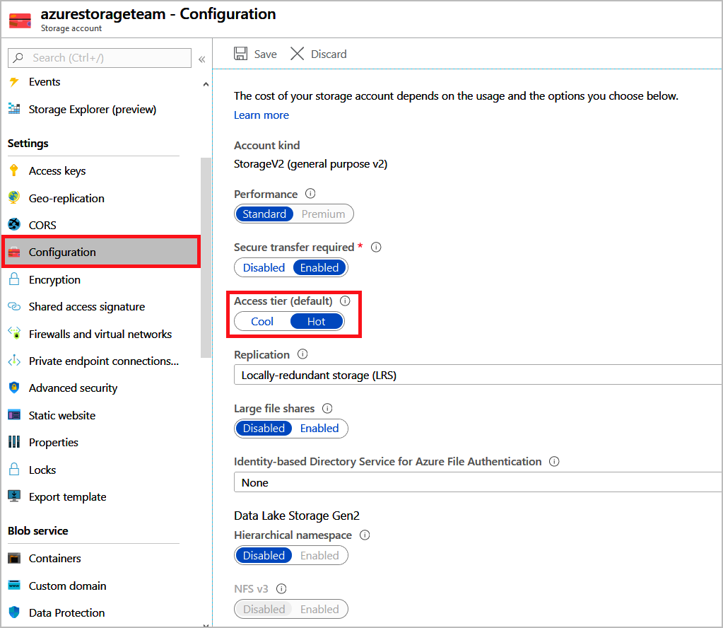

## Explore Azure database and analytics services

### Explore Azure Cosmos DB

Tailwind has acquired several smaller companies. Each of these companies had teams of developers who used different db services and various APIs to work with their data. A long-term plan might be to eventually move all of the disparate data to a common db service. For now, though, you'd like to enable each of these teams to work with an env where they can use their existing skills.

Azure Cosmos DB is a globally distributed, multi-model database service. You can elastically and independently scale throughput and storage across any number of Azure regions worldwide. You can take advantage of fast, single-digit-millisecond data access by using any one of several popular APIs. Azure Cosmos DB provides comprehensive service level agreements for throughput, latency, availability, and consistency guarantees.

Azure Cosmos DB supports schema-less data, which lets you build highly responsive and "Always On" applications to support constantly changing data. You can use this feature to store data that's updated and maintained by users around the world.

Ex. Tailwind provides a public portal that is used by customers across the globe to learn about the different tools that Tailwind creates. Developers maintain and update the data. The illustration shows a sample Azure Cosmos DB that's used to store data for the Tailwind training portal website.

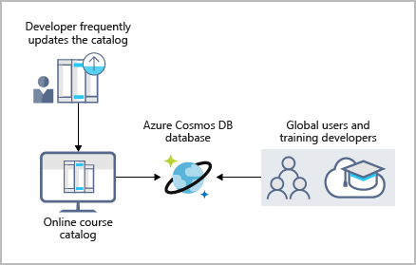

Azure Cosmos DB is flexible. At the lowest level, Azure Cosmos DB stores data in atom-record-sequence (ARS) format. The data is then abstracted and projected as an API, which you specify when you're creating your database. Your choices include SQL, MongoDB, Cassandra, Tables, and Gremlin. This level of flexibility means that as you migrate your company's databases to Azure Cosmos DB, your developers can stick with the API that they're the most comfortable with.

### Explore Azure SQL Database

Azure SQL Database is a relational database based on the latest stable version of the Microsoft SQL Server database engine. SQL Database is a high-performance, reliable, fully managed, and secure database. You can use it to build data-driven applications and websites in the programming language of your choice, without needing to manage infrastructure.

#### Features

Azure SQL db is PaaS database engine. It handles most of the db management functions, such as upgrading, patching, backups, and monitoring, without user involvement. SQL db provides 99.99 percent availability. PaaS capabilities that are built into SQL Database enable you to focus on the domain-specific db administration and optimization activities that are critical for your business. SQL db is a fully managed service that has built-in high availability, backups, and other common maintenance operations. MS handles all updates to the SQL and operating system code. You don't have to manage the underlying infrastructure.

You can create a highly available and high-performance data storage layer for the applications and solutions in Azure. SQL Database can be the right choice for a variety of modern cloud applications because it enables you to process both relational data and non-relational structures, such as graphs, JSON, spatial, and XML.

You can use advanced query processing features, such as high-performance, in-memory technologies and intelligent query processing. In fact, the newest capabilities of SQL Server are released first to SQL Database, and then to SQL Server itself. You get the newest SQL Server capabilities, with no overhead for updates or upgrades, tested across millions of databases.

#### Migration

Tailwind Traders currently uses several on-premises servers running SQL Server, which provide data storage for your public-facing website (for example, customer data, order history, and product catalogs). In addition, your on-premises servers running SQL Server also provide data storage for your internal-only training portal website. Tailwind Traders uses the website for new employee training materials (such as study materials, certification details, and training transcripts). The following illustration shows the types of data that your company might store in the Azure SQL Database training portal website.

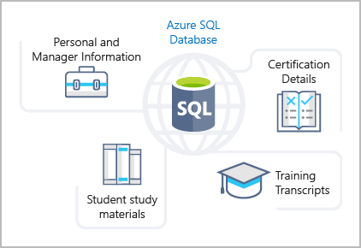

You can migrate your existing SQL Server databases with minimal downtime by using the Azure Database Migration Service. The Microsoft Data Migration Assistant can generate assessment reports that provide recommendations to help guide you through required changes prior to performing a migration. After you assess and resolve any remediation required, you're ready to begin the migration process. The Azure Database Migration Service performs all of the required steps. You just change the connection string in your apps.

## Exercise - Create a SQL database

### Task 1: Create the database

In this task, you create a SQL database based on the AdventureWorksLT sample database.

1. Sign in to the [Azure portal](https://portal.azure.com/learn.docs.microsoft.com).
2. Select **Create a resource** > **Databases** > **SQL database**. The **Create SQL Database** pane appears.
3. Enter the following values for each setting.

* Subscription: Concierge Subscription
* Resource group: sandbox resource group name]
* Database name:db1
* Server: Select: Create new

1. The **Create SQL Database Server** pane appears.
2. Enter the following values for each setting.

| **Setting** | **Value** |
| --- | --- |
| Server name | sqlservernnnn (replace **nnnn** with letters and digits for a globally unique name) |
| Location | (US) East US |
| Authentication method | Use SQL Authentication |
| Server admin login | sqluser |
| Password | Pa$$w0rd1234 |

| **Setting** | **Value** |
| --- | --- |
| Want to use SQL elastic pool? | No (default) |
| Compute + storage | General Purpose (default) |
| Backup storage redundancy | Geo-redundant backup storage |

1. Select **OK**.
2. Complete the remaining fields for **Create SQL Database** using the following values.
3. Select **Next : Networking**, and configure the following settings (accept defaults for fields not specified). Connectivity method: Public endpoint
4. Select **Next : Security**, and for **Enable Azure Defender for SQL**, choose **Not now**. Leave the remaining settings as default (not configured).
5. Select **Next : Additional settings**, and configure the following settings.
   * Use existing data: sample
   * Collation: SQL_Latin1_General_CP1_CI_AS (default)
6. Select **Review + create** to validate configuration entries.
7. Select **Create** to deploy the server and database. It can take approximately two to five minutes to create the server and deploy the sample database. The deployment pane shows the status, with updates for each resource that is created.
8. When deployment is complete, select **Go to resource**. The db1 SQL database Overview pane shows the essentials of the newly deployed database
9. In the command bar, select **Set server firewall**. The **Firewall settings** page appears.
10. Set **Allow Azure services and resources to access this server** to **Yes**, leaving other settings as default.
11. In the command bar, select **Save** to update firewall settings, and then close the Firewall settings pane.

### Task 2: Test the database

In this task, you configure the server and run a SQL query.

1. In Azure resources menu select **All resources**. Search for and select the **SQL database** resource Type, and ensure that your new database was created. You might need to refresh the page.
2. Select **db1**, the SQL database you created.
3. In the SQL database menu, select **Query editor (preview)**. The **Query editor (preview)** pane appears.
4. Sign in as **sqluser**, with the password **Pa$$w0rd1234**.
5. You will not be able to sign in because your IP address needs to be enabled in a firewall rule.
6. In the Query editor menu, select **Overview** (your edits will be lost), and in the command bar, select **Set server firewall**. The **Firewall settings** page appears.
7. In the **Client IP address** section, your IP will be shown (verify that it is the same client IP address from the error you received in the previous step).
8. In the command bar select **Add client IP**. This will add a **Rule name** that contains your IP address in both the **Start IP** and **End IP** fields.
9. In the command bar, select **Save** to save this firewall rule.
10. Select your db1 database in the breadcrumb at the top of the page to return to your SQL database, and then select **Query editor (preview)** from the menu. sign-in page.
11. Sign in again as **sqluser**, with the password **Pa$$w0rd1234**. This time you should succeed. It might take a couple of minutes for the new firewall rule to be deployed. If you still get an error, verify the client IP address in the error, and return to **Firewall settings** to add the correct client IP address.
12. After you sign in successfully, the query pane appears. Enter the SQL query into the editor.
13. Select **Run**, and then review the query results in the **Results** pane.

### Explore Azure database for MySQL

Azure Database for MySQL is a relational database service in the cloud, and it's based on the MySQL Community Edition database engine, versions 5.6, 5.7, and 8.0. With it, you have a 99.99 percent availability service level agreement from Azure, powered by a global network of Microsoft-managed datacenters. This helps keep your app running 24/7. With every Azure Database for MySQL server, you take advantage of built-in security, fault tolerance, and data protection that you would otherwise have to buy or design, build, and manage. With Azure Database for MySQL, you can use point-in-time restore to recover a server to an earlier state, as far back as 35 days. It delivers:

* Built-in high availability with no additional cost.
* Predictable performance and inclusive, pay-as-you-go pricing.
* Scale as needed, within seconds.
* Ability to protect sensitive data at-rest and in-motion.
* Automatic backups.
* Enterprise-grade security and compliance.

These capabilities require almost no administration, and all are provided at no additional cost. They allow you to focus on rapid app development and accelerating your time-to-market, rather than having to manage vms and infrastructure.You can migrate your existing MySQL dbs with minimal downtime by using the Azure db Migration Service. After you have completed your migration, you can continue to develop your application with the open-source tools and platform of your choice.

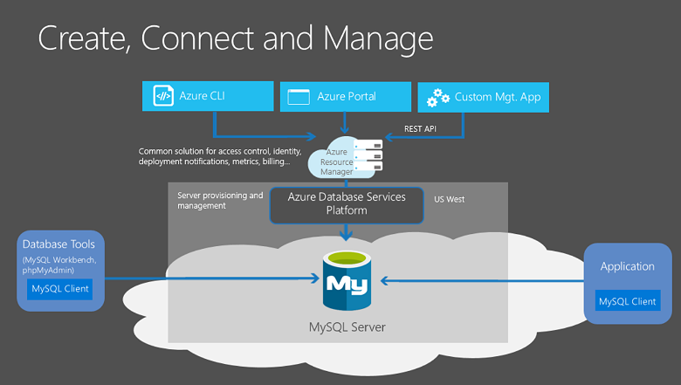

Azure Database for MySQL offers several service tiers, and each tier provides different performance and capabilities to support lightweight to heavyweight database workloads. You can build your first app on a small database for a few dollars a month, and then adjust the scale to meet the needs of your solution. Dynamic scalability enables database to transparently respond to rapidly changing resource requirements. You only pay for the resources you need, and only when you need them.

### Explore Azure Database for PostgreSQL

Azure Database for PostgreSQL is a relational database service in the cloud. The server sw is based on the community version of the open-source PostgreSQL db engine. Your familiarity with tools and expertise with PostgreSQL is applicable when you're using Azure db for PostgreSQL. Benefits:

* Built-in high availability compared to on-premises resources. There's no additional configuration, replication, or cost required to make your apps are always available.
* Simple and flexible pricing. You have predictable performance based on a selected pricing tier choice, includes SW patching, automatic backups, monitoring, security.
* Scale up or down as needed, within seconds. You can scale compute or storage independently as needed, to make sure you adapt your service to match usage.
* Adjustable automatic backups and point-in-time-restore for up to 35 days.
* Enterprise-grade security and compliance to protect sensitive data at-rest and in-motion. This security covers data encryption on disk and SSL encryption between client and server communication.

Azure db for PostgreSQL is available in deployment options: **Single Server** and **Hyperscale**.

#### **Single Server**

The Single Server deployment option delivers:

* Built-in high availability with no additional cost (99.99 percent SLA).
* Predictable performance and inclusive, pay-as-you-go pricing.
* Vertical scale as needed, within seconds.
* Monitoring and alerting to assess your server.
* Enterprise-grade security and compliance.
* Ability to protect sensitive data at-rest and in-motion.
* Automatic backups and point-in-time-restore for up to 35 days.

All those capabilities require almost no administration, and all are provided at no additional cost. You can focus on rapid app development and accelerating your time to market, rather than having to manage VMs and infrastructure. You can continue to develop your app with open-source tools.

The Single Server deployment option offers three pricing tiers: Basic, General Purpose, and Memory Optimized. Each tier offers different resource capabilities to support your database workloads. You can build your first app on a small database for a few dollars a month, and then adjust the scale to meet the needs of your solution. Dynamic scalability enables your database to transparently respond to rapidly changing resource requirements. You pay for the resources you need, and when you need.

#### **Hyperscale (Citus)**

The Hyperscale option horizontally scales queries across multiple machines by using sharing. Its query engine parallelizes incoming SQL queries across these servers for faster responses on large datasets. It serves apps that require greater scale and performance, generally workloads that are approaching, or already exceed, 100 GB of data.

The Hyperscale (Citus) deployment option supports multi-tenant applications, real-time operational analytics, and high throughput transactional workloads. Applications built for PostgreSQL can run distributed queries on Hyperscale (Citus) with standard connection libraries and minimal changes.

### Explore Azure SQL Managed Instance

Azure SQL Managed Instance is a scalable cloud data service that provides the broadest SQL Server database engine compatibility with all the benefits of a fully managed PaaS. Depending on your scenario, Azure SQL Managed Instance might offer more options for database needs.

#### Features

Like Azure SQL Database, Azure SQL Managed Instance is a platform as a service (PaaS) database engine, which means that your company will be able to take advantage of the best features of moving your data to the cloud in a fully-managed environment. Ex. your company will no longer need to purchase and manage expensive hardware, and you won't have to maintain the additional overhead of managing your on-premises infrastructure. On the other hand, your company will benefit from the quick provisioning and service scaling features of Azure, together with automated patching and version upgrades. In addition, you'll be able to rest assured that your data will always be there when you need it through built-in high availability features and a 99.99% uptime service level agreement (SLA). You'll also be able to protect your data with automated backups and a configurable backup retention period.

Azure SQL db and Azure SQL Managed Instance offer many of the same features; however, Azure SQL Managed Instance provides several options that might not be available to Azure SQL Db. Azure SQL Database only uses the default SQL_Latin1_General_CP1_CI_AS server collation.

#### Migration

Azure SQL Managed Instance makes it easy to migrate your on-premises data on SQL Server to the cloud using the Azure Database Migration Service (DMS) or native backup and restore. After you have discovered all of the features that your company uses, you need to assess which on-premises SQL Server instances you can migrate to Azure SQL Managed Instance to see if you have any blocking issues. Once you have resolved any issues, you can migrate your data, then cutover from onpremises SQL Server to your Azure SQL Managed Instance by changing the connection string in your apps.

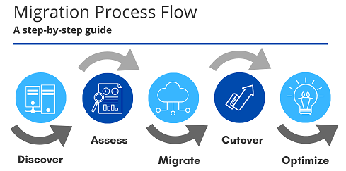

### Explore big data and analytics

Several years ago, Tailwind Traders rolled out a new GPS tracking system for all of its delivery vehicles. The new system provides real-time tracking data to your primary datacenter. Your CTO wants your team to look at several years of tracking data in order to determine trends. For example, an important trend might be a spike in deliveries around the holidays that would require hiring additional staff. Through an in-depth analysis of the tracking data that you've recorded, your CTO seeks to predict when changes are necessary, and then proactively take the necessary steps to appropriately manage spikes.

Data comes in all types of forms and formats. When we talk about big data, we're referring to large volumes of data. In this scenario, data is collected from the GPS sensors, which includes location information, data from weather systems, and many other sources that generate large amounts of data. This amount of data becomes increasingly hard to make sense of and to base decisions on. The volumes are so large that traditional forms of processing and analysis are no longer appropriate.

Open-source cluster technologies have been developed, over time, to try to deal with these large datasets. Microsoft Azure supports a broad range of technologies and services to provide big data and analytic solutions, including Azure Synapse Analytics, Azure HDInsight, Azure Databricks, and Azure Data Lake Analytics.

#### **Azure Synapse Analytics**

[Azure Synapse Analytics](https://docs.microsoft.com/en-us/azure/sql-data-warehouse/) (formerly Azure SQL Data Warehouse) is a limitless analytics service that brings together enterprise data warehousing and big data analytics. You can query data on your terms by using either serverless or provisioned resources at scale. You have a unified experience to ingest, prepare, manage, and serve data for immediate business intelligence and machine learning needs.

#### **Azure HDInsight**

[Azure HDInsight](https://azure.microsoft.com/services/hdinsight/) is a fully managed, open-source analytics service for enterprises. It's a cloud service that makes it easier, faster, and more cost-effective to process massive amounts of data. You can run popular open-source frameworks and create cluster types such as [Apache Spark](https://docs.microsoft.com/en-us/azure/hdinsight/spark/apache-spark-overview), [Apache Hadoop](https://docs.microsoft.com/en-us/azure/hdinsight/hadoop/apache-hadoop-introduction), [Apache Kafka](https://docs.microsoft.com/en-us/azure/hdinsight/kafka/apache-kafka-introduction), [Apache HBase](https://docs.microsoft.com/en-us/azure/hdinsight/hbase/apache-hbase-overview), [Apache Storm](https://docs.microsoft.com/en-us/azure/hdinsight/storm/apache-storm-overview), and [Machine Learning Services](https://docs.microsoft.com/en-us/azure/hdinsight/r-server/r-server-overview). HDInsight also supports a broad range of scenarios such as extraction, transformation, and loading (ETL), data warehousing, machine learning, and IoT.

#### **Azure Databricks**

[Azure Databricks](https://azure.microsoft.com/services/databricks/) helps you unlock insights from all your data and build artificial intelligence solutions. You can set up your Apache Spark environment in minutes, and then autoscale and collaborate on shared projects in an interactive workspace. Azure Databricks supports Python, Scala, R, Java, and SQL, as well as data science frameworks and libraries including TensorFlow, PyTorch, and scikit-learn.

#### **Azure Data Lake Analytics**

[Azure Data Lake Analytics](https://azure.microsoft.com/services/data-lake-analytics/) is an on-demand analytics job service that simplifies big data. Instead of deploying, configuring, and tuning hardware, you write queries to transform your data and extract valuable insights. The analytics service can handle jobs of any scale instantly by setting the dial for how much power you need. You only pay for your job when it's running, making it more cost-effective.

# Azure Fundamentals part 3: Describe core solutions and management tools on Azure

## Choose the best Azure IoT service for your application

IoT bridges the physical and digital worlds by enabling devices with sensors and an internet connection to communicate with cloud-based systems via the internet.

### Identify the product options

IoT enables devices to gather and then relay inf for data analysis. Smart devices are equipped with sensors that collect data. Few common sensors that measure attributes of physical world include:

* Environmental sensors that capture temperature and humidity levels.
* Barcode, QR code, or optical character recognition (OCR) scanners.
* Geo-location and proximity sensors. Light, color, and infrared sensors.
* Sound and ultrasonic sensors. Motion and touch sensors.
* Accelerometer and tilt sensors. Smoke, gas, and alcohol sensors.
* Error sensors to detect when there's a problem with the device.
* Mechanical sensors that detect anomalies or deformations.
* Flow, level, and pressure sensors for measuring gasses and liquids.

By using Azure IoT services, devices that are equipped with these sensors and that can connect to the internet could send their sensor readings to specific endpoint in Azure via a message. Message's data is then collected and aggregated, and it can be converted into reports and alerts. Alternately, all devices could be updated with new firmware to fix issues or add new functionality by sending software updates from Azure IoT services to each device.

Let's suppose your company manufactures and operates smart refrigerated vending machines. What kinds of information would you want to monitor? You might want to ensure that:

* Each machine is operating without any errors.
* The machines haven't been compromised.
* The machines' refrigeration systems are keeping their contents within a certain temperature
* You're notified when products reach a inventory level so you can restock the machines.

If the HW of your vending machines can collect and send this inf in standard message, the messages each machine sends can be received, stored, organized, and displayed by using Azure IoT services.

The collected data from these devices could be combined with Azure AI services to help you predict:

* When machines need proactive maintenance.
* When inventories will need to be replenished and new product ordered from vendors.

Many services can assist and drive end-to-end solutions for IoT on Azure.

#### Azure IoT Hub

[It](https://azure.microsoft.com/services/iot-hub/)’s a managed service hosted in the cloud and that acts as a central message hub for bidirectional communication between your IoT application and the devices it manages. You can use Azure IoT Hub to build IoT solutions with reliable and secure communications between millions of IoT devices and a cloud-hosted solution back end. You can connect virtually any device to your IoT hub.

The IoT Hub service supports communications both from the device to the cloud and from the cloud to the device. It also supports multiple messaging patterns, such as device-to-cloud telemetry, file upload from devices, and request-reply methods to control your devices from the cloud. After an IoT hub receives messages from a device, it can route that message to other Azure services.

From a cloud-to-device perspective, IoT Hub allows for command and control. That is, you can have either manual or automated remote control of connected devices, so you can instruct the device to open valves, set target temperatures, restart stuck devices, and so on.

IoT Hub monitoring helps you maintain the health of your solution by tracking events such as device creation, device failures, and device connections.

#### Azure IoT Central

It builds on top of IoT Hub by adding a dashboard that allows you to connect, monitor, and manage IoT devices. Visual UI makes it easy to quickly connect new devices and watch as they begin sending telemetry or error messages. You can watch overall performance across all devices in aggregate, and can set up alerts that send notifications. Finally, you can push firmware updates to the device.

IoT Central provides starter templates for common scenarios across industries, such as energy, healthcare, government. You then customize the design starter templates directly in UI by choosing from existing themes or creating your own custom theme, setting the logo, tailor the templates for the specific data that's sent from devices, reports you want to see, and the alerts you want to send.

You can use the UI to control your devices remotely. This feature allows you to push a software update or modify a property of the device. You can adjust the desired temperature for one or all of your refrigerated vending machines from directly inside of IoT Central.

A key part of IoT Central is the use of device templates. By using a device template, you can connect a device without any service-side coding. IoT Central uses the templates to construct the dashboards, alerts, and so on. Device developers still need to create code to run on the devices, and that code must match the device template specification.

#### Azure Sphere

[Azure Sphere](https://azure.microsoft.com/services/azure-sphere/) creates an end-to-end, highly secure IoT solution for customers that encompasses everything from the hardware and operating system on the device to the secure method of sending messages from the device to the message hub. Azure Sphere has built-in communication and security features for internet-connected devices. Azure Sphere comes in three parts:

* The first part is the Azure Sphere micro-processing unit (MCU), which is responsible for processing the operating system and signals from attached sensors. The following image displays the Seeed Azure Sphere MT3620 Development Kit MCU, one of several different starter kits that are available for prototyping and developing Azure Sphere applications.
* The second part is a customized Linux OS that handles communication with the security service and can run the vendor's software.
* The third part is Azure Sphere Security Service, also known as AS3. Its job is to make sure that the device has not been maliciously compromised. When the device attempts to connect to Azure, it first must authenticate itself, per device, which it does by using certificate-based authentication. If it authenticates successfully, AS3 checks to ensure that the device hasn't been tampered with. After it has established a secure channel of communication, AS3 pushes any OS or approved customer-developed sw updates to device.
* After the Azure Sphere system has validated the authenticity of the device and authenticated it, the device can interact with other Azure IoT services by sending telemetry and error information.

### Analyse the decision criteria

We'll analyse the criteria experts employ when decide which IoT service to use for a given business.

#### Is it critical to ensure that the device is not compromised?

Not in every case. Manufacturers and customers would rather not have their devices to be maliciously compromised and used for nefarious purposes, however in some cases it's more critical to ensure the integrity than others. Ex. would be that of an ATM in comparison to a washing machine. When security is a critical consideration in your product's design, the best product option is Azure Sphere, which provides a comprehensive end-to-end solution for IoT devices.

Azure Sphere ensures a secure channel of communication between the device and Azure by controlling everything from the HW to OS and the authentication process. This ensures that the integrity of the device is uncompromised. After a secure channel is established, messages can be received from the device securely, and messages or SW updates can be sent to the device remotely.

#### Do I need a dashboard for reporting and management?

Next decision will be the level of services you require from your IoT solution. If you merely want to connect to your remote devices to receive telemetry and occasionally push updates, and you don't need any reporting capabilities, you might prefer to implement Azure IoT Hub by itself. Programmers can still create a customized set of management tools and reports by using the IoT Hub RESTful API.

However, if you want a pre-built customizable UI with which you can view and control your devices remotely, you might prefer to start with IoT Central. With this solution, you can control a single device or all devices at once, and you can set up alerts for certain conditions, such as a device failure.

IoT Central integrates with many Azure products, including IoT Hub, to create dashboard with repor-ts and management features. You can use dashboard that's generated by template as is or customize it to suit your needs. You can have multiple dashboards and target them at a variety of users.

### Use IoT Hub

The Tailwind senior leadership team has decided to partner with a leading appliance manufacturer to create an exclusive, high-end brand that promises a pre-emptive maintenance service agreement. This unique feature would differentiate Tailwind Traders appliances in a crowded, competitive market. The feature also makes the brand lucrative, because a yearly subscription would be required. To build a strong brand reputation, the appliances will send telemetry information to a centralized location, where the data can be analysed and maintenance can be scheduled.

The devices will not require remote control. They will merely be sending their telemetry data for analysis. Because Tailwind Traders already has software in place for managing appliance maintenance requests, the company wants to integrate all functionality into this existing system.

#### Which service should you choose?

First, is it critical to ensure that the device or, in this case, each appliance, isn't compromised? It's preferable, but not critical, that the devices aren't compromised. The worst that could happen is that a hacker reads the current temperature of the customer's refrigerator..

Even if the customer calls and reports strange behaviour with their appliance, a technician could reset or replace the microcontroller. It might not warrant the extra expense or engineering resources that would be required to employ Azure Sphere.

Do I need a dashboard for reporting and management? No. Tailwind wants to integrate telemetry data and all functionality into existing system. In this case, Azure IoT Central is not required.

So, given the responses to the decision criteria, Azure IoT Hub is the best choice in this scenario.

#### Why not use Azure IoT Central?

Azure IoT Central provides a dashboard that allows companies to manage IoT devices individually and an aggregate, view reports, and set up error notifications via a GUI. But, in this scenario, Tailwind Traders wants to integrate the telemetry it collects and other analysis functionality into an existing software application. Furthermore, the company's appliances will be collecting data via sensors only and don't need the ability to update settings or software remotely. Therefore, the company doesn't need Azure IoT Central.

#### Why not use Azure Sphere?

Azure Sphere provides a complete solution for scenarios where security is critical. In this scenario, security is preferred but not critical. The appliances can't be updated with new software remotely. The sensors merely report usage data. As a result, Azure Sphere isn't necessary.

### Use IoT Central

Tailwind owns a fleet of delivery vehicles that transport products from warehouses to distribution centres, and from distribution centres to stores. The company is looking for a complete logistics solution that takes data sent from an onboard vehicle PC and turns it into actionable information. Furthermore, shipments can be outfitted with sensors from a third-party vendor to collect and monitor ambient conditions. These sensors can collect information such as the temperature, ....

A few goals of this logistics system include:

* Shipment monitoring with real-time tracing and tracking.
* Shipment integrity with real-time ambient condition monitoring.
* Security from theft, loss, or damage of shipments.
* Geo-fencing, route optimization, fleet management, and vehicle analytics.
* Forecasting for predictable departure and arrival of shipments.

The company would prefer a pre-built solution to collect the sensor and vehicle computer data, and provide a graphical user interface that displays reports about shipments and vehicles.

#### Which service should you choose?

Is it critical to ensure that the device or, each appliance, isn't compromised? Ideally, each sensor and vehicle PC would be impervious to interference. However, security was not mentioned as a critical concern. The vehicle PCs and sensors are built by a third-party vendor and, unless Tailwind wants to manufacture its own devices, the company will be forced to use HW that's already available.

Second, does Tailwind Traders need a dashboard for reporting and management? Yes, a reporting and management dashboard is a requirement.

Based on these responses to the decision criteria, Azure IoT Central is the best choice in this scenario. The Connected Logistics starter template provides an out-of-box dashboard that will satisfy many of these requirements. This dashboard is preconfigured to showcase the critical logistics device operations activity. Admittedly, the dashboard might need to be reconfigured to remove sea vessel gateways, but the truck gateway functionality would be almost exactly what Tailwind Traders needs.

#### Why not use IoT Hub?

If Tailwind Traders uses IoT Central, the company would actually be using an IoT hub that's preconfigured for its specific needs by the Connected Logistics starter template. Otherwise, the company would need to do a lot of custom development to build its own cloud-based dashboards and management systems on top of Azure IoT Hub.

#### Why not use Azure Sphere?

Azure Sphere provides a complete solution for scenarios where security is critical. In this scenario, security is ideal, but not a critical priority. Although Azure Sphere provides an end-to-end solution that includes HW, Tailwind will use HW from a third-party vendor. So, Azure Sphere is not necessary.

### Use Azure Sphere

Tailwind wants to implement a touchless point-of-sale solution for self-checkout. The self-checkout terminals should be, above all else, secure. Each terminal must be impervious to malicious code that could create fraudulent transactions, force the company to take the systems offline during a heavy shopping period, or send transactional data to a spying organization. The terminals should also report back vital information on the company's health and allow secure updates to its SW remotely.

After reviewing possible solutions during request for proposal process, Tailwind decides that it needs features that vendors have yet to implement. Instead of using an existing solution, company decides to work with a leading engineering firm that specializes in IoT solutions. This approach allows the company to build a uniquely secure terminal that gives it a retail platform to build on going forward.

Although most of the company's focus is on the terminal itself, Tailwind Traders realizes that it wants a solution that can help it make sense of all the data that will be generated by these terminals across all of its retail stores. And it wants an easy way to push software updates to its terminals.

#### Which service should you choose?

First, is it critical to ensure that the device or, in this case, each point-of-sale terminal, is not compromised? Absolutely. Device security is the primary requirement.

Next, does Tailwind need a dashboard for reporting and management? Yes, the company requires a reporting and management dashboard.

So, given the responses to the decision criteria, the IoT engineering firm will build a platform on top of both Azure IoT Central and Azure Sphere. Even though no specific starter template is available in Azure IoT Central for this scenario, one can easily be adapted to accommodate the kinds of reports the company wants to see and the management operations it wants to perform.

## Choose the best AI service for your needs

Artificial Intelligence (AI) is a category of computing that adapts and improves its decision-making ability over time based on its successes and failures. Microsoft Azure provides several AI solutions to choose from, each one depending on the problem you're trying to solve.

# Identify the product options

AI is a broad classification of computing that allows a software system to perceive its environment and take action that maximizes its chance of successfully achieving its goals. A goal of AI is to create a software system that's able to adapt, or learn something on its own without being explicitly programmed to do it. There are two basic approaches to AI.

The first is to employ a **deep learning** system that's modelled on the neural network of the human mind, enabling it to discover, learn, and grow through experience.

**Machine learning**, a data science technique that uses existing data to train a model, test it, then apply the model to new data to forecast future behaviours, outcomes, and trends. Forecasts or predictions from machine learning can make apps and devices smarter. Ex. when you shop online, machine learning powers product recommendation systems that offer additional products based on what you've bought and what other shoppers have bought who have purchased similar items in the past. Machine learning is also used to detect credit card fraud by analysing each new transaction and using what it has learned from analysing millions of fraudulent transactions. Virtually every device or software system that collects textual, visual, and audio data could feed a machine learning model that makes that device or software system smarter about how it functions in the future.

### Azure product options

At a high level, there are three primary product offerings from Microsoft, each of which is designed for a specific audience and use case, providing diverse set of tools, services, and programmatic APIs.

#### Azure Machine Learning

[Azure ML](https://azure.microsoft.com/services/machine-learning/) is platform for making predictions. It consists of tools and services that allow u to connect to data to train and test models to find one that will most accurately predict future result. After u've run experiments to test model, you can deploy and use it in real time via web API endpoint. Choose AML when data scientists need complete control over design and training of alg using own data. You can:

* Create a process that defines how to obtain data, how to handle missing or bad data, how to split the data into training set or test set, and deliver the data to the training process.
* Train and evaluate predictive models by using tools and programming languages familiar to data scientists.
* Create pipelines that define where and when to run the compute-intensive experiments that are required to score the algorithms based on the training and test data.
* Deploy the best-performing algorithm as an API to an endpoint so it can be consumed in real time by other applications.

#### Azure Cognitive Services

[Azure Cognitive Services](https://azure.microsoft.com/services/cognitive-services/) provides prebuilt ML models that enable applications to see, hear, speak, understand, and even begin to reason. Use Azure Cognitive Services to solve general problems, such as analysing text for emotional sentiment or analysing images to recognize objects or faces. You don't need special machine learning or data science knowledge to use these services. Developers access Azure Cognitive Services via APIs to easily include these features in just a few lines of code. While Azure ML requires you to bring your own data and train models over that data, Azure Cognitive Services, for the most part, provides pretrained models so that you can bring in your live data to get predictions on. Azure Cognitive Services can be divided into the following categories:

* **Language** services: Allow your apps to process natural language with prebuilt scripts, evaluate sentiment, and learn how to recognize what users want.
* **Speech** services: Convert speech into text and text into natural-sounding speech. Translate from one language to another and enable speaker verification and recognition.
* **Vision** services: Add recognition and identification capabilities when analysing visual content.
* **Decision** services: Add personalized recommendations for each user that automatically improve each time they're used, moderate content to monitor and remove offensive or risky content, and detect abnormalities in your time series data.

#### Azure Bot Service

[Azure Bot Service](https://azure.microsoft.com/services/bot-service/) and Bot Framework are platforms for creating virtual agents that understand and reply to questions just like a human. Azure Bot Service is a bit different from Azure ML and Azure Cognitive Services in that it has a specific use case. It creates a virtual agent that can intelligently communicate with humans. Behind the scenes, the bot you build uses other Azure services, such as Azure Cognitive Services, to understand what their human counterparts are asking for.

Bots can be used to shift simple repetitive tasks, on to automated systems that require direct human intervention. Users converse with bot by text, interactive cards, speech. Bot interaction can be quick question and answer, or sophisticated conversation that intelligently provides access to services.

### Analyse the decision criteria

#### Virtual agent that interfaces with humans via natural language?

Use Azure Bot Service when you need to create agent to interact with humans by natural language. Bot Service integrates knowledge sources, natural language processing, and form factors to allow interaction across different channels. Solutions usually rely on other AI services for such things as language understanding or translation for localizing replies into customer's preferred language.

Before you jump in to build custom chat experience by using Bot Service, it make sense to search for prebuilt/no-code solutions that cover common scenarios. Ex. you can use QnA Maker, available from Azure Marketplace, to build, train, & publish bot that uses FAQ pages, support websites, product manuals, SharePoint documents, or editorial content through easy-to-use UI or via REST APIs.

Likewise, Power Virtual Agents integrates with Microsoft Power Platform so that you can use hundreds of prebuilt connectors for data input. You can extend Power Virtual Agents by building custom workflows with Power Automate, and if you feel that the out-of-the-box experience is too limiting, you can still build more complex interactions with Microsoft Bot Framework.

#### Do you need a service that can understand the content and meaning of images, video, or audio, or that can translate text into a different language?

Use Azure Cognitive Services when it comes to general purpose tasks, such as performing speech to text, integrating with search, or identifying the objects in an image. Azure Cognitive Services is general purpose, meaning that many different kinds of customers can benefit from the work that Microsoft has already done to train and test these models and offer them inexpensively at scale.

#### Do you need to predict user behaviour or provide users with personalized recommendations in your app?

The Azure Cognitive Services Personalizer service watches your users' actions within an app. You can use Personalizer to predict their behaviour and provide relevant experiences as it identifies usage patterns. Here again, you could capture and store user behaviour and create your own custom Azure ML solution to do these things, but this approach would require much effort and expense.

#### Will your app predict future outcomes based on private historical data?

Choose Azure ML when you need to analyze data to predict future outcomes. Ex. suppose you need to analyze years' worth of financial transactions to discover new patterns that could help you create new products for company's clients. When you're working with proprietary data, you'll likely need to build a more custom-tailored ML model.

#### Do you need to build a model by using your own data or perform a different task than those listed above?

Use Azure ML for maximum flexibility. Data scientists can use the tools they're familiar with and the data you provide to develop deep learning and ML models tuned for your particular requirements.

### Use Machine Learning for decision support systems

The Tailwind e-commerce website allows its customers to browse and purchase items that can be delivered or picked up from a store nearest to their location. The Marketing team is convinced that it can increase sales dramatically by suggesting add-on products that complement the items in a shopper's cart at the point of checkout. The team could hard-code these suggestions, but it feels that a more organic approach would be to use its years' worth of sales data as well as new shopping trends to decide what products to display to the shopper. Additionally, the suggestions could be influenced by product availability, product profitability, and other factors. The Marketing team's existing data science experts have already done some initial analysis of the problem domain, and have determined that its plan might take months to prototype, and possibly a year to roll out.

#### Which service should you choose?

First, is Tailwind building a virtual agent that interfaces with humans via natural language? No, it is not, so Azure Bot Service is not a good candidate for this scenario.

Second, does Tailwind need a service that can understand the content and meaning of images, video, audio, or translate text into a different language? No, it doesn't, so the relevant Cognitive Services will not help the company.

Does Tailwind need to predict user behavior or provide users with personalized recommendations? Yes, it does. However, creating them based on user behavior is only part of requirement. Tailwind needs to create complex model that incorporates historical and trending sales data, inventory, ... It's possible that ACSP service could play role, but it couldn't handle the entire breadth of project alone.

Fourth, will the Tailwind Traders app predict future outcomes based on private historical data? Yes, and that is why in this scenario, Azure Machine Learning is likely the best choice.

The success of this effort would depend primarily on the ability of the model to select precisely the right up-sale products to suggest to the shopper. Because the model would need to be tweaked and tuned over time, an off-the-shelf model would likely not suffice.

Finally, it sounds like the Marketing team already employs data science experts, and team is willing to make at least a year-long commitment to building, testing, and tweaking the models to be used.

### Use Cognitive Services for data analysis

The first generation of the Tailwind Traders e-commerce website was available exclusively in English. However, when the Marketing team sponsored a demographics study for the company's brick-and-mortar locations, it found that, on average, only 80 percent of potential customers speak English. In some neighbourhoods, that number falls to 50 percent. The team sees the addition of multiple languages as a wonderful opportunity to serve non-English speakers with the same online e-commerce experience as English speakers.

#### Which service should you choose?

First, is Tailwind building a virtual agent that interfaces with humans via natural language? No, it is not, so Azure Bot Service is not a good candidate for this scenario. However, should Tailwind ever implement a customer service agent, it might want to consider using the Translator API to provide real-time translation to help customers who are not English speakers.

Second, does Tailwind Traders need a service that can understand the content and meaning of images, video, audio, or translate text into a different language? Yes, it does. Translating textual content from one language into another is a general purpose task that you can simplify by using the Azure Cognitive Services Translator service. The service is easy to integrate into your applications, websites, tools, and solutions. It allows you to add multilanguage user experiences in more than 60 languages, and you can use it on any hardware platform with any operating system for text-to-text language translation. Azure Cognitive Services is likely the best option for this scenario, but let's continue applying the decision criteria to make sure.

Does Tailwind need to predict user behavior or provide users with personalized recommendations? No, it doesn't, so the Azure Cognitive Services Personalizer is not a good candidate for this scenario.

Finally, will the Tailwind app need to predict future outcomes based on private historical data? No. Although it's possible to create ML model for multilanguage translation, it would be expensive and time consuming for Tailwind to attempt to build translation models themselves. The team has neither the deep learning competency nor the linguistic data that's required to train the models.

Now that you've examined all the expert criteria, you can confidently select Cognitive Services as the best product option for this scenario.

### Use Bot Service for interactive chat experiences

The Customer Service has long asked for a virtual agent to handle the vast majority of questions it gets asked. On the website, shoppers are impatient and perceive contact in a chat window as saving them time. The team wants shoppers to feel as though they're interacting with a real human. When it becomes clear that the VA can't provide an answer, the chat should be transferred to a human. Providing a VA would decrease the amount of time it takes for all shoppers to receive answers. The virtual agent could answer most questions, which would free up human customer service agents to provide support for more difficult questions or thorny account-related issues.

#### Which service should you choose?

First, is Tailwind building a VA that interfaces with humans via natural language? Yes, it is. Azure Bot Service should be used in this scenario to implement a virtual agent chat experience. Bot Service could benefit from the information on the website's Frequently Asked Questions page, along with thousands of chat sessions that have been stored between shoppers and customer service.

Second, does Tailwind need service that can understand content and meaning of imgs, video, audio, or translate text into different language? Possibly, yes. Azure Cognitive Services could be used along with Bot Service to build solution. To expedite implementation, the developers could explore using prebuilt solutions, such as QnA Maker (part of Cognitive Services) or Power Virtual Agents. Also, any Azure Bot solution would likely implement several Azure Cognitive Services, such as Language Understanding and possibly Translator, to translate from the shopper's language to English and back.

Does Tailwind need to predict user behavior or provide users with personalized recommendations? No, it doesn't. Azure Cognitive Services Personalizer is not a good candidate for this scenario.

Finally, will the Tailwind app need to predict future outcomes based on private historical data? No. Although Tailwind does have historical data to feed into a model, which would make it possible to use Azure ML to create a chat solution, another option is already tailored for chat bot experience.

## Choose the best Azure serverless technology for your business scenario

**Serverless computing** is a term used to describe an execution environment that's set up and managed for you. You merely specify what you want to happen by writing code or connecting and configuring components in a visual editor, and then specify the actions that trigger functionality, such as a timer or an HTTP request. Best of all, you never have to worry about an outage, your code can scale instantly to meet demand, and you pay based only on the actual usage of your code.

Tailwind, a traditional brick-and-mortar retailer, has found success selling online. The company sees several opportunities to improve its e-commerce website. Ex. it wants to provide more accurate real-time inventory information online to customers who want to visit their local store to purchase an item. The company also wants to respond more proactively to customers who've had a negative experience by providing a new customer-retention program.

### Identify the product options

Srverless computing is a cloud-hosted execution environment that runs your code but abstracts the underlying hosting environment. The term serverless computing is a misnomer. After all, there is a server (or a group of servers) that executes your code or desired functionality.

The key idea is that you're not responsible for setting up or maintaining the server. You don't have to worry about scaling it when there's increased demand, and you don't have to worry about outages. The cloud vendor takes care of all maintenance and scaling concerns for you.

You create instance of the service, and then add code. No infrastructure configuration or maintenan-ce is required, or even allowed. You configure your serverless apps to respond to events. Event could be REST endpoint, periodic timer, or even message received from another Azure service. Serverless app runs only when it's triggered by an event. Scaling and performance are handled automatically, and you're billed only for the resources you use. You don't even need to reserve resources.

Serverless computing is ordinarily used to handle back-end scenarios. In other words, serverless computing is responsible for sending messages from one system to another, or processing messages sent from other systems. It's not used for user-facing systems, rather, it works in the background.

This module covers two Azure serverless computing services: Azure Functions and Azure Logic Apps.

#### Azure Functions

With the [Azure Functions](https://azure.microsoft.com/services/functions/) service, you can host a single method or function by using a popular programming language in the cloud that runs in response to an event. An example of an event might be an HTTP request, a new message on a queue, or a message on a timer.

Bcs of its atomic nature, Azure Functions can serve many purposes in app's design. Functions can be written in many common programming languages, ex. C#, Python, JS, Typescript, Java, PowerShell.

Azure Functions scales automatically, and charges accrue only when a function is triggered. These qualities make Azure Functions a solid choice when demand is variable. Ex. you might be receiving messages from an IoT solution that monitors a fleet of delivery vehicles. You'll likely have more data arriving during business hours. Azure Functions can scale out to accommodate these busier times.

An Azure function is a stateless environment. A function behaves as if it's restarted every time it responds to an event. This feature is ideal for processing incoming data. And if state is required, the function can be connected to an Azure storage account.

Azure Functions can perform orchestration tasks by using an extension called Durable Functions, which allow developers to chain functions together while maintaining state.

Azure Functions solution is ideal when you're concerned only with code that's running service and not the underlying platform or infrastructure. You use Azure Functions most commonly when you need to perform work in response to event. You do this often via a REST request, timer, or message from another Azure service, and when that work can be completed quickly, within seconds or less.

#### Azure Logic Apps

[Logic Apps](https://azure.microsoft.com/services/logic-apps/) is a low-code/no-code development platform hosted as a cloud service. The service helps you automate and orchestrate tasks, business processes, and workflows when you need to integrate apps, data, systems, and services across enterprises or organizations. Logic Apps simplifies how you design and build scalable solutions, whether in the cloud, on-premises, or both. This solution covers app integration, data integration, system integration, enterprise application integration (EAI), and business-to-business (B2B) integration.

Azure Logic Apps is designed in a web-based designer and can execute logic that's triggered by Azure services without writing any code. You build an app by linking triggers to actions with connectors. A trigger is an event (such as a timer) that causes an app to execute, then a new message to be sent to a queue, or an HTTP request. An action is a task or step that can execute. There are logic actions such as those you would find in most programming languages. Examples of actions include working with variables, decision statements and loops, and tasks that parse and modify data.

To build enterprise integration solutions with Azure Logic Apps, you can choose from growing gallery of over 200 connectors. Gallery includes services such as Salesforce, SAP, Oracle DB, and file shares.

If you can't find the action or connector you need, you can build your own by using custom code.

#### What are the differences between these services?

You can call Azure Functions from Azure Logic Apps, and vice versa. The primary difference between the two services is their intent. Azure Functions is a serverless compute service, and Azure Logic Apps is intended to be a serverless orchestration service. Although you can use Azure Functions to orchestrate a long-running business process that involves various connections, this was not its primary use case when it was designed.

Additionally, the two services are priced differently. Azure Functions pricing is based on the number of executions and the running time of each execution. Logic Apps pricing is based on the number of executions and the type of connectors that it utilizes.

### Analyse the decision criteria

With two viable serverless options, it can be difficult to know which is the best one for the job.

#### Do you need to perform an orchestration across well-known APIs?

As we noted previously, Azure Logic Apps was designed with orchestration in mind, from the web-based visual configurator to the pricing model. Logic Apps excels at connecting a large array of disparate services via their APIs to pass and process data through many steps in a workflow.

It's possible to create the same workflow by using Azure Functions, but it might take a considerable amount of time to research which APIs to call and how to call them. Azure Logic Apps has already componentized these API calls so that you supply only a few details and the details of calling the necessary APIs is abstracted away.

#### Do you need to execute custom algorithms or perform specialized data parsing and data lookups?

With Azure Functions, you can use the full expressiveness of a programming language in a compact form. This lets you concisely build complex algorithms, or data lookup and parsing operations. You would be responsible for maintaining the code, handling exceptions resiliently, and so on.

Although Azure Logic Apps can perform logic (loops, decisions, and so on), if you have a logic-intensive orchestration that requires a complex algorithm, implementing that algorithm might be more verbose and visually overwhelming.

#### Do you have existing automated tasks written in an imperative programming language?

If you already have your orchestration or business logic expressed in C#, Java, Python, or another popular programming language, it might be easier to port your code into the body of an Azure Functions function app than to re-create it by using Azure Logic Apps.

#### Do you prefer a visual (declarative) workflow or writing (imperative) code?

Ultimately, your choice comes down to whether you prefer to work in a declarative environment or an imperative environment. Developers who have expertise in an imperative programming language might prefer to think about automation and orchestration from an imperative mindset. IT professionals and business analysts might prefer to work in a more visual low-code/no-code (declarative) environment.

### Use Azure Functions

Data about each product that's sold at Tailwind is packaged as a JSON message and sent to an event hub. The event hub distributes JSON message to subscribers allowing various systems to be notified. Tailwind wants to upgrade its e-commerce site to include real-time inventory tracking. Currently, the website updates product availability nightly at 2:00 AM. A Windows service that's written in C# contains all of the necessary logic to:

* Retrieve the messages.
* Parse the JSON.
* Perform a lookup across multiple databases to find additional product information.
* Potentially, send notifications to the purchasing department so that they can reorder quantities that fall below certain levels.

The Windows service runs in a virtual machine that's hosted on Azure. Most of the time, this system works fine. However, some products are in high demand, and some products are kept in low quantities at each store. Several times a day, customers drive to a store to pick up an item only to find that it's no longer in stock. Instead of running the algorithm nightly, the company wants to run the inventory updater each time a product is purchased.

#### Which service should you choose?

Because the Tailwind Traders developers team has already written the logic in C#, it would make sense to copy the relevant C# code from the Windows service and port it to an Azure function. The developers would bind the function to trigger each time a new message appears on a specific queue.

#### Why not choose Azure Logic Apps?

It's possible to implement the same logic in Azure Logic Apps. However, because the team has already invested time in building the service in C#, it can use the same code in an Azure function.

### Use Azure Logic Apps

Tailwind sends its customers an invitation to participate in a customer satisfaction survey randomly after a purchase. Currently, the customer satisfaction results are aggregated, averaged, and charted. However, its customer service department sees an opportunity to reach out proactively to customers who provide low scores and leave comments with a negative sentiment.

Ideally, negative customer satisfaction scores would trigger a customer retention workflow. First, a sentiment analysis would be generated based on the free-form comments, an email would be sent to the customer with an apology and a coupon code, and the message would be routed to the Dynamics 365 customer service team so that it could schedule a follow-up email.

Unfortunately, no Tailwind developer resources are available to take on this project. But customer service team works with cloud and IT professionals who might be able to construct a solution.

#### Which service should you choose?

In this scenario, Azure Logic Apps is likely the best solution. A cloud or IT professional could use existing connectors to perform a sentiment analysis by using the Azure Cognitive Services connector, send an email by using the Office 365 Outlook connector, and create a new record and follow-up email by using the Dynamics 365 customer service connector.

Because Azure Logic Apps is a low-code/no-code service, no developers are needed. A cloud or IT professional should be able to build and support this workflow.

#### Why not choose Azure Functions?

Although it's possible to build the entire solution by using Azure Functions, this approach might be a challenge if no software developers can be committed to this project. This is an ideal scenario for Azure Logic Apps. Connectors already exist for each of the steps outlined in the workflow. It would take quite a bit of research, development, and testing for a developer to build a solution that utilizes all these disparate software systems.

## Choose the best tools to help organizations build better solutions

Modern SW development practices are supported by tools that encompass virtually every aspect of the software development life cycle. Microsoft has created a comprehensive set of tools that help organizations implement DevOps practices, develop solutions, and save money while doing so.

### Understand your product options

Software developers and operations professionals strive to create working software systems that satisfy the needs of the organization. However, sometimes their short-term objectives are at cross-purposes, which can result in technical issues, delays, and downtime.

DevOps is a concept that combines philosophies and practices to facilitate technical teams as they work toward common goals. To accomplish this alignment, organizations employ practices and processes that automate the ongoing development, maintenance, and deployment of software systems. The aim is to expedite the release of software changes, ensure the ongoing deployability of the system, and ensure that all changes meet a high quality bar.

When done correctly, DevOps practices and processes touch nearly every aspect of a company and the SW development lifecycle, including planning, project management, and the collaboration of software developers and operations and quality assurance teams. Tooling automates and enforces most of the practices and processes, making it both difficult and unnecessary to work around.

DevOps requires a fundamental mindset change from the top down. Organizations can't merely install software tools or adopt services and hope to get all of the benefits promised by DevOps.

In this module, we'll focus on the Microsoft tools that can help accomplish some of the DevOps objectives. Organizations that aren't ready to fully embrace the power of DevOps can support technical teams in their cloud development activities. If you're interested in learning more about DevOps in general, Microsoft Learn has [several learning paths and modules](https://docs.microsoft.com/en-us/learn/browse/?terms=DevOps) that can help you.

Microsoft tools enable source-code management, continuous integration and continuous delivery (CI/CD), and automate the creation of testing environments. It seems as though these tools overlap in functionality, so in this module you'll learn about product options, and when to choose one product over another.

### Product options

At a high level, there are three primary offerings, each of which is aimed at a specific audience and use case, that provide a diverse set of tools, services, programmatic APIs, and more.

#### Azure DevOps Services

Azure DevOps Services is a suite of services that address every stage of the software development lifecycle.

* **Azure Repos** is a centralized source-code repository where software development, DevOps engineering, and documentation professionals can publish code for review & collaboration.
* **Azure Boards** is an agile project management suite that includes Kanban boards, reporting, and tracking ideas and work from high-level epics to work items and issues.
* **Azure Pipelines** is a CI/CD pipeline automation tool.
* **Azure Artifacts** is a repository for hosting artifacts, such as compiled source code, which can be fed into testing or deployment pipeline steps.
* **Azure Test Plans** is an automated test tool that can be used in a CI/CD pipeline to ensure quality before a software release.

Azure DevOps is a mature tool with a large feature set that began as on-premises server software and evolved into a software as a service (SaaS) offering from Microsoft.

#### GitHub and GitHub Actions

GitHub is arguably the world's most popular code repository for open-source software. Git is a decentralized source-code management tool, and GitHub is a hosted version of Git that serves as the primary remote. GitHub builds on top of Git to provide related services for coordinating work, reporting and discussing issues, providing documentation, ... It offers the following functionality:

* It's a shared source-code repository, including tools that enable developers to perform code reviews by adding comments and questions in a web view of the source code before it can be merged into the main code base.
* It facilitates project management, including Kanban boards.
* It supports issue reporting, discussion, and tracking.
* It features CI/CD pipeline automation tooling.
* It includes a wiki for collaborative documentation.
* It can be run from the cloud or on-premises

Most relevant for this module, GitHub Actions enables workflow automation with triggers for many lifecycle events. One such example would be automating a CI/CD toolchain.

A toolchain is a combination of software tools that aid in the delivery, development, and management of software applications throughout a system's development lifecycle. The output of one tool in the toolchain is the input of the next tool in the toolchain. Typical tool functions range from performing automated dependency updates to building and configuring the software, delivering the build artifacts to various locations, testing, and so on.

With such similarity between many GitHub and Azure DevOps features, you might wonder which product to choose for your organization. Unfortunately, the answer might not be straightforward.

Although both Azure DevOps and GitHub allow public and private code repositories, GitHub has long history with public repositories and is trusted by thousands of open-source project owners. GitHub is a lighter-weight tool than Azure DevOps, with a focus on individual developers contributing to the open-source code. Azure DevOps, on the other hand, is more focused on enterprise development, with heavier project-management and planning tools, and finer-grained access control.

**Note:** Your choices are not limited to Azure DevOps Services or GitHub and GitHub Actions. In practice, you can mix and match these services as needed. For example, you can use GitHub repos with Azure Boards for work item tracking.

#### Azure DevTest Labs

It provides automated means of managing the process of building, setting up, and tearing down VMs that contain builds of sw projects. This way, developers and testers can perform tests across variety of envs and builds. And this capability isn't limited to VMs. Anything you can deploy in Azure via an ARM template can be provisioned through DevTest Labs. Provisioning pre-created lab envs with their required configurations and tools already installed is huge time saver for professionals.

Suppose you need to test a new feature on an old version of an operating system. Azure DevTest Labs can set up everything automatically upon request. After the testing is complete, DevTest Labs can shut down and deprovision the VM, which saves money when it's not in use. To control costs, the management team can restrict how many labs can be created, how long they run, and so on.

### Analyze the decision criteria

In this unit, you'll analyze the criteria that experts employ when they choose DevOps tools or services to address specific business needs. Understanding the criteria can also help you better understand the nuanced differences between each product.

#### Do you need to automate and manage test-lab creation?

If your aim is to automate the creation and management of a test lab environment, consider choosing Azure DevTest Labs. Among the three tools and services we've described, it's the only one that offers this functionality. However, you can automate the provisioning of new labs as part of a toolchain by using Azure Pipelines or GitHub Actions.

#### Are you building open-source software?

Although Azure DevOps can publish public code repositories, GitHub has long been the preferred host for open-source software. If you're building open-source software, you would likely choose GitHub if for no other reasons than its visibility and general acceptance by the open-source development community.

**Note:** Your choices aren't limited to Azure DevOps Services or GitHub and GitHub Actions. In practice, you can mix and match these services as needed. For example, you can use GitHub repos with Azure Boards for work-item tracking.

#### Regarding source-code management and DevOps tools, what level of granularity do you need for permissions?

GitHub works on a simple model of read/write permissions to every feature. Meanwhile, Azure DevOps has a much more granular set of permissions that allow organizations to refine who is able to perform most operations across the entire toolset.

#### Regarding source-code management and DevOps tools, how sophisticated does your project management and reporting need to be?

Although GitHub has work items, issues, and a Kanban board, project management and reporting is area where Azure DevOps excels. Azure DevOps is highly customizable, which allows administrator to add custom fields to capture metadata and other inf alongside each work item. By contrast, the GitHub Issues feature uses tags as its primary means of helping a team categorize issues.

#### Regarding source-code management and DevOps tools, how tightly do you need to integrate with third-party tools?

Although we make no specific recommendations about third-party tools, it's important for you to understand your organization's existing investments in tools and services and to evaluate how these dependencies might affect your choice. It's likely that most vendors that create DevOps tools create hooks or APIs that can be used by both Azure Pipelines and GitHub Actions. Even so, it's probably worth the effort to validate that assumption.

### Use Azure DevOps to manage the application development lifecycle

SW team at Tailwind works on many different projects, both for internal and external usage. Team needs to give project sponsors & managers executive level reporting, including burndown charts, track progress against epics, and track custom inf that's specific in each work item and bug report.

As Tailwind grows and hires contractors and outside vendors for short-term work, the management team wants to ensure that these individuals have access only to the inf they need to do their work.

#### Which services should we choose?

First, does Tailwind Traders need to automate and manage test lab creation? No. So, in this scenario, Azure DevTest Labs is not a candidate, because it isn't intended for this specific use case.

Second, is Tailwind Traders building open-source software? Though it's not stated specifically, Tailwind Traders is building internal and external systems, such as their e-commerce system, which isn't open source. So that isn't a consideration in this scenario.

Third, what level of granularity does Tailwind Traders need for permissions? Earlier, we stated that Tailwind Traders will hire temporary employees and vendors for short-term work, which makes a granular permissions requirement an important consideration for upper management. Based on our description in the preceding unit, this feature would make Azure DevOps a leading candidate. By using Azure DevOps, Tailwind Traders administrators would also have a more robust set of options for controlling permissions across the entire portfolio of work.

Fourth, does Tailwind Traders require a sophisticated project management and reporting solution? Yes, robust project management and reporting features are one of the primary considerations. Here again, because of the amount of work-item customization and reporting the management team wants, Azure DevOps would likely be a good choice.

Fifth, does Tailwind Traders require tight integration with any third-party DevOps tools? Tool integration was not listed as a primary consideration for this scenario. As you learned in the preceding unit, most third-party DevOps tools integrate with both Azure DevOps and GitHub, which makes it likely that the team will find the tools it needs.

### Use GitHub to contribute to open-source software

Tailwind Traders hopes to publish an API that would allow third parties to integrate their own inventories of new and used items. This approach would allow Tailwind Traders to offer a wider variety of products directly from their e-commerce site.

Although the internal implementation of the API is closed source, Tailwind Traders wants to create a set of examples that call the API to perform various actions. The team needs a platform to share example code, collect feedback on the API, allow contributors to report issues, and build a community around feature requests.

#### Which service should you choose?

First, does Tailwind Traders need to automate and manage test lab creation? No. In this scenario, Azure DevTest Labs is not a candidate because it isn't designed for this use case.

Is Tailwind building open-source software? Yes. As we noted in a previous unit, developers are used to seeing this kind of content available on GitHub. With GitHub, Tailwind developers can publish their code, accept community contributions to improve the code examples, accept feedback and bug reports, and more. Because this scenario involves open-source code, GitHub is a leading candidate.

Third, what level of granularity does the Tailwind need for assigning permissions? Though it's not stated explicitly, fact that Tailwind will be accepting community contributions, issuing reports, and generally attempting to build community of developers around their API examples, company's permission needs are basic: users can view and write. GitHub would be a good candidate scenario.

Fourth, does Tailwind require a sophisticated project management and reporting solution? Again, bcs of the nature of this project, the team doesn't require a sophisticated project management and reporting solution. In this scenario, the strength of Azure DevOps Services isn't required.

Does Tailwind Traders require tight integration with any third-party DevOps tools? Tool integration wasn't listed as a primary consideration for this scenario and doesn't qualify or disqualify either tool.

GitHub is the best choice for this scenario. Although you could use Azure DevOps to make the repository public, some of the other features that involve the development community, such as feedback or bug reports, would be less accessible.

### Use Azure DevTest Labs to manage testing environments

Tailwind wants to be more methodical and careful when it pushes new versions of its e-commerce web to production. Company will expand its quality assurance (QA) team, and it will use the cloud to create and host VMs. Through this approach, it will create test envs that match the production env.

The management team has concerns around the costs of a more automated test environment. For instance, it wants to make sure that the QA professionals are not wasting time configuring the testing environment to match the production environment. The team wants to ensure that the VMs are destroyed when they're no longer in use. It wants to limit the number of VMs that each QA professional is allowed to spin up. Also, the team wants to ensure that each environment is configured correctly and consistent with the production environment.

#### Which service should you choose?

First, does Tailwind need to automate and manage test lab creation? Yes. This looks like a job for Azure DevTest Labs, because it can do everything that the team needs to accomplish in this scenario.

We could continue evaluating the decision criteria, but neither Azure DevOps nor GitHub is needed for this scenario. Remember that either Azure DevOps or GitHub could be used to create product releases that can automatically be included in any VMs that you create for testing purposes.

## Choose the best tools for managing and configuring your Azure environment

### Azure Resource Manager

Explore the Azure management, administration, and reporting tools, and choose the ones that best meet your organization's needs. By using Azure management tools, administrators, developers, and managers can interact with the cloud environment to perform such tasks as:

* Deploying dozens or hundreds of resources at a time.
* Configuring individual services programmatically.
* Viewing rich reports across usage, health, costs, and more.

Microsoft Azure provides a collection of management tooling options to choose from, depending on the situation.

### Identify the product options

At a high level, there are two broad categories of management tools: visual tools and code-based tools.

**Visual tools** provide full, visually friendly access to all the functionality of Azure. However, visual tools might be less useful when you're trying to set up a large deployment of resources with interdependencies and configuration options.

When you're attempting to quickly set up and configure Azure resources, a **code-based tool** is usually the better choice. Although it might take time to understand the right commands and parameters at first, after they've been entered, they can be saved into files and used repeatedly as needed. Also, the code that performs setup and configuration can be stored, versioned, and maintained along with application source code in a source code-management tool such as Git. This approach to managing hardware and cloud resources, which developers use when they write application code, is referred to as infrastructure as code.

There are two approaches to infrastructure as code: imperative code and declarative code. Imperative code details each individual step that should be performed to achieve a desired outcome. By contrast, declarative code details only a desired outcome, and it allows an interpreter to decide how to best achieve that outcome. This distinction is important because tools that are based on declarative code can provide a more robust approach to deploying dozens or hundreds of resources simultaneously and reliably.

### Your product options

Microsoft offers a variety of tools and services to manage your cloud environment, each aimed at different scenarios and users. The following video describes some of these options.

#### The Azure portal

By using the Azure portal, a web-based user interface, you can access virtually every feature of Azure. The Azure portal provides a friendly, graphical UI to view all the services you're using, create new services, configure your services, and view reports. The Azure portal is how most users first experience Azure. But, as your Azure usage grows, you'll likely choose a more repeatable code-centric approach to managing your Azure resources.

#### The Azure mobile app

The Azure mobile app provides iOS and Android access to your Azure resources when you're away from your computer. With it, you can:

* Monitor the health and status of your Azure resources.
* Check for alerts, quickly diagnose and fix issues, and restart a web app or VM.
* Run the Azure CLI or Azure PowerShell commands to manage your Azure resources.

#### Azure PowerShell

Azure PowerShell is a shell with which developers and DevOps and IT professionals can execute commands called cmdlets (pronounced command-lets). These commands call the Azure Rest API to perform every possible management task in Azure. Cmdlets can be executed independently or combined into a script file and executed together to orchestrate:

* The routine setup, teardown, and maintenance of a single resource or multiple connected resources.
* The deployment of an entire infrastructure, which might contain dozens or hundreds of resources, from imperative code.
* Capturing the commands in a script makes the process repeatable and automatable.

Azure PowerShell is available for Windows, Linux, and Mac, and you can access it in a web browser via Azure Cloud Shell.

Windows PowerShell has helped Windows-centric IT organizations automate many of their on-premises operations for years, and these organizations have built up a large catalogue of custom scripts and cmdlets, as well as expertise.

#### The Azure CLI

The Azure CLI command-line interface is an executable program with which a developer, DevOps professional, or IT professional can execute commands in Bash. The commands call the Azure Rest API to perform every possible management task in Azure. You can run the commands independently or combined into a script and executed together for the routine setup, teardown, and maintenance of a single resource or an entire environment.

In many respects, the Azure CLI is almost identical to Azure PowerShell in what you can do with it. Both run on Windows, Linux, and Mac, and can be accessed in a web browser via Cloud Shell. The primary difference is the syntax you use. If you're already proficient in PowerShell or Bash, you can use the tool you prefer.

#### ARM templates

Although it's possible to write imperative code in Azure PowerShell or the Azure CLI to set up and tear down one Azure resource or orchestrate an infrastructure comprising hundreds of resources, there's a better way to implement this functionality. By using ARM templates, you can describe the resources you want to use in a declarative JSON format. The benefit is that the entire ARM template is verified before any code is executed to ensure that the resources will be created and connected correctly. The template then orchestrates the creation of those resources in parallel. That is, if you need 50 instances of the same resource, all 50 instances are created at the same time.

Ultimately, the developer, DevOps professional, or IT professional needs only to define the desired state and configuration of each resource in the ARM template, and the template does the rest. Templates can even execute PowerShell and Bash scripts before or after the resource has been set up.

### Analyze the decision criteria

In this unit, you'll analyze the criteria that experts employ to help them decide which Azure management tools to use to address their business needs. Understanding the criteria can help you to better understand the nuanced differences among the products.

#### Do you need to perform one-off management, administrative, or reporting actions?

Azure PowerShell and the Azure CLI are Azure management tools that allow you to quickly obtain the IP address of a VM you've deployed, reboot a VM, or scale an app. You might want to keep custom scripts for both tools handy on your local hard drive for certain operations that you need to perform multiple times.

By contrast to the Azure CLI and PowerShell, ARM templates define the infrastructure requirements in your application for repeatable deployments. Although ARM templates aren't intended for one-off scenarios, it's possible to use them for this purpose. However, for one-off scenarios, you may prefer more agile tools like PowerShell, Azure CLI scripts, or the Azure portal.

ARM templates can include both PowerShell and/or Azure CLI scripts, which will give you the ability to utilize scripts for tasks that may not be possible with the ARM template itself. Ability to combine Azure management tools gives flexibility in choosing the right tool(s) for particular need.

The Azure portal can perform most, if not all, management and administrative actions. If you're just learning Azure and/or need to set up and manage resources infrequently, it makes sense to take advantage of the visual presentation that the Azure portal offers.

However, if you're in a cloud management or administrative role, it's less efficient to rely solely on visual scanning and clicking. To quickly find the settings and information you want to work with, the Azure CLI or PowerShell will give you the most flexibility for repeatable tasks.

The last management tool to discuss is the Azure mobile app, which you can access via an iOS or Android phone or tablet. Because it's full featured, it's likely the best choice when a laptop isn't readily available and you need to view and triage issues immediately.

#### Do you need a way to repeatedly set up one or more resources and ensure that all the dependencies are created in the proper order?

ARM templates define your application's infrastructure requirements for a repeatable deployment that is done in a consistent manner. A validation step ensures that all resources can be created in the proper order based on dependencies, in parallel, and idempotent.

By contrast, it's entirely possible to use either PowerShell or the Azure CLI to set up all the resources for a deployment. However, there's no validation step in these tools. If a script encounters an error, the dependency resources can't be rolled back easily, deployments happen serially, and only some operations are idempotent.

#### When you're scripting, do you come from a Windows administration or Linux administration background?

If you or your cloud administrators come from a Windows administration background, it's likely you'll prefer PowerShell. If you or your cloud administrators come from a Linux administration background, it's likely you'll prefer the Azure CLI. In practice, either tool can be used to perform most one-off administration tasks.

### Use the Azure portal to visually understand and manage your cloud environment

Tailwind Traders uses Azure extensively throughout its entire organization. To make sure that both the technical and executive teams are aware of the company's cloud spend, the director of cloud operations will begin to meet weekly with the chief financial officer (CFO) to talk about their cloud spend.

Conversations might begin at a high level, but the two officers might want to dive deep during the meeting to gain more insight into how Azure resources are being used. Ideally, they would be able to see the data displayed visually, but also be able to run custom reports in real time. Which tool can they use during their meeting?

#### Which service should you choose?

Apply the decision criteria you learned about in the preceding unit to find the right option.

First, in this scenario, does Tailwind Traders need to perform one-off management, administrative, or reporting actions? Yes, and given the requirement to view data visually and create custom reports during the meeting, the Azure portal is the best choice. The meeting attendees can quickly find answers to their questions by using a wealth of reporting options.

The next two decision criteria don't apply to this scenario, because the director of cloud operations and the CFO won't be deploying or configuring any resources.

The Azure portal is the correct product option for this scenario.

### Use Azure PowerShell for one-off administrative tasks

Tailwind Traders employs technologists with many different skills. A team of developers and administrators builds and maintains a collection of intranet applications that are vital to the business. The team members have strong backgrounds in Windows development and network administration.

The team moved its applications to the cloud, and it now needs a way to perform one-off testing, management, and administrative tasks in its intranet environment. The team quickly realized that managing Azure from the portal takes too much time and is not repeatable. Which tool should the company use for one-off tasks?

#### Which service should you choose?

First, in this scenario, does the Tailwind Traders team need to perform one-off management, administrative, or reporting tasks? Yes. However, the team already knows that it doesn't want to rely on the Azure portal for these one-off actions. Therefore, both Azure PowerShell and the Azure CLI are good options. We'll hone in on which tool the team should use in a moment.

Second, in this scenario, does Tailwind need a repeatable and reliable means of deploying its entire infrastructure? No, not in this scenario. Therefore, ARM templates are not the right choice.

When the Tailwind Traders team is doing scripting, does it come from a Windows administration or Linux administration background? This team has a Windows administration background. It would likely be most comfortable using Azure PowerShell, because this tool allows it to use the syntax it's most comfortable with to perform one-off administration tasks.

Azure PowerShell is the best choice for this scenario.

### Use the Azure CLI for one-off administrative tasks

As we noted in the preceding unit, Tailwind Traders employs technologists with many different skills. The DevOps team is primarily concerned with keeping external systems, such as the company's e-commerce site, up and running. This team has a Linux administration background. It frequently needs to perform administrative tasks related to the health of the cloud environment. The team quickly realized that managing Azure from the portal takes too much time and isn't repeatable. Which tool should it use for one-off tasks?

#### Which service should you choose?

Bcs this scenario is almost identical to one in preceding unit, you can skip over the first two criteria.

Choosing the right option in this scenario should be determined by the team's background. Bcs team has a Linux administration background, it would likely be most comfortable using Azure CLI. Azure CLI allows the team to use the Bash shell and its syntax to perform one-off administration tasks.

The Azure CLI is the best choice for this scenario.

### Use the Azure mobile app to manage Azure on the go

Tailwind experiences surges in e-commerce traffic that coincide with holidays and weekends. In the company's first few years, managers of critical systems had to convene at the office of the director of cloud operations during these important periods. However, now that Tailwind has successfully operationalized most critical systems, director wants to relax this requirement and allow employees to spend these dates with their families. Is there a product that can help support this scenario?

#### Which service should you choose?

First, does Tailwind Traders need to perform one-off management, administrative, reporting actions? Yes. The real question is, how? A phone or tablet solution could help key employees keep an eye on the health of the cloud environment when they're out of the office. The Azure mobile app is likely a good compromise, because it lets employees be away from work and still perform essential, one-off management and administrative tasks. The Azure mobile app is the right choice.

### Use ARM templates to deploy an entire cloud infrastructure

Tailwind Traders wants to operationalize their cloud deployments. The company needs a repeatable, reliable way to scale its operations during peak sales periods. Because you'll be choosing a process for scaling your production environment, you need to ensure that your chosen service:

* Is efficient and can potentially create many resources in parallel.
* Creates all dependencies in the correct order.
* Can be used without worrying that it failed in the middle of provisioning the necessary infrastructure.

#### Which service should you choose?

First, in this scenario, does Tailwind Traders need to perform one-off management, administrative, or reporting actions? This time, we're not looking to support one-time or one-off management or administration tasks. We're looking for a technology to automate the deployment of an entire infrastructure, as needed.

Second, does Tailwind need a repeatable and reliable way to deploy its entire infrastructure? Yes, this is exactly what the company needs. Our decision criteria lead us to choose ARM templates.

You could use Azure PowerShell or the Azure CLI, but these scripting technologies have significant limitations when it comes to deploying infrastructure. ARM templates can help overcome these limitations.

The third decision criterion assumes that you need to write a script by using imperative code. However, when you use ARM templates, you define your infrastructure declaratively by using JSON code. In some instances, you still might need imperative code for configuration or clean-up tasks. In these cases, you can trigger the execution of scripts by using either Azure PowerShell or the Azure CLI to perform these tasks. In this scenario, ARM templates are the correct choice.

## Choose the best monitoring service for visibility, insight, and outage mitigation

Modern SW systems running in the cloud are complex, and gaining visibility into the health and performance of your app-hosting environment across all of its layers of services is challenging. Fortunately, there are several solutions from MS that can help you react quickly to outages, research intermittent issues, optimize your usage, and be proactive in handling future planned downtime.

### Identify your product options

Several basic questions or concerns face all companies that use the cloud.

* Are we using the cloud correctly? Can we squeeze more performance out of our cloud spend?
* Are we spending more than we need to?
* Do we have our systems properly secured?
* How resilient are our resources? If we experience a regional outage, could we fail over to another region?
* How can we diagnose and fix issues that occur intermittently?
* How can we quickly determine the cause of an outage?
* How can we learn about planned downtime?

Fortunately, by using a combination of monitoring solutions on Azure, you can:

* Gain answers, insights, and alerts to help ensure that you've optimized your cloud usage.
* Ascertain the root cause of unplanned issues.
* Prepare ahead of time for planned outages.

### The product options

At a high level, there are three primary Azure monitoring offerings, each of which is aimed at a specific audience and use case and provides a diverse set of tools, services, programmatic APIs, ...

#### Azure Advisor

[Azure Advisor](https://azure.microsoft.com/services/advisor/) evaluates your Azure resources and makes recommendations to help improve reliability, security, and performance, achieve operational excellence, and reduce costs. Advisor is designed to help you save time on cloud optimization. The recommendation service includes suggested actions you can take right away, postpone, or dismiss. The recommendations are available via the Azure portal and the API, and you can set up notifications to alert to new recommendations.

When you're in the Azure portal, the Advisor dashboard displays personalized recommendations for all your subscriptions, and you can use filters to select recommendations for specific subscriptions, resource groups, or services. The recommendations are divided into five categories:

* **Reliability**: Used to ensure and improve the continuity of your business-critical apps.
* **Security**: Used to detect threats and vulnerabilities that might lead to security breaches.
* **Performance**: Used to improve the speed of your applications.
* **Cost**: Used to optimize and reduce your overall Azure spending.
* **Operational Excellence**: Used to help you achieve process and workflow efficiency, resource manageability, and deployment best practices.

#### Azure Monitor

[Azure Monitor](https://azure.microsoft.com/services/monitor/) is a platform for collecting, analyzing, visualizing, and potentially taking action based on the metric and logging data from your entire Azure and on-premises environment. The following diagram illustrates just how comprehensive Azure Monitor is.

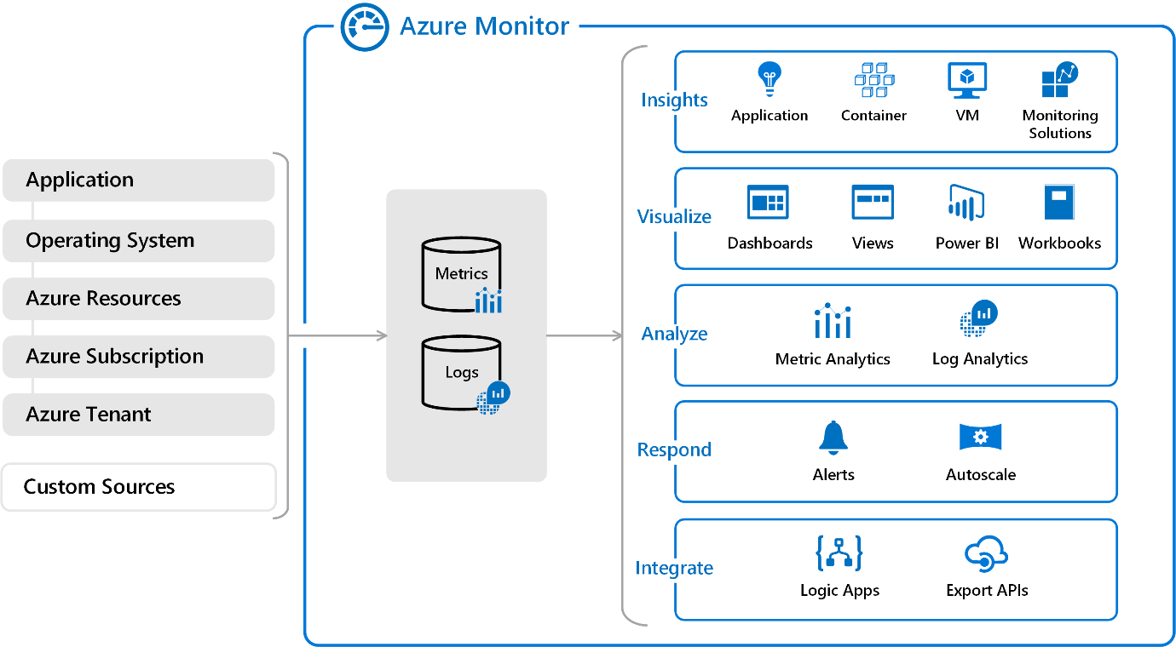

On the left is a list of the sources of logging and metric data that can be collected at every layer in your application architecture, from application to operating system and network.

In the centre, you can see how the logging and metric data is stored in central repositories.

On the right, the data is used in a number of ways. You can view real-time and historical performance across each layer of your architecture, or aggregated and detailed information. The data is displayed at different levels for different audiences. You can view high-level reports on the Azure Monitor Dashboard or create custom views by using Power BI and Kusto queries.

You can use the data to help react to critical events in real time, through alerts delivered via SMS, email,... Or use thresholds to trigger autoscaling functionality to scale up/down to meet the demand. Some popular products such as Azure Application Insights, a service for sending telemetry inf from app source code to Azure, uses Azure Monitor under hood. With App Insights, your app developers can take advantage of the powerful data-analysis platform in Azure Monitor to gain deep insights into an app's operations and diagnose errors without having to wait for users to report them.

#### Azure Service Health

It provides personalized view of health of the Azure services, regions and resources you rely on. The status.azure.com website, which displays only major issues that broadly affect Azure customers, doesn't provide the full picture. But Azure Service Health displays both major and smaller, localized issues that affect you. Service issues are rare, but it's important to be prepared for unexpected. You can set up alerts that help you triage outages and planned maintenance. After outage, Service Health provides official incident reports, called root cause analyses (RCAs), which you can share with stakeholders. Service Health helps you keep eye on several event types:

* **Service issues** are problems in Azure, such as outages, that affect you right now. You can drill down to the affected services, regions, updates from your engineering teams, and find ways to share and track the latest information.
* **Planned maintenance** events can affect availability. You can drill down to affected services, regions, and details to show how an event will affect you and what you need to do. In the rare case reboot is required, Service Health allows you to choose when to perform the maintenance to minimize the downtime.
* **Health advisories** are issues that require you to act to avoid service interruption, including service retirements & breaking changes. They’re announced in advance to allow you to plan.

### Analyse the decision criteria

#### Do you need to analyze how you're using Azure to reduce costs, improve resilience, or harden your security?

Choose Azure Advisor when you're looking for an analysis of your deployed resources. Azure Advisor analyzes the configuration and usage of your resources and provides suggestions on how to optimize for reliability, security, performance, costs, and operations based on experts' best practices.

#### Do you want to monitor Azure services or your usage of Azure?

If you want to keep tabs on Azure itself, especially the services and regions you depend on, you want to choose Azure Service Health. You can view the current status of the Azure services you rely on, upcoming planned outages, and services that will be sunset. You can set up alerts that help you stay on top of incidents and upcoming downtime without having to visit the dashboard regularly.

However, if you want to keep track of performance or issues related to your specific VM or container instances, databases, apps, …, you want to visit Azure Monitor and create reports and notifications to help you understand how services are performing or diagnose issues related to your Azure usage.

#### Do you want to measure custom events alongside other usage metrics?

Choose Azure Monitor when you want to measure custom events alongside other collected telemetry data. Custom events, such as those added in the source code of your software applications, could help identify and diagnose why your application is behaving a certain way.

#### Do you need to set up alerts for outages or when autoscaling is about to deploy new instances?

Here again, you would use Azure Monitor to set up alerts for key events that are related to your specific resources.

### Use Azure Advisor

Tailwind wants to optimize its cloud spend. The organization is concerned about security breaches, because it stores customer data and historical purchase data in cloud-based databases. As the org ramps up its cloud expertise, it wants to better understand its use of the cloud, better best practices, and pinpoint "easy wins" where it can tighten up its cloud spend and security practices.

#### Which service should you choose?

First, in this scenario, does Tailwind need to analyze its Azure usage for the sake of optimization? Yes. Tailwind understands that it might be spending too much, is concerned about its security practices, and wants to have its cloud usage analyzed against industry best practices. Therefore, Azure Advisor is the perfect option for this scenario.

Second, does Tailwind want to monitor the health of Azure services that affect all customers or the resources that are deployed on Azure? This scenario isn't concerned with operations. However, Azure Advisor does analyse and provide recommendations for achieving operational excellence.

Third, does Tailwind want to measure custom events alongside other usage metrics? No, measuring custom events isn't mentioned as a requirement and isn't a consideration in this scenario.

Does Tailwind want to set up alerts for outages or when deploy new instances? Again, this scenario isn't concerned with operations. However, Azure Advisor does analyse & provide recommendations for achieving operational excellence.

Azure Advisor is the right product option to help Tailwind better understand and optimize both its cloud spend and its cloud security posture. This product might help the org with other areas of its cloud usage as well.

### Use Azure Monitor

The Tailwind Traders e-commerce website is experiencing intermittent errors, and the team is unsure of the cause. Because of the nature of the errors, the team suspects that it's either a database or caching issue. What are the circumstances surrounding the errors? Does it happen only during peak usage times? What is the state of the team's Azure SQL instance? What is the state of its Redis caching server? How can it trace the issues to a root cause?

#### Which service should you choose?

First, in this scenario, does Tailwind need an analysis of its Azure usage for the sake of optimization? No, optimization isn't the team's objective in this scenario, so Azure Advisor isn't a candidate.

Second, in this scenario, does Tailwind Traders want to monitor the health of Azure services that affect all customers or the resources deployed on Azure? Because this issue happens intermittently, it's unlikely to affect an entire Azure region or service. It's more likely that a logic issue exists somewhere in their e-commerce website code, or another issue is causing database failures or caching locks. In this scenario, the team could use Azure Monitor to pinpoint a specific user session and look at the performance of each service that's involved in the issue.

Third, in this scenario, does Tailwind Traders want to measure custom events alongside other usage metrics? Yes. Software developers can send additional information about the state of the web application via Application Insights to help locate the root cause of the issue. Application Insights relies on the Azure Monitor platform to store custom event information.

Fourth, in this scenario, does Tailwind Traders want to set up alerts for outages or for when autoscaling is about to deploy new instances? No, alerting isn't their objective in this scenario.

Azure Monitor is the best option for helping Tailwind track this issue. The team can use a wealth of tools to help it gain insight into the app's performance at a high level and dive into specific issues.

### Use Azure Service Health

Tailwind wants to operationalize its cloud env. Its cloud operations team wants to let stakeholders know about upcoming planned downtime in advance. The team wants its solution architects to be forewarned about any MS plans to sunset services so it can rearchitect its SW products accordingly.

When outages do happen, the team wants to quickly ascertain whether the issue is specific to their services or a service interruption that affects many Azure customers. The team also wants to provide key stakeholders with reports that explain how and why the incident occurred, and so on.

#### Which service should you choose?

First, in this scenario, does Tailwind Traders need to analyze its Azure usage for the sake of optimization? No, so Azure Advisor isn't a candidate for this scenario.

Second, does Tailwind Traders want to monitor the health of Azure services that affect all customers or the resources deployed on Azure? In this scenario, the requirement is to stay abreast of upcoming planned downtime. Additionally, the team wants to capture official incident reports. For this reason, Azure Service Health is the strongest candidate to choose for this scenario.

Third, in this scenario, does Tailwind want to measure custom events alongside other usage metrics? No, measuring custom events isn't mentioned as a requirement.

Fourth, in this scenario, does Tailwind Traders want to set up alerts for outages or when autoscaling is about to deploy new instances? Setting up alerts for outages is a requirement in this scenario, but creating alerts for other events such as autoscaling are not in scope. Use Azure Service Health to set up alerts that are specific to Azure outages that affect all Azure customers. Use Azure Monitor to set up alerts for outages and other events that affect only your specific resources.

In this scenario, Azure Service Health is the correct option to choose.

# Azure Fundamentals part 4: Describe general security and network security features

## Protect against security threats by using Azure Security Centre

Tailwind is broadening its use of Azure services. It still has on-premises workloads with current security-related configuration best practices and business procedures. How does the company ensure that all of its systems meet a min level of security and that its inf is protected from attacks?

### What's Azure Security Center?

[Azure Security Center](https://azure.microsoft.com/services/security-center) is a monitoring service that provides visibility of your security posture across all of your services, both on Azure and on-premises. Term security posture refers to cybersecurity policies and controls, as well as how well you can predict, prevent, and respond to security threats. Security Center can:

* Monitor security settings across on-premises and cloud workloads.
* Automatically apply required security settings to new resources as they come online.
* Provide security recommendations that are based on your current configurations, resources, and networks.
* Continuously monitor your resources and perform automatic security assessments to identify potential vulnerabilities before those vulnerabilities can be exploited.
* Use machine learning to detect and block malware from being installed on your virtual machines (VMs) and other resources. You can also use adaptive application controls to define rules that list allowed applications to ensure that only applications you allow can run.
* Detect and analyze potential inbound attacks and investigate threats and any post-breach activity that might have occurred.
* Provide just-in-time access control for network ports. Doing so reduces attack surface by ensuring that the network only allows traffic that you require at the time that you need it to.

### Understand your security posture

Tailwind can use Security Center to get a detailed analysis of different components in its env. Because the company's resources are analyzed against the security controls of any governance policies it has assigned, it can view its overall regulatory compliance from a security perspective all from one place. See the following example of what you might see in Azure Security Center.



Let's say that Tailwind Traders must comply with the Payment Card Industry's Data Security Standard (PCI DSS). This report shows that the company has resources that it needs to remediate.

In the **Resource security hygiene** section, Tailwind can see the health of its resources from a security perspective. To help prioritize remediation actions, recommendations are categorized as low, medium, and high. Here's an example.

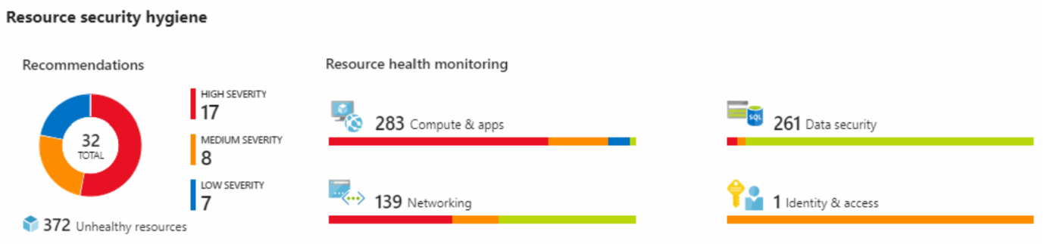

### What's secure score?

[Secure score](https://docs.microsoft.com/en-us/azure/security-center/secure-score-security-controls/) is a measurement of an org's security posture. Secure score is based on security controls, or groups of related security recommendations. Score is based on percentage of security controls that you satisfy. The more security controls you satisfy, the higher the score you receive. Score improves when you remediate all of the recommendations for single resource within control.

Following the secure score recommendations can help protect your organization from threats. From a centralized dashboard in Azure Security Center, orgs can monitor and work on the security of their Azure resources like identities, data, apps, devices, and infrastructure. Secure score helps you:

* Report on the current state of your organization's security posture.
* Improve your security posture by providing discoverability, visibility, guidance, and control.
* Compare with benchmarks and establish key performance indicators (KPIs).

### Protect against threats

Security Centre includes advanced cloud defence capabilities for VMs, network security, and file integrity. Let's look at how some of these capabilities apply to Tailwind Traders.

* **Just-in-time VM access** Tailwind Traders will configure just-in-time access to VMs. This access blocks traffic by default to specific network ports of VMs, but allows traffic for a specified time when an admin requests and approves it.
* **Adaptive application controls** Tailwind Traders can control which applications are allowed to run on its VMs. In the background, Security Center uses machine learning to look at the processes running on a VM. It creates exception rules for each resource group that holds the VMs and provides recommendations. This process provides alerts that inform the company about unauthorized applications that are running on its VMs.
* **Adaptive network hardening** Security Center can monitor the internet traffic patterns of the VMs, and compare those patterns with the company's current network security group (NSG) settings. From there, Security Center can make recommendations about whether the NSGs should be locked down further and provide remediation steps.
* **File integrity monitoring** Tailwind can also configure the monitoring of changes to important files on both WS and Linux, registry settings, apps, and other aspects that might indicate a security attack.

### Respond to security alerts

Tailwind can use Security Center to get a centralized view of all of its security alerts. From there, the company can dismiss false alerts, investigate them further, remediate alerts manually, or use an automated response with a workflow automation.

**Workflow automation** uses Azure Logic Apps and Security Center connectors. The logic app can be triggered by a threat detection alert or by a Security Center recommendation, filtered by name or by severity. You can then configure the logic app to run an action, such as sending an email, or posting a message to a MS Teams channel.

## Detect and respond to security threats by using Azure Sentinel

Security management on a large scale can benefit from a dedicated security information and event management (SIEM) system. A SIEM system aggregates security data from many different sources (as long as those sources support an open-standard logging format). It also provides capabilities for threat detection and response. [Azure Sentinel](https://azure.microsoft.com/services/azure-sentinel/) is Microsoft's cloud-based SIEM system. It uses intelligent security analytics and threat analysis. Azure Sentinel enables you to:

* **Collect cloud data at scale** Collect data across all users, devices, applications, and infrastructure, both on-premises and from multiple clouds.
* **Detect previously undetected threats** Minimize false positives by using Microsoft's comprehensive analytics and threat intelligence.
* **Investigate threats with artificial intelligence** Examine suspicious activities at scale, tapping into years of cybersecurity experience from Microsoft.
* **Respond to incidents rapidly** Use built-in orchestration & automation of common tasks.

### Connect your data sources

Tailwind decides to explore the capabilities of Azure Sentinel. First, the company identifies and connects its data sources. Azure Sentinel supports a number of data sources, which it can analyze for security events. These connections are handled by built-in connectors or industry-standard log formats and APIs.

* **Connect Microsoft solutions** Connectors provide real-time integration for services like Microsoft Threat Protection solutions, Microsoft 365 sources (including Office 365), Azure Active Directory, and Windows Defender Firewall.
* **Connect other services and solutions** Connectors are available for common non-Microsoft services and solutions, including AWS CloudTrail, Citrix Analytics (Security), Sophos XG Firewall, VMware Carbon Black Cloud, and Okta SSO.
* **Connect industry-standard data sources** Azure Sentinel supports data from other sources that use the Common Event Format (CEF) messaging standard, Syslog, or REST API.

### Detect threats

Tailwind Traders needs to be notified when something suspicious occurs. It decides to use both built-in analytics and custom rules to detect threats.

**Built in analytics** use templates designed by MS's team of security experts and analysts based on known threats, common attack vectors, and escalation chains for suspicious activity. Templates can be customized and search across the env for any activity that looks suspicious. Some templates use machine learning behavioral analytics that are based on Microsoft proprietary algorithms.

**Custom analytics** are rules that you create to search for specific criteria within your environment. You can preview the number of results that the query would generate (based on past log events) and set a schedule for the query to run. You can also set an alert threshold.

### Investigate and respond

When Azure Sentinel detects suspicious events, Tailwind Traders can investigate specific alerts or incidents (a group of related alerts). With the investigation graph, the company can review information from entities directly connected to the alert, and see common exploration queries to help guide the investigation.

Here's an example that shows what an investigation graph looks like in Azure Sentinel.

The company will also use [Azure Monitor Workbooks](https://docs.microsoft.com/en-us/azure/azure-monitor/platform/workbooks-overview/) to automate responses to threats. For example, it can set an alert that looks for malicious IP addresses that access the network and create a workbook that does the following steps:

1. When the alert is triggered, open a ticket in the IT ticketing system.
2. Send a message to the security operations channel in Microsoft Teams or Slack to make sure the security analysts are aware of the incident.
3. Send all of the information in the alert to the senior network admin and to the security admin. The email message includes two user option buttons: **Block** or **Ignore**.
   * When an admin chooses **Block**, the IP address is blocked in the firewall, and the user is disabled in Azure Active Directory. When an admin chooses **Ignore**, the alert is closed in Azure Sentinel, and the incident is closed in the IT ticketing system.

The workbook continues to run after it receives a response from the admins. Workbooks can be run manually or automatically when a rule triggers an alert.

## Store and manage secrets by using Azure Key Vault

As Tailwind builds its workloads in the cloud, it needs to carefully handle sensitive information such as passwords, encryption keys, and certificates. This information needs to be available for an application to function, but it might allow an unauthorized person access to application data.

[Azure Key Vault](https://azure.microsoft.com/services/key-vault) is a centralized cloud service for storing an application's secrets in a single, central location. It provides secure access to sensitive information by providing access control and logging capabilities.

### What can Azure Key Vault do?

* **Manage secrets** You can use Key Vault to securely store and tightly control access to tokens, passwords, certificates, API keys, and other secrets.
* **Manage encryption keys** You can use Key Vault as a key management solution. Key Vault makes it easier to create and control the encryption keys that are used to encrypt your data.
* **Manage SSL/TLS certificates** Key Vault enables you to provision, manage, and deploy your public and private Secure Sockets Layer/Transport Layer Security (SSL/TLS) certificates for both your Azure resources and your internal resources.
* **Store secrets backed by hardware security modules (HSMs)** These secrets and keys can be protected either by software or by FIPS 140-2 Level 2 validated HSMs.

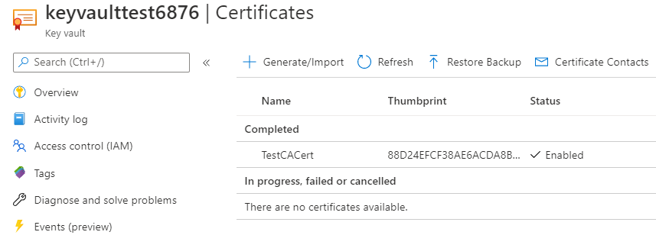

### What are the benefits of Azure Key Vault?

* **Centralized application secrets** Centralizing the storage for your application secrets enables you to control their distribution, and reduces the chances that secrets are accidentally leaked.
* **Securely stored secrets and keys** Azure uses industry-standard algorithms, key lengths, and HSMs. Access to Key Vault requires proper authentication and authorization.
* **Access monitoring and access control** By using Key Vault, you can monitor and control access to your application secrets.
* **Simplified administration of application secrets** Key Vault makes it easier to enroll and renew certificates from public certificate authorities (CAs). You can also scale up and replicate content within regions and use standard certificate management tools.
* **Integration with other Azure services** You can integrate Key Vault with storage accounts, container registries, event hubs, and many more Azure services. These services can then securely reference the secrets stored in Key Vault.

## Exercise - Manage a password in Azure Key Vault

In this exercise, you add a password to Azure Key Vault. A password is an example of sensitive information that you need to protect. You then read the password from Azure Key Vault to verify that the password is accessible.

In practice, there are several ways to add secrets to and read secrets from Key Vault. You can use the Azure portal, the Azure CLI, or Azure PowerShell. By using your favourite programming language, your applications can also securely access the secrets that they need.

Here, you create a secret in Key Vault by using the Azure portal. You then access the secret from the portal and from the Azure CLI in Azure Cloud Shell.

The Azure CLI is a way to work with Azure resources from the command line or from scripts. Cloud Shell is a browser-based shell experience to manage and develop Azure resources. Think of Cloud Shell as an interactive console that runs in the cloud.

### Create a key vault

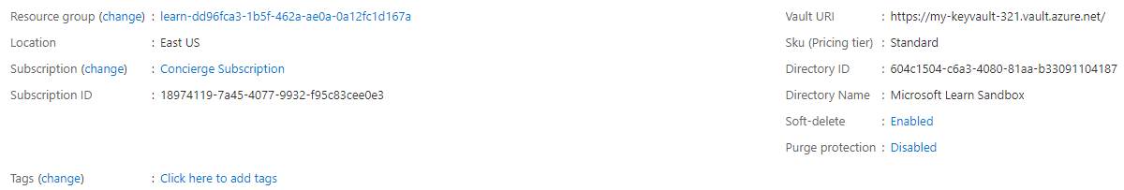

### Add a password to the key vault

1. On the left menu pane, under **Settings**, select **Secrets**. Your key vault pane appears.
2. From the top menu bar, select **Generate/Import**. The **Create a secret** pane appears.
3. Fill in the following values for each setting.
4. Accept the remaining settings at their default values. Notice that you can specify properties such as the activation date and the expiration date. You can also disable access to the secret.
5. Select **Create**.

### Show the password

Here, you access the password from Key Vault two times. First, you access it from the Azure portal. Next, you access it from the Azure CLI.

1. From your **Key Vault/Secrets** pane, select **MyPassword**. The **MyPassword/Versions** pane appears. You see that the current version is enabled.
2. Select the current version. The **Secret Version** pane appears.  
   Under **Secret Identifier**, you see a URI that you can now use with applications to access the secret. Remember, only authorized applications can access this secret.
3. Select **Show Secret Value**. The unique value for this version of the password appears.
4. From Cloud Shell, run this command.

**Note**: Replace **my-keyvault-NNN** with the name you used earlier.

az keyvault secret show \

--name MyPassword \

--vault-name my-keyvault-NNN \

--query value \

--output tsv

You see the password in the output.

### Clean up

The sandbox automatically cleans up your resources when you're finished with this module. When you're working in your own subscription, it's a good idea at the end of a project to identify whether you still need the resources you created. Resources left running can cost you money. You can delete resources individually or delete the resource group to delete the entire set of resources.

## Host your Azure virtual machines on dedicated physical servers by using Azure Dedicated Host

On Azure, VMs run on shared hardware that MS manages. Although the underlying hardware is shared, your VM workloads are isolated from workloads that other Azure customers run. Some organizations must follow regulatory compliance that requires them to be the only customer using the physical machine that hosts their virtual machines. [Azure Dedicated Host](https://azure.microsoft.com/services/virtual-machines/dedicated-host/) provides dedicated physical servers to host your Azure VMs for WS and Linux.



Diagram shows how VMs relate to dedicated hosts and host groups. A dedicated host is mapped to a physical server in an Azure datacenter. A host group is a collection of dedicated hosts.

### What are the benefits of Azure Dedicated Host?

* Gives you visibility into, and control over, the server infrastructure that's running your Azure VMs.
* Helps address compliance requirements by deploying your workloads on an isolated server.
* Lets you choose the number of processors, server capabilities, VM series, and VM sizes within the same host

### Availability considerations for Dedicated Host

After a dedicated host is provisioned, Azure assigns it to the physical server in Microsoft's cloud datacenter. For high availability, you can provision multiple hosts in a host group, and deploy your VMs across this group. VMs on dedicated hosts can also take advantage of maintenance control. This feature enables you to control when regular maintenance updates occur, within a 35-day rolling window.

### Pricing considerations

You're charged per dedicated host, independent of how many VMs you deploy to it. The host price is based on the VM family, type (hardware size), and region. SW licensing, storage, and network usage are billed separately from the host and VMs. See [Azure Dedicated Host pricing](https://aka.ms/ADHPricing/).

## Secure network connectivity on Azure

Every application and service, whether on-premises or in the cloud, needs to be designed with security in mind. There's too much at risk. For example, a denial-of-service attack might prevent customers from reaching your website or services and block you from doing business. Or, your website might be defaced, causing damage to your reputation. A data breach would be even worse, because it can ruin hard-earned trust while causing significant personal and financial harm.

### What is defense in depth?

Tailwind Traders currently runs its workloads on-premises, in its datacenter. Running on-premises means that the company is responsible for all aspects of security, from physical access to buildings all the way down to how data travels in and out of the network. The company wants to know how its current defense-in-depth strategy compares to running in the cloud.

The objective of defense in depth is to protect information and prevent it from being stolen by those who aren't authorized to access it. A defense-in-depth strategy uses a series of mechanisms to slow the advance of an attack that aims at acquiring unauthorized access to data.

## Layers of defense in depth

You can visualize defense in depth as a set of layers, with the data to be secured at the center. Each layer provides protection so that if one layer is breached, a subsequent layer is already in place to prevent further exposure. This approach removes reliance on any single layer of protection. It slows down an attack and provides alert telemetry that security teams can act upon, either automatically or manually. Here's a brief overview of the role of each layer:

* The physical security layer is first line of defence to protect computing HW in datacenter.
* The identity and access layer controls access to infrastructure and change control.
* The perimeter layer uses distributed denial of service (DDoS) protection to filter large-scale attacks before they can cause a denial of service for users.
* The network layer limits communication between resources through segmentation and access controls.
* The compute layer secures access to virtual machines.
* The application layer helps ensure that apps are secure and free of security vulnerabilities.
* The data layer controls access to business and customer data that you need to protect.

These layers provide a guideline for you to help make security configuration decisions in all of the layers of your applications. Azure provides security tools and features at every level of the defense-in-depth concept.

#### **Physical security**

Physically securing access to buildings and controlling access to computing HW within datacenter are first line of defense. With physical security, intent is to provide physical safeguards against access to assets. These safeguards ensure that other layers can't be bypassed, and loss or theft is handled appropriately. MS uses various physical security mechanisms in its cloud datacenters.

#### **Identity and access**

At this layer, it's important to:

* Control access to infrastructure and change control.
* Use single sign-on (SSO) and multifactor authentication.
* Audit events and changes.

The identity and access layer is all about ensuring that identities are secure, access is granted only to what's needed, and sign-in events and changes are logged.

#### **Perimeter**

* Use DDoS protection to filter large-scale attacks before they can affect the availability of a system for users.
* Use perimeter firewalls to identify and alert on malicious attacks against your network.

At the network perimeter, it's about protecting from network-based attacks against your resources. Identifying these attacks, eliminating their impact, and alerting you when they happen are important ways to keep your network secure.

#### **Network**

* Limit communication between resources.
* Deny by default.
* Restrict inbound internet access and limit outbound access where appropriate.
* Implement secure connectivity to on-premises networks.

At this layer, the focus is on limiting the network connectivity across all your resources to allow only what's required. By limiting this communication, you reduce the risk of an attack spreading to other systems in your network.

#### **Compute**

* Secure access to virtual machines.
* Implement endpoint protection on devices and keep systems patched and current.

Malware, unpatched systems, and improperly secured systems open your environment to attacks. The focus in this layer is on making sure that your compute resources are secure and that you have the proper controls in place to minimize security issues.

#### **Application**

* Ensure that applications are secure and free of vulnerabilities.
* Store sensitive application secrets in a secure storage medium.
* Make security a design requirement for all application development.

Integrating security into the application development lifecycle helps reduce the number of vulnerabilities introduced in code. Every development team should ensure that its applications are secure by default.

#### **Data**

In almost all cases, attackers are after data:

* Stored in a database.
* Stored on disk inside virtual machines.
* Stored in software as a service (SaaS) applications, such as Office 365.
* Managed through cloud storage.

Those who store and control access to data are responsible for ensuring that it's properly secured. Often, regulatory requirements dictate the controls and processes that must be in place to ensure the confidentiality, integrity, and availability of the data.

### Security posture

Is your org's ability to protect from and respond to security threats. The common principles used to define a security posture are confidentiality, integrity, and availability, known collectively as CIA.

**Confidentiality:** The principle of least privilege means restricting access to information only to individuals explicitly granted access, at only the level that they need to perform their work. This information includes protection of user passwords, email content, and access levels to applications and underlying infrastructure.

**Integrity:** Prevent unauthorized changes to information:

* + At rest: when it's stored.
  + In transit: when it's being transferred from one place to another, including from a local computer to the cloud.

A common approach used in data transmission is for the sender to create a unique fingerprint of the data by using a one-way hashing algorithm. The hash is sent to the receiver along with the data. The receiver recalculates the data's hash and compares it to the original to ensure that the data wasn't lost or modified in transit.

**Availability:** Ensure that services are functioning and can be accessed only by authorized users. Denial-of-service attacks are designed to degrade the availability of a system, affecting its users.

## Protect virtual networks by using Azure Firewall

A firewall is a network security device that monitors incoming and outgoing network traffic and decides whether to allow or block specific traffic based on a defined set of security rules. You can create firewall rules that specify ranges of IP addresses. Only clients granted IP addresses from within those ranges are allowed to access the destination server. Firewall rules can also include specific network protocol and port inf.

### What's Azure Firewall?

[Azure Firewall](https://azure.microsoft.com/services/azure-firewall) is a managed, cloud-based network security service that helps protect resources in your Azure virtual networks. A virtual network is similar to a traditional network that you'd operate in own datacenter. It's a fundamental building block for your private network that enables virtual machines and other compute resources to securely communicate with each other, the internet, and on-premises networks. Here's a diagram that shows a basic Azure Firewall implementation:

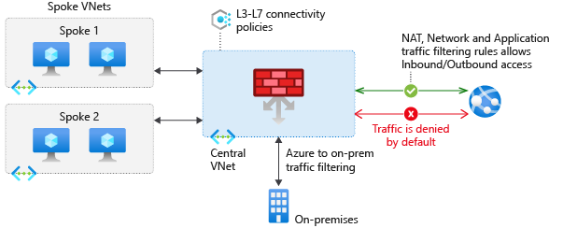

Azure Firewall is a stateful firewall. A stateful firewall analyzes the complete context of a network connection, not just an individual packet of network traffic. Azure Firewall features high availability and unrestricted cloud scalability. Azure Firewall provides many features, including:

* Built-in high availability.
* Unrestricted cloud scalability.
* Inbound and outbound filtering rules.
* Inbound Destination Network Address Translation (DNAT) support.
* Azure Monitor logging.

Azure Firewall provides a central location to create, enforce, and log application and network connectivity policies across subscriptions and virtual networks. Azure Firewall uses a static (unchanging) public IP address for your virtual network resources, which enables outside firewalls to identify traffic coming from your virtual network. The service is integrated with Azure Monitor to enable logging and analytics. You typically deploy Azure Firewall on a central virtual network to control general network access.

### What can I configure with Azure Firewall?

With Azure Firewall, you can configure:

* Application rules that define fully qualified domain names (FQDNs) that can be accessed from a subnet.
* Network rules that define source address, protocol, destination port, and destination address.
* Network Address Translation (NAT) rules that define destination IP addresses and ports to translate inbound requests.

[Azure Application Gateway](https://azure.microsoft.com/services/application-gateway) also provides a firewall that's called the web app firewall (WAF). WAF provides centralized, inbound protection for your web applications against common exploits and vulnerabilities. [Azure Front Door](https://azure.microsoft.com/services/frontdoor/) & [Azure Content Delivery Network](https://azure.microsoft.com/services/cdn/) also provide WAF services.

### Protect from DDoS attacks by using Azure DDoS Protection

Any large company can be the target of a large-scale network attack. Tailwind is no exception. Attackers might flood your network to make a statement or simply for the challenge. As Tailwind Traders moves to the cloud, it wants to understand how Azure can help prevent distributed denial of service (DDoS) and other attacks.

### What are DDoS attacks?

A [distributed denial of service](https://azure.microsoft.com/services/ddos-protection) attack attempts to overwhelm and exhaust an application's resources, making the application slow or unresponsive to legitimate users. DDoS attacks can target any resource that's publicly reachable through the internet, including websites.

### What is Azure DDoS Protection?

[Azure DDoS Protection](https://azure.microsoft.com/services/ddos-protection/) (Standard) helps protect your Azure resources from DDoS attacks.

When you combine DDoS Protection with recommended app design practices, you help provide a defence against DDoS attacks. DDoS Protection uses the scale and elasticity of MS's global network to bring DDoS mitigation capacity to every Azure region. The DDoS Protection service helps protect your Azure apps by analysing and discarding DDoS traffic at the Azure network edge, before it can affect your service's availability. Diagram shows network traffic flowing into Azure from both customers and an attacker:

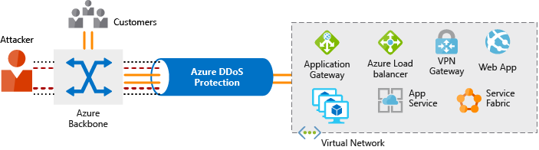

DDoS Protection identifies the attacker's attempt to overwhelm the network and blocks further traffic from them, ensuring that traffic never reaches Azure resources. Legitimate traffic from customers still flows into Azure without any interruption of service.

DDoS Protection can also help you manage your cloud consumption. When you run on-premises, you have a fixed number of compute resources. But in the cloud, elastic computing means that you can automatically scale out your deployment to meet demand. A cleverly designed DDoS attack can cause you to increase your resource allocation, which incurs unneeded expense. DDoS Protection Standard helps ensure that the network load you process reflects customer usage. You can also receive credit for any costs accrued for scaled-out resources during a DDoS attack.

### What service tiers are available to DDoS Protection?

#### **Basic**

The Basic service tier is automatically enabled for free as part of your Azure subscription. Always-on traffic monitoring and real-time mitigation of common network-level attacks provide the same defenses that Microsoft's online services use. The Basic service tier ensures that Azure infrastructure itself is not affected during a large-scale DDoS attack.

The Azure global network is used to distribute and mitigate attack traffic across Azure regions.

#### **Standard**

The Standard service tier provides additional mitigation capabilities that are tuned specifically to Azure Virtual Network resources. DDoS Protection Standard is relatively easy to enable and requires no changes to your applications. The Standard tier provides always-on traffic monitoring and real-time mitigation of common network-level attacks. It provides the same defenses that MS's online services use.

Protection policies are tuned through dedicated traffic monitoring and machine learning algorithms. Policies are applied to public IP addresses, which are associated with resources deployed in virtual networks such as Azure Load Balancer and Application Gateway.

The Azure global network is used to distribute and mitigate attack traffic across Azure regions.

### What kinds of attacks can DDoS Protection help prevent?

The Standard service tier can help prevent:

* **Volumetric attacks:** The goal of this attack is to flood the network layer with a substantial amount of seemingly legitimate traffic.
* **Protocol attacks:** These attacks render a target inaccessible by exploiting a weakness in the layer 3 and layer 4 protocol stack.
* **Resource-layer (application-layer) attacks (only with web application firewall):** These attacks target web application packets to disrupt the transmission of data between hosts. You need a web application firewall (WAF) to protect against L7 attacks. DDoS Protection Standard protects the WAF from volumetric and protocol attacks.

| **Property** | **Description** |
| --- | --- |
| Name | A unique name for the NSG. |
| Priority | A number between 100 and 4096. Rules are processed in priority order,  with lower numbers processed before higher numbers. |
| Source or Destination | A single IP address or IP address range, service tag, or application security group. |
| Protocol | **TCP**, **UDP**, or **Any**. |
| Direction | Whether the rule applies to inbound or outbound traffic. |
| Port Range | A single port or range of ports. |
| Action | **Allow** or **Deny**. |

## Filter network traffic by using network security groups

Although Azure Firewall and Azure DDoS Protection can help control what traffic can come from outside sources, Tailwind Traders also wants to understand how to protect its internal networks on Azure. Doing so will give the company an extra layer of defence against attacks.

### What are network security groups?

A [network security group](https://docs.microsoft.com/en-us/azure/virtual-network/security-overview#network-security-groups?azure-portal=true) enables you to filter network traffic to and from Azure resources within an Azure virtual network. You can think of NSGs like an internal firewall. An NSG can contain multiple inbound and outbound security rules that enable you to filter traffic to and from resources by source and destination IP address, port, and protocol.

### How do I specify NSG rules?

A network security group can contain as many rules as you need, within Azure subscription limits. When you create a network security group, Azure creates a series of default rules to provide a baseline level of security. You can't remove the default rules, but you can override them by creating new rules with higher priorities.

## Exercise - Configure network access to a VM by using a network security group

In this exercise, you configure network access to a VM running on Azure. You start by creating Linux VM and installing Nginx, a popular web server, on that VM. To make your web server accessible, you then create a network security group rule that allows inbound access on port 80 (HTTP).

There are many ways to create and manage VMs, including their network settings. For example, you can use the Azure portal, the Azure CLI, Azure PowerShell, or an ARM template.

Here, you use the Azure CLI. The Azure CLI enables you to connect to Azure and run administrative commands on Azure resources. As with other command-line interfaces, you can run commands directly from a terminal or you can add commands to a Bash script or a PowerShell script. The Azure CLI runs on Windows, macOS, or Linux.

Here, you access the Azure CLI from Azure Cloud Shell. Cloud Shell is a browser-based shell experience that you use to manage and develop Azure resources. Think of Cloud Shell as an interactive console that runs in the cloud.

### Create a Linux virtual machine and install Nginx

Use the following Azure CLI commands to create a Linux VM and install Nginx. After your VM is created, you'll use the Custom Script Extension to install Nginx. The Custom Script Extension is an easy way to download and run scripts on your Azure VMs. It's just one of the many ways you can configure the system after your VM is up and running.

1. From Cloud Shell, run the following az vm create command to create a Linux VM:

az vm create \

--resource-group [sandbox resource group name] \

--name my-vm \

--image UbuntuLTS \

--admin-username azureuser \

--generate-ssh-keys

You name the VM **my-vm**. You use this name to refer to the VM in later steps.

1. Run the following az vm extension set command to configure Nginx on your VM:

az vm extension set \

--resource-group [sandbox resource group name] \

--vm-name my-vm \

--name customScript \

--publisher Microsoft.Azure.Extensions \

--version 2.1 \

--settings '{"fileUris":["https://raw.githubusercontent.com/MicrosoftDocs/mslearn-welcome-to-azure/master/configure-nginx.sh"]}' \

--protected-settings '{"commandToExecute": "./configure-nginx.sh"}'

This command uses the Custom Script Extension to run a Bash script on your VM. The script is stored on GitHub.

While the command runs, you can choose to [examine the Bash script](https://raw.githubusercontent.com/MicrosoftDocs/mslearn-welcome-to-azure/master/configure-nginx.sh) from a separate browser tab.

To summarize, the script:

* 1. Runs apt-get update to download the latest package information from the internet. This step helps ensure that the next command can locate the latest version of the Nginx package.
  2. Installs Nginx.
  3. Sets the home page, /var/www/html/index.html, to print a welcome message that includes your VM's host name.

### Access your web server

In this procedure, you get the IP address for your VM and attempt to access your web server's home page.

1. Run the following az vm list-ip-addresses command to get your VM's IP address and store the result as a Bash variable:

Azure CLICopy

IPADDRESS="$(az vm list-ip-addresses \

--resource-group [sandbox resource group name] \

--name my-vm \

--query "[].virtualMachine.network.publicIpAddresses[*].ipAddress" \

--output tsv)"

1. Run the following curl command to download the home page:

BashCopy

curl --connect-timeout 5 http://$IPADDRESS

The --connect-timeout argument specifies to allow up to five seconds for the connection to occur.

After five seconds, you see an error message that states that the connection timed out:

curl: (28) Connection timed out after 5001 milliseconds

This message means that the VM was not accessible within the timeout period.

As an optional step, try to access the web server from a browser:

* 1. Run the following to print your VM's IP address to the console:

echo $IPADDRESS

You see an IP address, for example, 23.102.42.235.

* 1. Copy the IP address that you see to the clipboard.
  2. Open a new browser tab and go to your web server.
  3. After a few moments, you see that the connection isn't happening. If you wait for the browser to time out.

### List the current network security group rules

Your web server wasn't accessible. To find out why, let's examine your current NSG rules.

1. Run the following az network nsg list command to list the network security groups that are associated with your VM:

az network nsg list \

--resource-group [sandbox resource group name] \

--query '[].name' \

--output tsv

You see this: my-vmNSG

Every VM on Azure is associated with at least one network security group. In this case, Azure created an NSG for you called my-vmNSG.

1. Run the following az network nsg rule list command to list the rules associated with the NSG named my-vmNSG:

az network nsg rule list \

--resource-group [sandbox resource group name] \

--nsg-name my-vmNSG

You see a large block of text in JSON format in the output. In the next step, you'll run a similar command that makes this output easier to read.

1. Run the az network nsg rule list command a second time. This time, use the --query argument to retrieve only the name, priority, affected ports, and access (**Allow** or **Deny**) for each rule. The --output argument formats the output as a table so that it's easy to read.

az network nsg rule list \

--resource-group [sandbox resource group name] \

--nsg-name my-vmNSG \

--query '[].{Name:name, Priority:priority, Port:destinationPortRange, Access:access}' \

--output table

Name Priority Port Access

----------------- ---------- ------ --------

default-allow-ssh 1000 22 Allow

You see the default rule, default-allow-ssh. This rule allows inbound connections over port 22 (SSH). SSH (Secure Shell) is a protocol that's used on Linux to allow administrators to access the system remotely.

The priority of this rule is 1000. Rules are processed in priority order, with lower numbers processed before higher numbers.

By default, a Linux VM's NSG allows network access only on port 22. This enables administrators to access the system. You need to also allow inbound connections on port 80, which allows access over HTTP.

### Create the network security rule

Here, you create a network security rule that allows inbound access on port 80 (HTTP).

1. Run the following az network nsg rule create command to create a rule called allow-http that allows inbound access on port 80:

az network nsg rule create \

--resource-group [sandbox resource group name] \

--nsg-name my-vmNSG \

--name allow-http \

--protocol tcp \

--priority 100 \

--destination-port-ranges 80 \

--access Allow

For learning purposes, here you set the priority to 100. In this case, the priority doesn't matter. You would need to consider the priority if you had overlapping port ranges.

1. To verify the configuration, run az network nsg rule list to see the updated list of rules:

az network nsg rule list \

--resource-group [sandbox resource group name] \

--nsg-name my-vmNSG \

--query '[].{Name:name, Priority:priority, Port:destinationPortRange, Access:access}' \

--output table

You see this both the default-allow-ssh rule and your new rule, allow-http:

Name Priority Port Access

----------------- ---------- ------ --------

default-allow-ssh 1000 22 Allow

allow-http 100 80 Allow

### Access your web server again

Now that you've configured network access to port 80, let's try to access the web server a second time.

1. Run the same curl command that you ran earlier:

curl --connect-timeout 5 http://$IPADDRESS

You see this:

<html><body><h2>Welcome to Azure! My name is my-vm.</h2></body></html>

**Note:** There may be a slight delay between rules being added and ports being opened.

1. As an optional step, refresh your browser tab that points to your web server.

### Clean up

In practice, you can create a standalone network security group that includes the inbound and outbound network access rules you need. If you have multiple VMs that serve the same purpose, you can assign that NSG to each VM at the time you create it. This technique enables you to control network access to multiple VMs under a single, central set of rules.

## Combine Azure services to create a complete network security solution

Considering an Azure security solution, consider all the elements of defense in depth. Here are reco-mmendations on how to combine Azure services to create a complete network security solution.

### Secure the perimeter layer

Perimeter layer is about protecting org's resources from network-based attacks. Identifying attacks, alerting appropriate teams, eliminating their impact are important for network security. To do this:

* Use Azure DDoS Protection to filter large-scale attacks before they can cause a denial of service for users.
* Use perimeter firewalls with Azure Firewall to identify and alert on malicious attacks against your network.

### Secure the network layer

At this layer, the focus is on limiting network connectivity across all of your resources to allow only what's required. Segment your resources and use network-level controls to restrict communication to only what's needed. By restricting connectivity, you reduce the risk of lateral movement throughout your network from an attack. Use network security groups to create rules that define allowed inbound and outbound communication at this layer.

Limit communication between resources by segmenting network and configuring access controls.

* Deny by default.
* Restrict inbound internet access and limit outbound where appropriate.
* Implement secure connectivity to on-premises networks.

### Combine services

You can combine Azure networking and security services to manage your network security and provide increased layered protection.

**Network security groups and Azure Firewall**

Azure Firewall complements the functionality of network security groups. Together, they provide better defense-in-depth network security.

Network security groups provide distributed network-layer traffic filtering to limit traffic to resources within virtual networks in each subscription.

Azure Firewall is a fully stateful, centralized network firewall as a service. It provides network-level and application-level protection across different subscriptions and virtual networks.

**Azure Application Gateway web application firewall and Azure Firewall**

Web app firewall (WAF) is a feature of Azure App Gateway that provides your web apps with centralized, inbound protection against common exploits and vulnerabilities. AF provides:

* Inbound protection for non-HTTP/S protocols (for example, RDP, SSH, and FTP).
* Outbound network-level protection for all ports and protocols.
* Application-level protection for outbound HTTP/S.

### Summary

* Azure Firewall is a managed, cloud-based network security service that helps protect resources in Azure virtual networks.
* An Azure virtual network is similar to a traditional network that you'd operate in your own datacenter. It enables virtual machines and other compute resources to securely communicate with each other, the internet, and on-premises networks.
* A network security group (NSG) enables you to filter network traffic to and from Azure resources within a virtual network.
* Azure DDoS Protection helps protect Azure resources from DDoS attacks.

# Azure Fundamentals part 5: Describe identity, governance, privacy, and compliance features

With the rise of remote work, bring your own device (BYOD), mobile applications, and cloud applications, the primary security boundary has shifted from firewalls and physical access controls to identity. Understanding who is using your systems and what they have permission to do are critical to keeping your data safe from attackers. To stay organized, manage costs, and meet your compliance goals, you need a good cloud governance strategy.

## Secure access to your applications by using Azure identity services

Traditionally, protecting access to systems and data involved the on-premises network perimeter and physical access controls. With people increasingly able to work from anywhere, plus the rise of bring your own device (BYOD) strategies, mobile applications, and cloud applications, many of those access points are now outside the company's physical networks.

Identity has become the new primary security boundary. Accurately proving that someone is a valid user of your system, with an appropriate level of access, is critical to maintaining control of your data. This identity layer is now more often the target of attack than the network is.

### How will Tailwind Traders secure access to its cloud applications?

The mobile workforce of Tailwind is increasing, as are the number of apps that the company runs in the cloud. Retail employees located around the world are issued tablet devices from which they can create orders for customers and plan their work schedules. Drivers can use their own mobiles to access scheduling and logistics apps. Tailwind uses AD to secure its on-premises env. It needs to ensure that only employees can sign in and access the company's business apps. It also needs to ensure that short-term staff can access these apps only when they're under active contract. How can AAD help Tailwind secure all of its apps accessed from the intranet and from public networks?

### Compare authentication and authorization

Recall that Tailwind Traders must ensure that only employees can sign in and access its business applications. Tailwind also needs to ensure that employees can access only authorized applications.

Two fundamental concepts that you need to understand when talking about identity and access are authentication (AuthN) and authorization (AuthZ). Authentication and authorization both support everything else that happens. They occur sequentially in the identity and access process.

#### What is authentication?

Authentication is the process of establishing the identity of a person or service that wants to access a resource. It involves the act of challenging a party for legitimate credentials and provides the basis for creating a security principal for identity and access control. It establishes whether the user is who they say they are.

#### What is authorization?

Authentication establishes the user's identity, but authorization is the process of establishing what level of access an authenticated person or service has. It specifies what data they're allowed to access and what they can do with it.

#### How are authentication and authorization related?

Here's a diagram that shows the relationship between authentication and authorization:

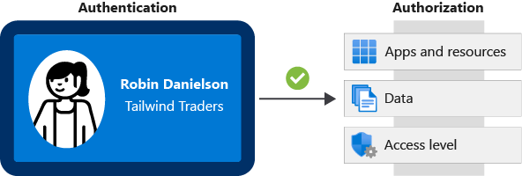

The identification card represents credentials that the user has to prove their identity (you'll learn more about the types of credentials later in this module.) Once authenticated, authorization defines what kinds of applications, resources, and data that user can access.

## What is Azure Active Directory?

AAD provides identity services that enable your users to sign in and access both MS cloud apps and cloud apps that you develop. AAD supports single sign-on (SSO). Tailwind already uses AD to secure its on-premises environments. The company doesn't want its users to have a different username and password to remember for accessing apps and data in the cloud. Can the company integrate its existing AD instance with cloud identity services to create a seamless experience for its users?

### How does Azure AD compare to Active Directory?

Active Directory is related to Azure AD, but they have some key differences. Microsoft introduced Active Directory in Windows 2000 to give organizations the ability to manage multiple on-premises infrastructure components and systems by using a single identity per user.

For on-premises envs, AD running on WS Server provides an identity and access management service that's managed by your own org. AAD is MS's cloud-based identity and access management service. With AAD, you control the identity accounts, but MS ensures that the service is available globally.

When you secure identities on-premises with Active Directory, Microsoft doesn't monitor sign-in attempts. When you connect Active Directory with Azure AD, Microsoft can help protect you by detecting suspicious sign-in attempts at no extra cost. For example, Azure AD can detect sign-in attempts from unexpected locations or unknown devices.

### Who uses Azure AD?

**IT administrators:** Administrators can use Azure AD to control access to applications and resources based on their business requirements.

**App developers:** Developers can use Azure AD to provide a standards-based approach for adding functionality to applications that they build, such as adding SSO functionality to an app or enabling an app to work with a user's existing credentials.

**Users:** Users can manage their identities. For example, self-service password reset enables users to change or reset their password with no involvement from an IT administrator or help desk.

**Online service subscribers:** Microsoft 365, Microsoft Office 365, Azure, and Microsoft Dynamics CRM Online subscribers are already using Azure AD.

Tenant is representation of org. Tenant is typically separated from other tenants and has its own identity. Each MS 365, Office 365, Azure, Dynamics CRM Online tenant is automatically AAD tenant.

Here's a screenshot of what IT administrator see in Azure portal when working with Active Directory:

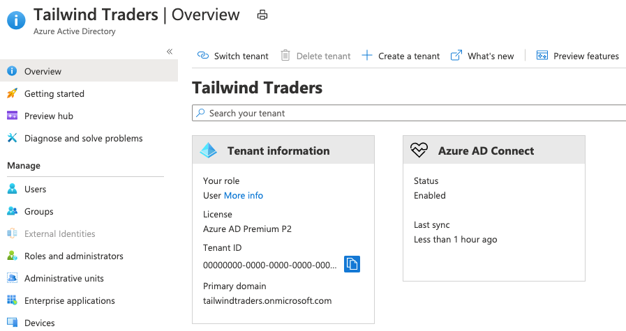

### What services does Azure AD provide?

**Authentication:** This includes verifying identity to access applications and resources. It also includes providing functionality such as self-service password reset, multifactor authentication, a custom list of banned passwords, and smart lockout services.

**Single sign-on:** SSO enables you to remember only one username and one password to access multiple applications. A single identity is tied to a user, which simplifies the security model. As users change roles or leave an organization, access modifications are tied to that identity, which greatly reduces the effort needed to change or disable accounts.

**Application management:** You can manage your cloud and on-premises apps by using AAD. Features like Application Proxy, SaaS apps, the My Apps portal (also called the access panel), and single sign-on provide a better user experience.

**Device management:** AAD supports registration of devices. Registration enables devices to be managed through tools like MS Intune. It allows for device-based Conditional Access policies to restrict access attempts to only coming from known devices, regardless of requesting user account.

### What kinds of resources can Azure AD help secure?

AAD helps users access both external and internal resources. External resources might include Microsoft Office 365, the Azure portal, and thousands of other SaaS applications. Internal resources might include apps on your corporate network and intranet, along with any cloud applications developed within your organization.

### What's single sign-on?

Single sign-on enables a user to sign in one time and use that credential to access multiple resources and applications from different providers.

More identities mean more passwords to remember and change. Password policies can vary among applications. As complexity requirements increase, it becomes increasingly difficult for users to remember them. The more passwords a user has to manage, the greater the risk of a credential-related security incident. Consider the process of managing all those identities. Additional strain is placed on help desks as they deal with account lockouts and password reset requests. If a user leaves an org, tracking down all those identities and ensuring they are disabled can be challenging. If an identity is overlooked, this might allow access when it should have been eliminated.

With SSO, you need to remember only one ID and one password. Access across applications is granted to a single identity that's tied to the user, which simplifies the security model. As users change roles or leave an organization, access is tied to a single identity. This change greatly reduces the effort needed to change or disable accounts. Using SSO for accounts makes it easier for users to manage their identities and increases your security capabilities.

### How can I connect Active Directory with Azure AD?

Connecting AD with Azure AD enables to provide a consistent identity experience to users. There are a few ways to connect existing AD installation with AAD. The most popular method is AAD Connect.

AAD Connect synchronizes user identities between on-premises AD and AAD. AAD Connect synchronizes changes between both identity systems, so you can use features like SSO, multifactor authentication, and self-service password reset under both systems. Self-service password reset prevents users from using known compromised passwords.

Diagram that shows how Azure AD Connect fits between on-premises Active Directory and Azure AD:

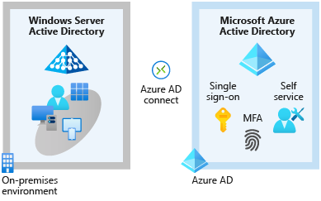

As Tailwind integrates its existing AD instance with AAD, it creates a consistent access model across its organization. Doing so greatly simplifies its ability to sign in to different applications, manage changes to user identities and control, and monitor and block unusual access attempts.

## What are multifactor authentication and Conditional Access?

Tailwind allows delivery drivers to use their mobiles to access scheduling apps. How can the IT department ensure that an access attempt is really from a valid Tailwind worker?

### What's multifactor authentication?

Multifactor authentication is a process where a user is prompted during the sign-in process for an additional form of identification. Exs. include a code on their mobile phone or a fingerprint scan.

Think about how you sign in to websites, email, or online gaming services. In addition to your username and password, have you ever needed to enter a code that was sent to your phone? If so, you've used multifactor authentication to sign in.

Multifactor authentication provides additional security for your identities by requiring two or more elements to fully authenticate. These elements fall into three categories:

* **Something the user knows:** This might be an email address and password.
* **Something the user has:** This might be a code that's sent to the user's mobile phone.
* **Something the user is:** This is typically some sort of biometric property, such as a fingerprint or face scan that's used on many mobile devices.

Multifactor authentication increases identity security by limiting the impact of credential exposure (for example, stolen usernames and passwords). With multifactor authentication enabled, an attacker who has a user's password would also need to have possession of their phone or their fingerprint to fully authenticate.

Compare multifactor authentication with single-factor authentication. Under single-factor authentication, an attacker would need only a username and password to authenticate. Multifactor authentication should be enabled wherever possible because it adds enormous benefits to security.

### What's Azure AD Multi-Factor Authentication?

Azure AD Multi-Factor Authentication is a Microsoft service that provides multifactor authentication capabilities. Azure AD Multi-Factor Authentication enables users to choose an additional form of authentication during sign-in, such as a phone call or mobile app notification.

These services provide Azure AD Multi-Factor Authentication capabilities:

* **Azure Active Directory:** The Azure Active Directory free edition enables Azure AD Multi-Factor Authentication for administrators with the global admin level of access, via the Microsoft Authenticator app, phone call, or SMS code. You can also enforce Azure AD Multi-Factor Authentication for all users via the Microsoft Authenticator app only, by enabling security defaults in your Azure AD tenant. Azure Active Directory Premium (P1 or P2 licenses) allows for comprehensive and granular configuration of Azure AD Multi-Factor Authentication through Conditional Access policies (explained shortly).
* **Multifactor authentication for Office 365:** A subset of Azure AD Multi-Factor Authentication capabilities is part of your Office 365 subscription.

For more information on licenses and Azure AD Multi-Factor Authentication capabilities, see [Available versions of Azure AD Multi-Factor Authentication](https://docs.microsoft.com/en-us/azure/active-directory/authentication/concept-mfa-licensing#available-versions-of-azure-multi-factor-authentication?azure-portal=true).

### What's Conditional Access?

It’s a tool that AAD uses to allow (or deny) access to resources based on identity signals. These signals include who, where the user is, and what device the user is requesting access from.

Conditional Access helps IT administrators:

* Empower users to be productive wherever and whenever.
* Protect the organization's assets.

Conditional Access also provides a more granular multifactor authentication experience for users. Ex. a user might not be challenged for 2. authentication factor if they're at a known location. However, they might be challenged for a 2. authentication factor if their sign-in signals are unusual.

During sign-in, Conditional Access collects signals from the user, makes decisions based on those signals, and then enforces that decision by allowing or denying the access request or challenging for a multifactor authentication response.

Here, the signal might be the user's location, the user's device, or the application that the user is trying to access. Based on these signals, the decision might be to allow full access if the user is signing in from their usual location. If the user is signing in from an unusual location or a location that's marked as high risk, then access might be blocked entirely or possibly granted after the user provides a second form of authentication. Enforcement is the action that carries out the decision. Ex. the action is to allow access or require the user to provide a second form of authentication.

### When can I use Conditional Access?

Conditional Access is useful when you need to:

* Require multifactor authentication to access an application.
* You can configure whether all users require multifactor authentication or only certain users, such as administrators.
* You can also configure whether multifactor authentication applies to access from all networks or only untrusted networks.
* Require access to services only through approved client applications.
* For example, you might want to allow users to access Office 365 services from a mobile device as long as they use approved client apps, like the Outlook mobile app.
* Require users to access your application only from managed devices.
* A managed device is a device that meets your standards for security and compliance.
* Block access from untrusted sources, such as access from unknown or unexpected locations.

Conditional Access comes with a What If tool, which helps you plan and troubleshoot your Conditional Access policies. You can use this tool to model your proposed Conditional Access policies across recent sign-in attempts from your users to see what the impact would have been if those policies had been enabled. The What If tool enables you to test your proposed Conditional Access policies before you implement them.

### Where is Conditional Access available?

To use Conditional Access, you need an Azure AD Premium P1 or P2 license. If you have a Microsoft 365 Business Premium license, you also have access to Conditional Access features.

### Summary

* Authentication (AuthN) establishes the user's identity.
* Authorization (AuthZ) establishes the level of access that an authenticated user has.
* Single sign-on (SSO) enables a user to sign in one time and use that credential to access multiple resources and applications.
* Azure Active Directory (Azure AD) is a cloud-based identity and access management service. Azure AD enables an organization to control access to apps and resources based on its business requirements.
* Azure AD Multi-Factor Authentication provides additional security for identities by requiring two or more elements to fully authenticate. In general, multifactor authentication can include something the user knows, something the user has, and something the user is.
* Conditional Access is a tool that Azure AD uses to allow or deny access to resources based on identity signals such as the user's location.

## Build a cloud governance strategy on Azure

The term governance describes the general process of establishing rules and policies and ensuring that those rules and policies are enforced.

When running in the cloud, a good governance strategy helps you maintain control over the applications and resources that you manage in the cloud. Maintaining control over your environment ensures that you stay compliant with:

* Industry standards, like [PCI DSS](https://docs.microsoft.com/en-us/microsoft-365/compliance/offering-pci-dss).
* Corporate or organizational standards, such as ensuring that network data is encrypted.

Governance is most beneficial when you have:

* Multiple engineering teams working in Azure.
* Multiple subscriptions to manage.
* Regulatory requirements that must be enforced.

Standards that must be followed for all cloud resources.

### How will Tailwind Traders improve agility while maintaining control?

By working in the cloud, you essentially have immediate access to compute, storage, and networking components. Many kinds of groups and users, including people from development, test, operations, and security teams, can potentially have direct access to cloud resources.

### Control access to cloud resources by using Azure role-based access control

When you have multiple IT and engineering teams, how can you control what access they have to the resources in your cloud environment? It's a good security practice to grant users only the rights they need to perform their job, and only to the relevant resources.

Instead of defining the detailed access requirements for each individual, and then updating access requirements when new resources are created, Azure enables you to control access through [Azure role-based access control](https://docs.microsoft.com/en-us/azure/role-based-access-control/overview) (Azure RBAC).

Azure provides built-in roles that describe common access rules for cloud resources. You can define your own roles. Each role has an associated set of access permissions that relate to that role. When you assign individuals or groups to one or more roles, they receive all of the associated access.

### How is role-based access control applied to resources?

Role-based access control is applied to a scope, which is a resource or set of resources that this access applies to. Here's a diagram that shows the relationship between roles and scopes.

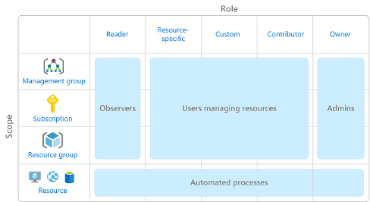

Scopes include:

* A management group (a collection of multiple subscriptions).
* A single subscription.
* A resource group.
* A single resource.

Observers, Users managing resources, Admins, and Automated processes illustrate the kinds of users or accounts that would typically be assigned each of the various roles. When you grant access at a parent scope, those permissions are inherited by all child scopes. For example:

* When you assign the [Owner](https://docs.microsoft.com/en-us/azure/role-based-access-control/built-in-roles#owner) role to a user at the management group scope, that user can manage everything in all subscriptions within the management group.
* When you assign the [Reader](https://docs.microsoft.com/en-us/azure/role-based-access-control/built-in-roles#reader) role to a group at the subscription scope, the members of that group can view every resource group and resource within the subscription.
* When you assign the [Contributor](https://docs.microsoft.com/en-us/azure/role-based-access-control/built-in-roles#contributor) role to an application at the resource group scope, the application can manage resources of all types within that resource group, but not other resource groups within the subscription.

### When should I use Azure RBAC?

Use Azure RBAC when you need to:

* Allow user to manage VMs in a subscription and another user to manage virtual networks.
* Allow a database administrator group to manage SQL databases in a subscription.
* Allow a user to manage all resources in a rg, such as virtual machines, websites, and subnets.
* Allow an application to access all resources in a resource group.

### How is Azure RBAC enforced?

Azure RBAC is enforced on any action that's initiated against an Azure resource that passes through Azure Resource Manager. Resource Manager is a management service that provides a way to organize and secure your cloud resources.

You typically access Resource Manager from the Azure portal, Azure Cloud Shell, Azure PowerShell, and the Azure CLI. Azure RBAC doesn't enforce access permissions at the application or data level. Application security must be handled by your application.

RBAC uses an allow model. When you're assigned a role, RBAC allows you to perform certain actions, such as read, write, or delete. If one role assignment grants you read permissions to a resource group and a different role assignment grants you write permissions to the same resource group, you have both read and write permissions on that resource group.

### Who does Azure RBAC apply to?

You can apply Azure RBAC to an individual person or to a group. You can also apply Azure RBAC to other special identity types, such as service principals and managed identities. These identity types are used by applications and services to automate access to Azure resources.

### How do I manage Azure RBAC permissions?

You manage access permissions on the **Access control (IAM)** pane in the Azure portal. This pane shows who has access to what scope and what roles apply. You can also grant or remove access from this pane.

The following screenshot shows an example of the **Access control (IAM)** pane for a resource group. In this example, Alain Charon has been assigned the **Backup Operator** role for this resource group.

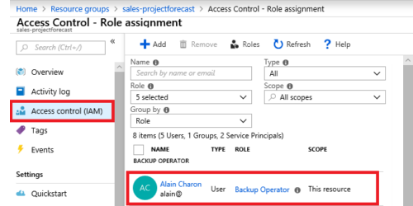

## Prevent accidental changes by using resource locks

A [resource lock](https://docs.microsoft.com/en-us/azure/azure-resource-manager/management/lock-resources) prevents resources from being accidentally deleted or changed. Even with Azure role-based access control (Azure RBAC) policies in place, there's still a risk that people with the right level of access could delete critical cloud resources. Think of a resource lock as a warning system that reminds you that a resource should not be deleted or changed.

### How do I manage resource locks?

You can manage resource locks from the Azure portal, PowerShell, the Azure CLI, or from an Azure Resource Manager template.

To view, add, or delete locks in the Azure portal, go to the **Settings** section of any resource's **Settings** pane in the Azure portal.

### What levels of locking are available?

You can apply locks to a subscription, a resource group, or an individual resource. You can set the lock level to **CanNotDelete** or **ReadOnly**.

* **CanNotDelete** means authorized people can still read and modify a resource, but they can't delete the resource without first removing the lock.
* **ReadOnly** means authorized people can read a resource, but they can't delete or change the resource. Applying this lock is like restricting all authorized users to the permissions granted by the **Reader** role in Azure RBAC.

### How do I delete or change a locked resource?

Locking helps prevent accidental changes, you can still make changes by following two-step process.

To modify a locked resource, you must first remove the lock. After you remove the lock, you can apply any action you have permissions to perform. This additional step allows the action to be taken, but it helps protect your administrators from doing something they might not have intended to do.

Resource locks apply regardless of RBAC permissions. Even if you're an owner of the resource, you must still remove the lock before you can perform the blocked activity.

### Combine resource locks with Azure Blueprints

What if a cloud administrator accidentally deletes a resource lock? If the resource lock is removed, its associated resources can be changed or deleted.

To make the protection process more robust, you can combine resource locks with Azure Blueprints. Azure Blueprints enables you to define the set of standard Azure resources that your organization requires. For example, you can define a blueprint that specifies that a certain resource lock must exist. Azure Blueprints can automatically replace the resource lock if that lock is removed.

## Exercise - Protect a storage account from accidental deletion by using a resource lock

In this exercise, you see how resource locks help prevent accidental deletion of your Azure resources.

To do so, you create a resource group from the Azure portal. Think of a resource group as a container for related Azure resources. Then you add a lock to your resource group and verify that you can't delete the resource group.

You then add a storage account to your resource group and see how the lock from the parent resource group prevents the storage account from being deleted. A storage account is a container that groups a set of Azure Storage services together.

**Important:** You need your own [**Azure subscription**](https://azure.microsoft.com/free/) to complete the exercises in this module. If you don't have an Azure subscription, you can still read along.

### Create the resource group

Here you create a resource group that's named **my-test-rg**.

1. Go to the [Azure portal](https://portal.azure.com/) and sign in.
2. At the top of the page, select **Resource groups**.
3. Select **+ New**. The **Create a resource group** page appears.
4. In the **Basics** tab, fill in the following fields.
5. Select **Review + create**, and then select **Create**.

### Add a lock to the resource group

Add a resource lock to the resource group. To do so:

1. From the Azure portal, select your resource group, **my-test-rg**.
2. Under **Settings**, select **Locks**, and then select **Add**.
3. Fill in these fields.
4. Select **OK**. You see that the resource lock is applied to your resource group.

### Verify that the resource group is protected from deletion

1. From the top of the page, select **my-test-rg** to go to your resource group's overview page.
2. Select **Delete resource group**.
3. At the prompt, enter **my-test-rg**, and then select **OK**. You see a message that tells you that

the resource group is locked and can't be deleted.

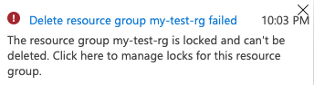

### Protect a storage account from accidental deletion

Here, you add a storage account to your resource group and see how the lock from the parent resource group prevents the storage account from being deleted. To do so:

1. From the Azure portal, at the top of the page, select **Home** to return to the start page.
2. Select **Storage accounts**. Then select **+ New**. The **Create storage account** page appears.
3. In the **Basics** tab, fill in the following fields.

**Note:** Replace **NNN** with a series of numbers. The numbers help to ensure that your storage account name is unique.

1. Select **Review + create**, and then select **Create**. The deployment might take a few moments to complete.
2. Select **Go to resource**.
3. At the top of the page, select **Delete**.  
   A screenshot of the Azure portal showing the location of the Delete button.  
   You see a message that tells you the resource or its parent is locked and can't be deleted. Here's an example that shows the error message for a storage account that's named **mysa1234**.  
   A screenshot of the Azure portal showing the error message. The error message states that the storage account can't be deleted because the resource or its parent resource group is locked.

Although you didn't create a lock specifically for the storage account, the lock you created for the parent resource group prevents you from deleting the resource. In other words, the storage account inherits the lock from the parent resource group.

### Delete the resource group and the storage account

You no longer need your resource group or storage account. Here you remove both. When you delete a resource group, you also delete its child resources, such as the storage account you previously created. To delete the resource group, you first need to remove the resource lock.

1. From the Azure portal, select **Home** > **Resource groups** > **my-test-rg** to go to your resource group.
2. Under **Settings**, select **Locks**.
3. Locate **rg-delete-lock**, and select **Delete** on that same row.
4. Select **Overview**, and then select **Delete resource group**.
5. At the prompt, enter **my-test-rg**, and then select **OK**. The deletion operation might take a few moments to complete.
6. When the operation completes, select **Home** > **Resource groups**. You see that the **my-test-rg** resource group no longer exists in your account. Your storage account is also deleted.

## Organize your Azure resources by using tags

As your cloud usage grows, it's increasingly important to stay organized. A good organization strategy helps you understand your cloud usage and can help you manage costs.

For example, as Tailwind Traders prototypes new ways to deploy its applications on Azure, it needs a way to mark its test environments so that it can easily identify and delete resources in these environments when they're no longer needed.

One way to organize related resources is to place them in their own subscriptions. You can also use resource groups to manage related resources. Resource tags are another way to organize resources. Tags provide extra information, or metadata, about your resources. This metadata is useful for:

* **Resource management** Tags enable you to locate and act on resources that are associated with specific workloads, environments, business units, and owners.
* **Cost management and optimization** Tags enable you to group resources so that you can report on costs, allocate internal cost centers, track budgets, & forecast estimated cost.
* **Operations management** Tags enable you to group resources according to how critical their availability is to your business. This grouping helps you formulate service-level agreements. An SLA is an uptime or performance guarantee between you and your users.
* **Security** Tags enable you to classify data by its security level, such as public or confidential.
* **Governance and regulatory compliance** Tags enable you to identify resources that align with governance or regulatory compliance requirements, such as ISO 27001. Tags can also be part of your standards enforcement efforts. For example, you might require that all resources be tagged with an owner or department name.
* **Workload optimization and automation** Tags can help you visualize all of the resources that participate in complex deployments. For example, you might tag a resource with its associated workload or application name and use software such as Azure DevOps to perform automated tasks on those resources.

### How do I manage resource tags?

You can add, modify, or delete resource tags through PowerShell, the Azure CLI, Azure Resource Manager templates, the REST API, or the Azure portal.

You can also manage tags by using Azure Policy. Ex. you can apply tags to a resource group, but those tags aren't automatically applied to the resources within that resource group. You can use Azure Policy to ensure that a resource inherits the same tags as its parent resource group. You can also use Azure Policy to enforce tagging rules and conventions. Ex. you can require that certain tags be added to new resources as they're provisioned. You can also define rules that reapply tags that have been removed.

### An example tagging structure

A resource tag consists of a name and a value. You can assign one or more tags to each Azure resource. After reviewing its business requirements, Tailwind Traders decides on the following tags.

* **AppName:** The name of the application that the resource is part of.
* **CostCenter:** The internal cost center code.
* **Owner:** The name of the business owner who's responsible for the resource.
* **Environment:** An environment name, such as "Prod," "Dev," or "Test."
* **Impact:** How important the resource is to business operations, such as "Mission-critical," "High-impact," or "Low-impact."

Here's an example that shows these tags as they're applied to a virtual machine during provisioning.

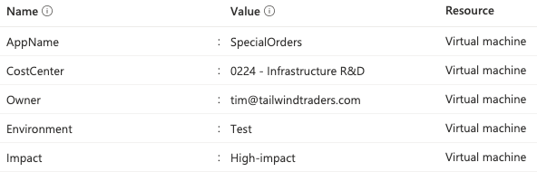

The Tailwind Traders team can run queries, for example, from PowerShell or the Azure CLI, to list all resources that contain these tags.

Keep in mind that you don't need to enforce that a specific tag is present on all of your resources. For example, you might decide that only mission-critical resources have the **Impact** tag. All non-tagged resources would then not be considered as mission-critical.

## Control and audit your resources by using Azure Policy

In a previous exercise in this module, you identified your governance and business requirements. How do you ensure that your resources stay compliant? Can you be alerted if a resource's configuration has changed?

[Azure Policy](https://azure.microsoft.com/services/azure-policy) is a service in Azure that enables you to create, assign, and manage policies that control or audit your resources. These policies enforce different rules across all of your resource configurations so that those configurations stay compliant with corporate standards.

### How does Azure Policy define policies?

Azure Policy enables you to define both individual policies and groups of related policies, known as initiatives. AP evaluates your resources and highlights resources that aren't compliant with the policies you've created. Azure Policy can also prevent noncompliant resources from being created.

Azure Policy comes with built-in policy and initiative definitions for Storage, Networking, Compute, Security Center, and Monitoring. Ex. if you define a policy that allows only a certain SKU (stock-keeping unit) size for VMs to be used in your env, that policy is invoked when you create a new VM and whenever you resize existing VMs. AP also evaluates and monitors all current VMs in your env.

In some cases, Azure Policy can automatically remediate noncompliant resources and configurations to ensure the integrity of the state of the resources. For example, if all resources in a certain resource group should be tagged with **AppName** tag and a value of "SpecialOrders," Azure Policy will automatically reapply that tag if it was missing.

Azure Policy also integrates with Azure DevOps by applying any continuous integration and delivery pipeline policies that pertain to the pre-deployment and post-deployment phases of your apps.

### Azure Policy in action

Implementing a policy in Azure Policy involves three tasks:

1. Create a policy definition.
2. Assign the definition to resources.
3. Review the evaluation results.

#### Task 1. Create a policy definition

A policy definition expresses what to evaluate and what action to take. For example, you could prevent VMs from being deployed in certain Azure regions. You also could audit your storage accounts to verify that they only accept connections from allowed networks.

Every policy definition has conditions under which it's enforced. Policy definition has accompanying effect that takes place when the conditions are met. Here are some example policy definitions:

* **Allowed virtual machine SKUs** This policy enables you to specify a set of VM SKUs that your organization can deploy.
* **Allowed locations** This policy enables you to restrict the locations that your organization can specify when it deploys resources. Its effect is used to enforce your geographic compliance requirements.
* **MFA should be enabled on accounts with write permissions on your subscription** This policy requires that multifactor authentication (MFA) be enabled for all subscription accounts with write privileges to prevent a breach of accounts or resources.
* **CORS should not allow every resource to access your web apps** Cross-origin resource sharing is HTTP feature that enables web application running under one domain to access resources in another. For security reasons, modern web browsers restrict cross-site scripting by default. This policy allows only required domains to interact with your web app.
* **System updates should be installed on your machines** This policy enables Azure Security Center to recommend missing security system updates on your servers.

#### Task 2. Assign the definition to resources

To implement your policy definitions, you assign definitions to resources. A policy assignment is a policy definition that takes place within a specific scope. This scope could be a management group (a collection of multiple subscriptions), a single subscription, or a resource group.

Policy assignments are inherited by all child resources within that scope. If a policy is applied to rg, that policy is applied to all resources within that rg. You can exclude subscope from policy assignment if there are specific child resources you need to be exempt from the policy assignment.

#### Task 3. Review the evaluation results

When a condition is evaluated against your existing resources, each resource is marked as compliant or noncompliant. You can review the noncompliant policy results and take any action that's needed.

Policy evaluation happens about once per hour. If you make changes to your policy definition and create a policy assignment, that policy is evaluated over your resources within the hour.

## What are Azure Policy initiatives?

An Azure Policy initiative is a way of grouping related policies together. The initiative definition contains all of the policy definitions to help track your compliance state for a larger goal. Ex. Azure Policy includes an initiative named **Enable Monitoring in Azure Security Center**. Its goal is to monitor all of the available security recommendations for all Azure resource types in Azure Security Center. Under this initiative, the following policy definitions are included:

* **Monitor unencrypted SQL Database in Security Center** This policy monitors for unencrypted SQL databases and servers.
* **Monitor OS vulnerabilities in Security Center** This policy monitors servers that don't satisfy the configured OS vulnerability baseline.
* **Monitor missing Endpoint Protection in Security Center** This policy monitors for servers that don't have an installed endpoint protection agent.

In fact, the **Enable Monitoring in Azure Security Center** initiative contains over 100 separate policy definitions.

Azure Policy also includes initiatives that support regulatory compliance standards, such as HIPAA and ISO 27001.

### How do I define an initiative?

You define initiatives by using the Azure portal or command-line tools. From the Azure portal, you can search the list of built-in initiatives that are built into Azure. You also can create your own custom policy definition. The image shows a few ex Azure Policy initiatives in the Azure portal.

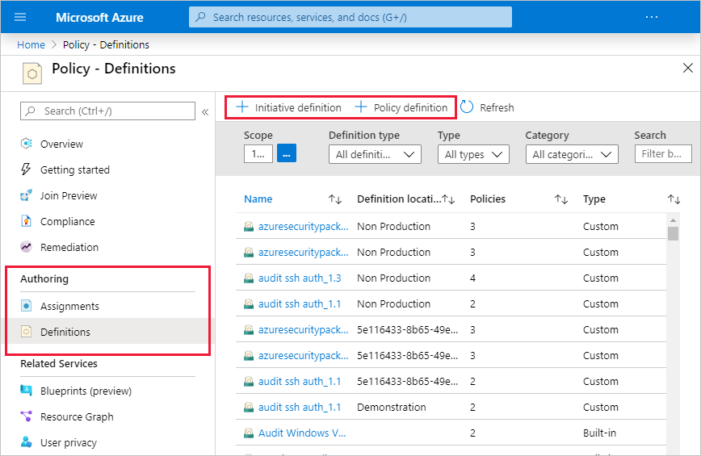

### How do I assign an initiative?

Like a policy assignment, an initiative assignment is an initiative definition that's assigned to a specific scope of a management group, a subscription, or a resource group.

Even if you have only a single policy, an initiative enables you to increase the number of policies over time. Because the associated initiative remains assigned, it's easier to add and remove policies without the need to change the policy assignment for your resources.

## Exercise - Restrict deployments to a specific location by using Azure Policy

In this exercise, you create a policy in Azure Policy that restricts the deployment of Azure resources to a specific location. You verify the policy by attempting to create a storage account in a location that violates the policy.

Tailwind wants to limit the location where resources can be deployed to **East US** region. Reasons:

* **Improved cost tracking** To track costs, Tailwind Traders uses different subscriptions to track deployments to each of its regional locations. The policy will ensure that all resources are deployed to the **East US** region.
* **Adhere to data residency and security compliance** Tailwind Traders must adhere to a compliance rule that states where customer data can be stored. Here, customer data must be stored in the **East US** region.

Recall that you can assign a policy to a management group, a single subscription, or a resource group. Here, you assign the policy to a resource group so that policy doesn't affect any other resources in your Azure subscription.

**Important:** You need your own [**Azure subscription**](https://azure.microsoft.com/free/) to complete the exercises in this module. If you don't have an Azure subscription, you can still read along.

### Explore predefined policies

Before you configure your location policy, let's take a brief look at some predefined policies. As an example, you'll look at policies that relate to Azure Compute services.

1. From the Azure portal, at the top of the page, select **Home** to return to the start page.
2. At the top of the page, enter **policy** in the search bar. Then, select **Policy** from the list of results to access Azure Policy.
3. Under **Authoring**, select **Definitions**.
4. From the **Category** dropdown list, select only **Compute**. Notice that the **Allowed virtual machine SKUs** definition enables you to specify a set of virtual machine SKUs that your organization can deploy.

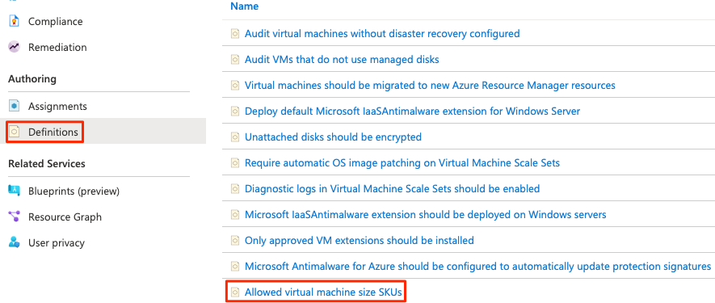

As an optional step, explore any other policies or categories that interest you.

### Configure the location policy

Here you configure the allowed location policy by using Azure Policy. Then you assign that policy to your resource group. To do so:

1. From the **Policy** pane, under **Authoring**, select **Assignments**.  
   An assignment is a policy that has been assigned to take place within a specific scope. For example, a definition could be assigned to the subscription scope.
2. Select **Assign Policy**.
3. Under **Scope**, select the ellipsis.  
   From the dialog box that appears, set:
   1. **Subscription** field to your Azure subscription.
   2. **Resource Group** field to **my-test-rg**.
   3. Select **Select**.
4. Under **Policy definition**, select the ellipsis.
   1. In the search bar, enter location.
   2. Select the **Allowed locations** definition.
   3. Select **Select**.

This policy definition specifies the location into which all resources must be deployed. If a different location is chosen, deployment will fail.

1. Select **Next** to move to the **Parameters** tab.
2. From the **Allowed locations** dropdown list, select **East US**.
3. Select **Review + create**, and then select **Create**.  
   You see that the **Allowed locations** policy assignment is now listed on the **Policy | Assignments** pane. It enforces the policy on the **my-test-rg** resource group.

### Verify the location policy

Here you attempt to add a storage account to your rg at a location that violates your location policy.

1. From the Azure portal, at the top of the page, select **Home** to return to the start page.
2. Select **Create a resource**.
3. Enter **storage account** in the search box, and press Enter.
4. If you're taken to a search results pane, select **Storage account** from the results.
5. Select **Create**. Then, enter the following values for each setting.

**Note:** Replace **NNN** with a series of numbers. Numbers help to ensure that your storage account name is unique.

### Delete the policy assignment

1. From the Azure portal, select **Home** > **Policy**.
2. Under **Authoring**, select **Assignments**.
3. On the **Allowed locations** row, select the ellipsis. Then, select **Delete assignment**. When prompted, select **Yes**.

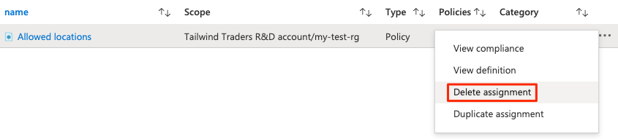

### Delete the resource group

You no longer need your resource group. Here you remove it from your subscription.

1. From the Azure portal, select **Home** > **Resource groups** > **my-test-rg** to go to your resource group.
2. Select **Overview**, and then select **Delete resource group**.
3. At the prompt, enter **my-test-rg**, and then select **OK**. The deletion operation might take a few moments to complete.
4. After the operation completes, select **Home** > **Resource groups**. You see that the **my-test-rg** resource group no longer exists in your account.

## Govern multiple subscriptions by using Azure Blueprints

What happens when your cloud env starts to grow beyond one subscription? How can you scale con-figuration of features, knowing they need to be enforced for resources in new subscriptions? Instead of having to configure features ex Azure Policy for each subscription, with [Azure Blueprints](https://azure.microsoft.com/services/blueprints) you can define repeatable set of governance tools and standard Azure resources that org requires. Development teams can rapidly build and deploy new envs with knowledge, they're building within org compliance with set of built-in components that speed development and deployment phases.

Azure Blueprints orchestrates the deployment of various resource templates and other artifacts, such as:

* Role assignments
* Policy assignments
* Azure Resource Manager templates
* Resource groups

### Azure Blueprints in action

When you form a cloud center of excellence team or a cloud custodian team, that team can use Azure Blueprints to scale their governance practices throughout the organization. Implementing a blueprint in Azure Blueprints involves these three steps:

1. Create an Azure blueprint.
2. Assign the blueprint.
3. Track the blueprint assignments.

With Azure Blueprints, the relationship between the blueprint definition (what should be deployed) and the blueprint assignment (what was deployed) is preserved. In other words, Azure creates a record that associates a resource with the blueprint that defines it. This connection helps you track and audit your deployments. Blueprints are also versioned. Versioning enables you to track and comment on changes to your blueprint.

### What are blueprint artifacts?

Each component in the blueprint definition is known as an artifact. It is possible for artifacts to have no additional parameters (configurations). An example is the **Deploy threat detection on SQL servers** policy, which requires no additional configuration.

Artifacts can also contain one or more parameters that you can configure. The following screenshot shows the **Allowed locations** policy. This policy includes a parameter that specifies the allowed locations.

You can specify a parameter's value when you create the blueprint definition or when you assign the blueprint definition to a scope. In this way, you can maintain one standard blueprint but have the flexibility to specify the relevant configuration parameters at each scope where the definition is assigned.

### How will Tailwind Traders use Azure Blueprints for ISO 27001 compliance?

[ISO 27001](https://www.iso.org/isoiec-27001-information-security.html) is a standard that applies to the security of IT systems, published by the International Organization for Standardization. As part of its quality process, Tailwind wants to certify that it complies with this standard. Azure Blueprints has several built-in blueprint definitions that relate to ISO 27001.

As an IT administrator, you decide to investigate the **ISO 27001: Shared Services Blueprint** definition. Here's an outline of your plan.

1. Define a management group that's named **PROD-MG**. Recall that a management group manages access, policies, and compliance across multiple Azure subscriptions. Every new Azure subscription is added to this management group when the subscription is created.
2. Create a blueprint definition that's based on the **ISO 27001: Shared Services Blueprint** template. Then publish the blueprint.
3. Assign the blueprint to your **PROD-MG** management group.

The following image shows artifacts that are created when you run an ISO 27001 blueprint from a template.

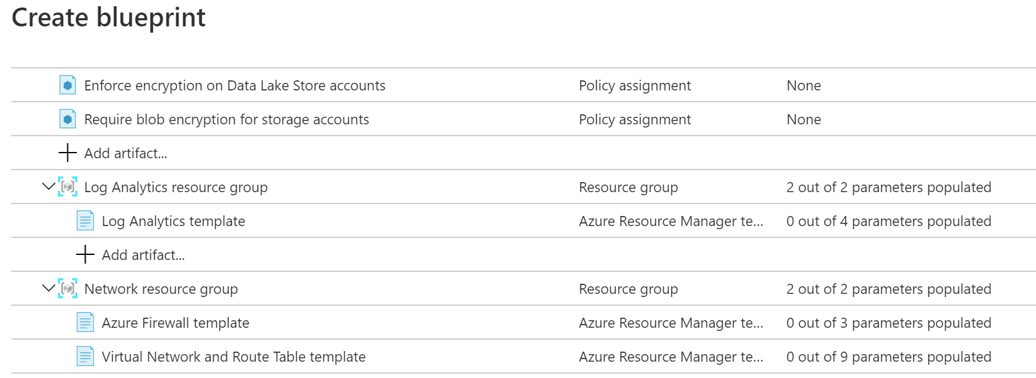

You see that the blueprint template contains policy assignments, Resource Manager templates, and resource groups. The blueprint deploys these artifacts to any existing subscriptions within the **PROD-MG** management group. The blueprint also deploys these artifacts to any new subscriptions as they're created and added to the management group.

## Accelerate your cloud adoption journey by using the Cloud Adoption Framework for Azure

The [Cloud Adoption Framework for Azure](https://docs.microsoft.com/en-us/azure/cloud-adoption-framework/) provides you with proven guidance to help with your cloud adoption journey. The Cloud Adoption Framework helps you create and implement the business and technology strategies needed to succeed in the cloud.

### What's in the Cloud Adoption Framework?

As mentioned in the video, Cloud Adoption Framework consists of tools, documentation, and proven practices. The Cloud Adoption Framework includes these stages:

1. Define your strategy.
2. Make a plan.
3. Ready your organization.
4. Adopt the cloud.
5. Govern and manage your cloud environments.

The govern stage focuses on cloud governance. You can refer back to the Cloud Adoption Framework for recommended guidance as you build your cloud governance strategy. To help build your adoption strategy, the Cloud Adoption Framework breaks out each stage into further exercises and steps. Let's take a brief look at each stage.

### Define your strategy

Here, you answer why you're moving to the cloud and what you want to get out of cloud migration. Do you need to scale to meet demand or reach new markets? Will it reduce costs or increase business agility? When you define your cloud business strategy, you should understand [cloud economics](https://azure.microsoft.com/overview/cloud-economics) and consider business impact, turnaround time, global reach, performance, and more. Here are the steps in this stage:

* **Define and document your motivations**: Meeting with stakeholders and leadership can help you answer why you're moving to the cloud.
* **Document business outcomes**: Meet with leadership from your finance, marketing, sales, and human resource groups to help you document your goals.
* **Evaluate financial considerations**: Measure objectives and identify the return expected from a specific investment.
* **Understand technical considerations**: Evaluate those technical considerations through the selection and completion of your first technical project.

### Make a plan

Here, you build a plan that maps your aspirational goals to specific actions. A good plan helps ensure that your efforts map to the desired business outcomes. Here are the steps in this stage:

* **Digital estate**: Create an inventory of the existing digital assets and workloads that you plan to migrate to the cloud.
* **Initial organizational alignment**: Ensure that the right people are involved in your migration efforts, both from a technical standpoint as well as from a cloud governance standpoint.
* **Skills readiness plan**: Build a plan that helps individuals build the skills they need to operate in the cloud.
* **Cloud adoption plan**: Build a comprehensive plan that brings together the development, operations, and business teams toward a shared cloud adoption goal.

### Ready your organization

Here, you create a landing zone, or an environment in the cloud to begin hosting your workloads. Here are the steps in this stage:

* **Azure setup guide**: Review the Azure setup guide to become familiar with the tools and approaches you need to use to create a landing zone.
* **Azure landing zone**: Begin to build out the Azure subscriptions that support each of the major areas of your business. A landing zone includes cloud infrastructure as well as governance, accounting, and security capabilities.
* **Expand the landing zone**: Refine your landing zone to ensure that it meets your operations, governance, and security needs.
* **Best practices**: Start with recommended and proven practices to help ensure that your cloud migration efforts are scalable and maintainable.

### Adopt the cloud

Here, you begin to migrate your applications to the cloud. Along the way, you might find ways to modernize your applications and build innovative solutions that use cloud services. The Cloud Adoption Framework breaks this stage into two parts: migrate and innovate.

**Migrate**: Here are the steps in the migrate part of this stage.

* **Migrate your first workload**: Use the Azure migration guide to deploy your first project to the cloud.
* **Migration scenarios**: Use additional in-depth guides to explore more complex migration scenarios.
* **Best practices**: Check in with the Azure cloud migration best practices checklist to verify that you're following recommended practices.
* **Process improvements**: Identify ways to make the migration process scale while requiring less effort.

**Innovate**: Here are the steps in the innovate part of this stage.

* **Business value consensus**: Verify that investments in new innovations add value to the business and meet customer needs.
* **Azure innovation guide**: Use this guide to accelerate development and build a minimum viable product (MVP) for your idea.
* **Best practices**: Verify that your progress maps to recommended practices before you move forward.
* **Feedback loops**: Check in frequently with your customers to verify that you're building what they need.

### Govern and manage your cloud environments

Here, you begin to form your cloud governance and cloud management strategies. As the cloud estate changes over time, so do cloud governance processes and policies. You need to create resilient solutions that are constantly optimized.

**Govern**: Here are the steps in the govern part of this stage.

* **Methodology**: Consider your end state solution. Then define a methodology that incrementally takes you from your first steps all the way to full cloud governance.
* **Benchmark**: Use the [governance benchmark tool](https://cafbaseline.com/) to assess your current state and future state to establish a vision for applying the framework.
* **Initial governance foundation**: Create an MVP that captures the first steps of your governance plan.
* **Improve the initial governance foundation**: Iteratively add governance controls that address tangible risks as you progress toward your end state solution.

**Manage**: Here are the steps in the manage part of this stage.

* **Establish a management baseline**: Define your minimum commitment to operations management. A management baseline is the minimum set of tools and processes that should be applied to every asset in an environment.
* **Define business commitments**: Document supported workloads to establish operational commitments with the business and agree on cloud management investments for each workload.
* **Expand the management baseline**: Apply recommended best practices to iterate on your initial management baseline.
* **Advanced operations and design principles**: For workloads that require a higher level of business commitment, perform a deeper architecture review to deliver on your resiliency and reliability commitments.

## Create a subscription governance strategy

At the beginning of any cloud governance implementation, you identify a cloud organization structure that meets your business needs. This step often involves forming a cloud center of excellence team (also called a cloud enablement team or a cloud custodian team). This team is empowered to implement governance practices from a centralized location for the entire organization.

Teams often start their Azure governance strategy at the subscription level. There are three main aspects to consider when you create and manage subscriptions: billing, access control, and subscription limits.

### Billing

You can create one billing report per subscription. If you have multiple departments and need to do a "chargeback" of cloud costs, one possible solution is to organize subscriptions by department or by project.

Resource tags can also help. You'll explore tags later in this module. When you define how many subscriptions you need and what to name them, take into account your internal billing requirements.

### Access control

A subscription is a deployment boundary for Azure resources. Every subscription is associated with an Azure Active Directory tenant. Each tenant provides administrators the ability to set granular access through defined roles by using Azure role-based access control.

When you design your subscription architecture, consider the deployment boundary factor. For example, do you need separate subscriptions for development and for production environments? With separate subscriptions, you can control access to each one separately and isolate their resources from one another.

### Subscription limits

Subscriptions also have some resource limitations. For example, the maximum number of network Azure ExpressRoute circuits per subscription is 10. Those limits should be considered during your design phase. If you'll need to exceed those limits, you might need to add more subscriptions. If you hit a hard limit maximum, there's no flexibility to increase it.

Management groups are also available to assist with managing subscriptions. A management group manages access, policies, and compliance across multiple Azure subscriptions. You'll learn more about management groups later in this module.

### Summary

Cloud governance requires good analysis and requirement gathering. Luckily, the Cloud Adoption Framework for Azure can help you define and implement your governance strategy. There are several services and features in Azure to support these efforts:

* Azure role-based access control enables you to create roles that define access permissions.
* Resource locks prevent resources from being accidentally deleted or changed.
* Resource tags provide extra information, or metadata, about your resources.
* Azure Policy is a service in Azure that enables you to create, assign, and manage policies that control or audit your resources.
* Azure Blueprints enables you to define a repeatable set of governance tools and standard Azure resources that your organization requires.

## Examine privacy, compliance, and data protection standards on Azure

In general, compliance means to adhere to a law, standard, or set of guidelines. Regulatory compliance refers to the discipline and process of ensuring that a company follows the laws that governing bodies enforce.

### How will Tailwind Traders protect its data in the cloud and stay compliant?

Tailwind knows that moving an application to the cloud means that data is now outside of its own walls. The company understands that cloud provider has access to the server HW & infrastructure.

Tailwind Traders must also adhere to multiple regulatory and compliance frameworks. For example, it must follow certain rules to ensure that it properly handles credit card data. It will still need to ensure that its applications comply with applicable regulations and standards.

### Explore compliance terms and requirements

As Tailwind Traders moves to running its applications in the cloud, it wants to know how Azure adheres to applicable regulatory compliance frameworks. The company asks:

* How compliant is Azure when it comes to handling personal data?
* How compliant are each of Azure's individual services?

Microsoft's online services build upon a common set of regulatory and compliance controls. Think of a control as a known good standard that you can compare your solution against to ensure security. These controls address today's regulations and adapt as regulations evolve.

### Which compliance categories are available on Azure?

Although there are many more, the following image shows some of the more popular compliance offerings that are available on Azure. These offerings are grouped under four categories: Global, US Government, Industry, and Regional.

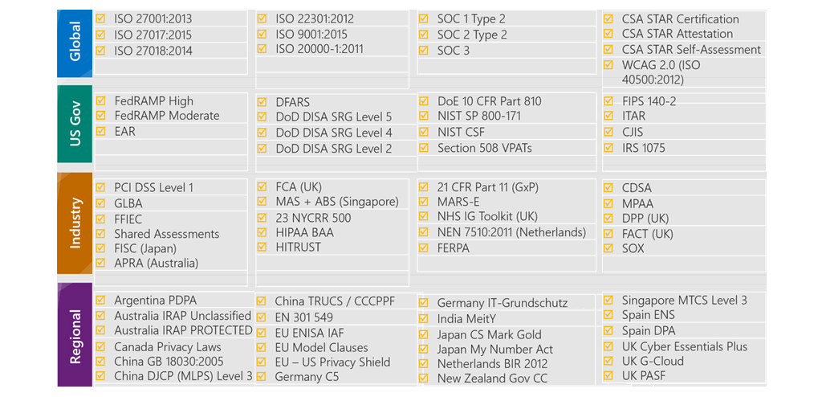

To get a sense of the variety of the compliance offerings available on Azure, let's take a closer look at a few of them.

While not all of these compliance offerings will be relevant to you or your team, they show that MS's commitment to compliance is comprehensive, ongoing, and independently tested and verified.

### Criminal Justice Information Service

Any US state or local agency that wants to access the FBI's Criminal Justice Information Services (CJIS) database is required to adhere to the CJIS Security Policy. Azure is the only major cloud provider that contractually commits to conformance with the CJIS Security Policy. Microsoft adheres to the same requirements that law enforcement and public safety entities must meet.

### Cloud Security Alliance STAR Certification

Azure, Intune, and MS Power BI have obtained Cloud Security Alliance (CSA) STAR Certification, which involves a rigorous independent third-party assessment of a cloud provider's security posture.

STAR Certification is based on achieving International Organization of Standards/International Electrotechnical Commission (ISO/IEC) 27001 certification and meeting criteria specified in the Cloud Controls Matrix (CCM). This certification demonstrates that a cloud service provider:

* Conforms to the applicable requirements of ISO/IEC 27001.
* Has addressed issues critical to cloud security as outlined in the CCM.
* Has been assessed against the STAR Capability Maturity Model for the management of activities in CCM control areas.

### European Union Model Clauses

Microsoft offers customers European Union (EU) Standard Contractual Clauses that provide contractual guarantees around transfers of personal data outside of the EU.

Microsoft is the first company to receive joint approval from the EU's Article 29 Working Party that the contractual privacy protections Azure delivers to its enterprise cloud customers meet current EU standards for international transfers of data. Meeting this standard ensures that Azure customers can use Microsoft services to move data freely through Microsoft's cloud, from Europe to the rest of the world.

### Health Insurance Portability and Accountability Act

The Health Insurance Portability and Accountability Act (HIPAA) is a US federal law that regulates patient Protected Health Information (PHI).

Azure offers customers a HIPAA Business Associate Agreement (BAA), which stipulates adherence to certain security and privacy provisions in HIPAA and the HITECH Act. To assist customers in their individual compliance efforts, Microsoft offers a BAA to Azure customers as a contract addendum.

### International Organization of Standards/International Electrotechnical Commission 27018

Microsoft is the first cloud provider to have adopted the ISO/IEC 27018 code of practice, which covers the processing of personal information by cloud service providers.

### Multi-Tier Cloud Security Singapore

After rigorous assessments conducted by the Multi-Tier Cloud Security (MTCS) Certification Body, Microsoft cloud services received MTCS 584:2013 Certification across all three service classifications: Infrastructure as a service (IaaS), Platform as a service (PaaS) and Software as a service (SaaS). MS is the first global cloud solution provider to receive this certification across all 3 classifications.

### Service Organization Controls 1, 2, and 3

Microsoft-covered cloud services are audited at least annually against the Service Organization Controls (SOC) report framework by independent third-party auditors.

The Microsoft cloud services audit covers controls for data security, availability, processing integrity, and confidentiality as applicable to in-scope trust principles for each service.

### National Institute of Standards and Technology Cybersecurity Framework

National Institute of Standards and Technology Cybersecurity Framework is voluntary framework that consists of standards, guidelines, and best practices to manage cybersecurity-related risks.

Microsoft cloud services have undergone independent, third-party Federal Risk and Authorization Management Program (FedRAMP) Moderate and High Baseline audits. Microsoft cloud services certified according to the FedRAMP standards.

Additionally, through a validated assessment performed by the Health Information Trust Alliance (HITRUST), a leading security and privacy standards development and accreditation organization, Office 365 is certified to the objectives specified in the NIST CSF.

### United Kingdom Government G-Cloud

The United Kingdom (UK) Government G-Cloud is a cloud computing certification for services used by government entities in the United Kingdom. Azure has received official accreditation from the UK government.

## Access the Microsoft Privacy Statement, the Online Services Terms, and the Data Protection Addendum

In this part, you learn how the Microsoft Privacy Statement, the Online Services Terms, and the Data Protection Addendum explain the personal data Microsoft collects, how Microsoft uses it, and for what purposes. For Tailwind Traders, understanding Microsoft's commitment to privacy helps ensure that their customer and application data will be protected.

### What's in the Microsoft Privacy Statement?

The [Microsoft Privacy Statement](https://privacy.microsoft.com/privacystatement) explains what personal data Microsoft collects, how Microsoft uses it, and for what purposes. The privacy statement covers all of Microsoft's services, websites, apps, software, servers, and devices. This list ranges from enterprise and server products to devices that you use in your home to software that students use at school.

MS's privacy statement also provides inf that's relevant to specific products such as WS and Xbox.

### What's in the Online Services Terms?

The [Online Services Terms](https://www.microsoft.com/licensing/terms/product/ForallOnlineServices) (OST) is a legal agreement between Microsoft and the customer. The OST details the obligations by both parties with respect to the processing and security of customer data and personal data. The OST applies specifically to Microsoft's online services that you license through a subscription, including Azure, Dynamics 365, Office 365, and Bing Maps.

### What is the Data Protection Addendum?

The Data Protection Addendum (DPA) further defines the data processing and security terms for online services. These terms include:

* Compliance with laws.
* Disclosure of processed data.
* Data Security, which includes security practices and policies, data encryption, data access, customer responsibilities, and compliance with auditing.
* Data transfer, retention, and deletion.

To access the DPA:

1. Go to the [Licensing Terms and Documentation](https://www.microsoftvolumelicensing.com/DocumentSearch.aspx).
2. In the search bar, enter **DPA**.
3. From the search results, locate the link to the DPA in your preferred language. Alternatively, in the search bar that appears, enter your preferred language to filter the results. Here's an example that retrieves the English version of the DPA.

Transparency is important when it comes to how a cloud provider communicates its privacy policies and how it treats your data. The Microsoft Privacy Statement, the OST, and the DPA detail Microsoft's commitment to protecting data and privacy in the cloud.

## Explore the Trust Center

Tailwind Traders needs to stay up to date on the latest security standards for protecting its data. Today, the security team needs to verify whether Azure meets ISO 27001, a commonly used information security standard. Where can the company access this information?

The [Trust Center](https://www.microsoft.com/trust-center?rtc=1%3Fazure-portal%3Dtrue) showcases Microsoft's principles for maintaining data integrity in the cloud and how Microsoft implements and supports security, privacy, compliance, and transparency in all Microsoft cloud products and services. The Trust Center is an important part of the Microsoft Trusted Cloud Initiative and provides support and resources for the legal and compliance community.

The Trust Center provides:

* In-depth information about security, privacy, compliance offerings, policies, features, and practices across Microsoft cloud products.
* Additional resources for each topic.
* Links to the security, privacy, and compliance blogs and upcoming events.

The Trust Center is a great resource for other people in your organization who might play a role in security, privacy, and compliance. These people include business managers, risk assessment and privacy officers, and legal compliance teams.

### Explore the Trust Center

As an optional exercise, let's take a brief look at the Trust Center's entry for ISO 27001. Access to the Trust Center doesn't require an Azure subscription or a Microsoft account.

1. Go to the [Trust Center](https://www.microsoft.com/trust-center?rtc=1%3Fazure-portal%3Dtrue).
2. Locate the **Additional resources** section on the page. Under **Compliance offerings**, select **Learn more**.

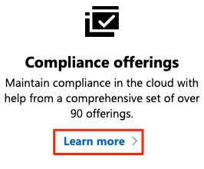

Under the Regulatory & industry compliance section, click **Microsoft compliance offerings**. You're taken to [Microsoft compliance offerings](https://docs.microsoft.com/en-us/microsoft-365/compliance/offering-home). The offerings are grouped into four categories: **Global**, **US Government**, **Industry**, and **Regional**.

1. Under **Global**, select **ISO 27001**.

The ISO 27001 Information Security Management Standards page is typical of the type of compliance information we provide.

1. Briefly review the documentation for ISO/IEC 27001.

You see:

* + An overview of the standard.
  + Which cloud services are in scope.
  + An overview of the audit cycle and links to audit reports.
  + Answers to frequently asked questions.
  + Additional resources and white papers.

The areas of documentation for other compliance offerings will vary, but this format is the typical one that you'll find.

## Access Azure compliance documentation

E-commerce is an important part of Tailwind Traders' sales strategy. Its [online retail store](https://www.tailwindtraders.com/) enables customers to easily browse and order products. Customers typically pay by credit card, so Tailwind Traders has a responsibility under the Payment Card Industry (PCI) Data Security Standard (DSS). This global standard, known as PCI DSS, seeks to prevent fraud through increased control of credit card data. The standard applies to any organization that stores, processes, or transmits payment and cardholder data.

You've been tasked with investigating whether hosting the company's e-commerce application on Azure would be compliant with PCI DSS. You start with the Azure compliance documentation.

### What is the Azure compliance documentation?

The [Azure compliance documentation](https://docs.microsoft.com/en-us/azure/compliance/) provides you with detailed documentation about legal and regulatory standards and compliance. Here you find compliance offerings across these categories: Global, US government, Financial services, Health, Media and manufacturing, Regional.

There are also additional compliance resources, such as audit reports, privacy information, compliance implementations and mappings, and white papers and analyst reports. Country and region privacy and compliance guidelines are also included. Some resources might require you to be signed in to your cloud service to access them.

### Examine PCI DSS compliance

The legal team at Tailwind Traders wants to learn more about how PCI DSS relates to the company's e-commerce application on Azure.

1. Go to the [Azure compliance documentation](https://docs.microsoft.com/en-us/azure/compliance/).
2. Under **Financial services**, select **PCI DSS**.
   * An overview of the PCI DSS standard.
   * How PCI DSS applies to Microsoft.
   * Which cloud services are in scope.
   * An overview of the audit cycle.
   * Answers to frequently asked questions.
   * Additional resources and white papers.

### Access additional compliance resources

From the [Azure compliance documentation](https://docs.microsoft.com/en-us/azure/compliance/), you can access additional compliance resources. Ex. from the **Audit reports** section, you find a link to audit reports for [PCI DSS](https://servicetrust.microsoft.com/ViewPage/MSComplianceGuideV3?docTab=7027ead0-3d6b-11e9-b9e1-290b1eb4cdeb_PCI_DSS%3Fazure-portal%3Dtrue). From there, you can access several different files, including the Attestation of Compliance reports and the PCI DSS Shared Responsibility Matrix.

Under **Compliance blueprints**, you find reference blueprints, or policy definitions, for common standards that you can apply to your Azure subscription. The [PCI DSS](https://docs.microsoft.com/en-us/azure/governance/blueprints/samples/pci-dss-3.2.1/) blueprint deploys a core set of policies that map to PCI DSS compliance and help you govern your Azure workloads against this standard.

You can then see if the Azure resources in your application architecture have been configured correctly for PCI DSS compliance, or which resources you need to remediate.

Because standards evolve, the Tailwind Traders team might check the audit report periodically to ensure that Azure has any recent changes.

## What is Azure Government?

[Azure Government](https://azure.microsoft.com/global-infrastructure/government) is a separate instance of the Microsoft Azure service. It addresses the security and compliance needs of US federal agencies, state and local governments, and their solution providers. Azure Government offers physical isolation from non-US government deployments and provides screened US personnel. Azure Government services handle data that is subject to certain government regulations and requirements:

* Federal Risk and Authorization Management Program (FedRAMP)
* National Institute of Standards and Technology (NIST) 800.171 Defense Industrial Base (DIB)
* International Traffic in Arms Regulations (ITAR)
* Internal Revenue Service (IRS) 1075
* Department of Defense (DoD) L4
* Criminal Justice Information Service (CJIS)

To provide the highest level of security and compliance, Azure Government uses physically isolated datacenters and networks located only in the US. Azure Government customers, such as the US federal, state, and local government or their partners, are subject to validation of eligibility.

Azure Government provides the broadest compliance and Level 5 DoD approval. Azure Government is [available in eight geographies](https://azure.microsoft.com/global-infrastructure/geographies/#geographies?azure-portal=true) and offers the most compliance certifications of any cloud provider.

## What is Azure China 21Vianet?

[Azure China 21Vianet](https://docs.microsoft.com/en-us/azure/china) is operated by 21Vianet. It's a physically separated instance of cloud services located in China. Azure China 21Vianet is independently operated and transacted by Shanghai Blue Cloud Technology Co., Ltd. ("21Vianet"), a wholly owned subsidiary of Beijing 21Vianet Broadband Data Center Co., Ltd.

According to the China Telecommunication Regulation, providers of cloud services, infrastructure as a service (IaaS) and platform as a service (PaaS), must have value-added telecom permits. Only locally registered companies with less than 50 percent foreign investment qualify for these permits. To comply with this regulation, the Azure service in China is operated by 21Vianet, based on the technologies licensed from Microsoft.

As the first foreign public cloud service provider offered in China in compliance with government regulations, Azure China 21Vianet provides world-class security as discussed on the Trust Center, as required by Chinese regulations for all systems and applications built on its architecture.

### Azure products and services available in China

The Azure services are based on the same Azure, Office 365, and Power BI technologies that make up the Microsoft global cloud service, with comparable service levels. Azure agreements and contracts in China, where applicable, are signed between customers and 21Vianet.

Azure includes the core components of IaaS, PaaS, and SaaS. These components include network, storage, data management, identity management, and many other services.

Azure China 21Vianet supports most of the same services that global Azure has, such as geosynchronous data replication and autoscaling. Even if you already use global Azure services, to operate in China you might need to rehost or refactor some or all your applications or services.

# Azure Fundamentals part 6: Describe Azure cost management and service level agreements

## Compare costs by using the Total Cost of Ownership Calculator

Before Tailwind takes its next steps toward migrating to the cloud, it wants to better understand what it spends today in its datacenter. Having a firm understanding of where the company is today will give it a greater sense of what cloud migration means in terms of cost.

### What's the TCO Calculator?

The [TCO Calculator](https://azure.microsoft.com/pricing/tco/calculator) helps you estimate the cost savings of operating your solution on Azure over time, instead of in your on-premises datacenter.

The term total cost of ownership is commonly used in finance. It can be hard to see all hidden costs related to operating a technology capability on-premises. SW licenses and HW are additional costs.

With the TCO Calculator, you enter the details of your on-premises workloads. Then you review the suggested industry average cost (which you can adjust) for related operational costs. These costs include electricity, network maintenance, and IT labor. You're then presented with a side-by-side report. Using the report, you can compare those costs with the same workloads running on Azure.

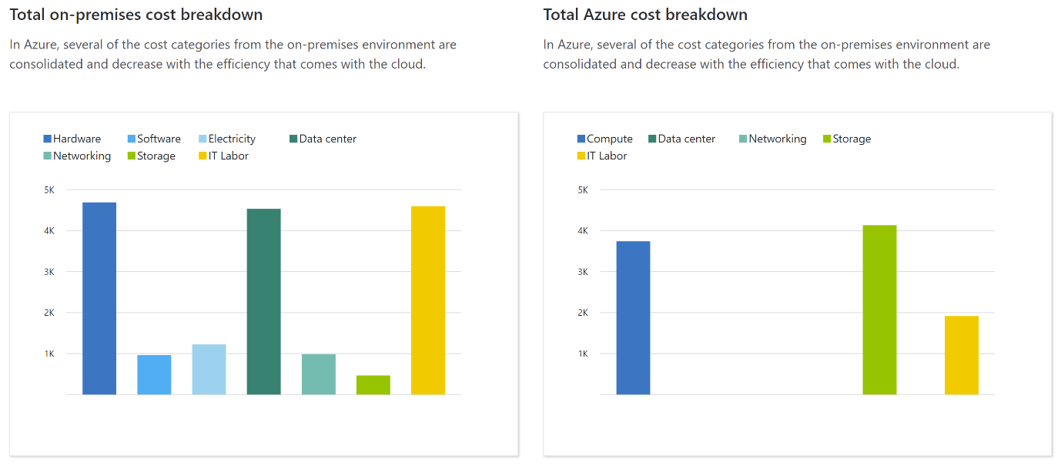

**Note:** You don't need an Azure subscription to work with the TCO Calculator.

### How does the TCO Calculator work?

Working with the TCO Calculator involves three steps: Define your workloads, Adjust assumptions and View the report.

#### Step 1: Define your workloads

First, you enter the specifications of your on-premises infrastructure into the TCO Calculator, based on these four categories:

* **Servers:** This category includes operating systems, virtualization methods, CPU cores, and memory (RAM).
* **Databases:** This category includes database types, server hardware, and the Azure service you want to use, which includes the expected maximum concurrent user sign-ins.
* **Storage:** includes storage type and capacity, which includes any backup or archive storage.
* **Networking:** This category includes the amount of network bandwidth you currently consume in your on-premises environment.

#### Step 2: Adjust assumptions

Next, you specify whether your current on-premises licenses are enrolled for [Software Assurance](https://www.microsoft.com/licensing/licensing-programs/software-assurance-default), which can save you money by reusing those licenses on Azure. You also specify whether you need to replicate your storage to another Azure region for greater redundancy.

Then, you can see the key operating cost assumptions across several different areas, which vary among teams and organizations. These costs have been certified by Nucleus Research, an independent research company. For example, these costs include:

* Electricity price per kilowatt hour (KWh).
* Hourly pay rate for IT administration.
* Network maintenance cost as a % of network hardware and software costs.

To improve the accuracy of the TCO Calculator results, you adjust the values so that they match the costs of your current on-premises infrastructure.

#### Step 3: View the report

Choose a time frame between one and five years. the TCO Calculator generates a report that's based on the information you've entered. Here's an example:



For each category (compute, datacenter, networking, storage, and IT labor), you can also view a side-by-side comparison of the cost breakdown of operating those workloads on-premises versus operating them on Azure. Here's an example:



You can download, share, or save this report to review later.

## Exercise - Compare sample workload costs by using the TCO Calculator

In this exercise, you use the Total Cost of Ownership (TCO) Calculator to compare the cost of running a sample workload in the datacenter versus on Azure.

Tailwind is interested in moving some of its on-premises workloads to cloud. But first, Chief wants to understand more about moving from fixed cost structure to ongoing monthly cost structure.

You've been tasked to investigate whether there are any potential cost savings in moving your European datacenter to the cloud over the next three years. You need to take into account all of the potentially hidden costs involved with operating on-premises and in the cloud.

Instead of manually collecting everything you think might be included, you use the TCO Calculator as a starting point. You adjust the provided cost assumptions to match Tailwind Traders' on-premises environment.

**Note:** Remember, you don't need an Azure subscription to work with the TCO Calculator.

Let's say that:

* Tailwind Traders runs two sets, or banks, of 50 virtual machines (VMs) in each bank.
* The first bank of VMs runs Windows Server under Hyper-V virtualization.
* The second bank of VMs runs Linux under VMware virtualization.
* There's also a storage area network (SAN) with 60 terabytes (TB) of disk storage.
* You consume an estimated 15 TB of outbound network bandwidth each month.
* There are also a number of databases involved, but for now, you'll omit those details.

Recall that the TCO Calculator involves three steps:



### Define your workloads

Enter the specifications of your on-premises infrastructure into the TCO Calculator.

1. Go to the [TCO Calculator](https://azure.microsoft.com/pricing/tco/calculator).
2. Under **Define your workloads**, select **Add server workload** to create a row for your bank of Windows Server VMs.
3. Under **Servers**, set the value for each of these settings:

| **Setting** | **Value** |
| --- | --- |
| Name | **Servers: Windows VMs** |
| Workload | **Windows/Linux Server** |
| Environment | **Virtual Machines** |
| Operating system | **Windows** |
| VMs | **50** |
| Virtualization | **Hyper-V** |
| Core(s) | **8** |
| RAM (GB) | **16** |
| Optimize by | **CPU** |
| Windows Server 2008/2008 R2 | **Off** |

1. Select **Add server workload** to create a second row for your bank of Linux VMs. Then specify these settings:

| **Setting** | **Value** |
| --- | --- |
| Name | **Servers: Linux VMs** |
| Workload | **Windows/Linux Server** |
| Environment | **Virtual Machines** |
| Operating system | **Linux** |
| VMs | **50** |
| Virtualization | **VMware** |
| Core(s) | **8** |
| RAM (GB) | **16** |
| Optimize by | **CPU** |

1. Under **Storage**, select **Add storage**. Then specify these settings:

|  |  |
| --- | --- |
| Name | **Server Storage** |
| Storage type | **Local Disk/SAN** |
| Disk type | **HDD** |
| Capacity | **60 TB** |
| Backup | **120 TB** |
| Archive | **0 TB** |

1. Under **Networking**, set **Outbound bandwidth** to **15 TB**.
2. Select **Next**.`

### Adjust assumptions

Here, you specify your currency. For brevity, you leave the remaining fields at their default values. In practice, you would adjust any cost assumptions and make any adjustments to match your current on-premises environment.

1. At the top of the page, select your currency. This example uses **US Dollar ($)**.
2. Select **Next**.

### View the report

Take a moment to review the generated report.

Remember, you've been tasked to investigate cost savings for your European datacenter over the next three years.

To make these adjustments:

* Set **Timeframe** to **3 Years**.
* Set **Region** to **North Europe**.

Scroll to the summary at the bottom. You see a comparison of running your workloads in the datacenter versus on Azure. The prices you see might differ, but here's an example of the cost savings you might expect.

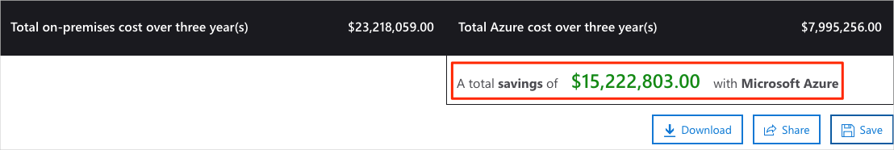

Select **Download** to download or print a copy of the report in PDF format.

Great work. You now have the information that you can share with your Chief Financial Officer. If you need to make adjustments, you can revisit the TCO Calculator to generate a fresh report.

## Purchase Azure services

You meet with your Chief Financial Officer and some of the team leads. You learn about some assumptions you've missed. You were able to quickly update your total estimated spend through the Total Cost of Ownership (TCO) Calculator.

During the meeting, some new questions arose as the discussion moves toward cloud migration:

* What types of Azure subscriptions are available?
* How do we purchase Azure services?
* Does location or network traffic affect cost?
* What other factors affect the final cost?
* How can we get a more detailed estimate of the cost to run on Azure?

It's important to learn how costs are generated in Azure so that you can understand how your purchasing and solution design decisions can impact your final cost. You agree to research these questions, so let's review each one in greater detail.

### What types of Azure subscriptions can I use?

You probably know that an Azure subscription provides you with access to Azure resources, such as VMs, storage, and databases. The types of resources you use impact your monthly bill. Azure offers both free and paid subscription options to fit your needs and requirements. They are:

* **Free trial:** A free trial subscription provides you with 12 months of popular free services, a credit to explore any Azure service for 30 days, and more than 25 services that are always free. Your Azure services are disabled when the trial ends or when your credit expires for paid products, unless you upgrade to a paid subscription.
* **Pay-as-you-go:** A pay-as-you-go subscription enables you to pay for what you use by attaching a credit or debit card to your account. Organizations can apply for volume discounts and prepaid invoicing.
* **Member offers:** Your existing membership to certain Microsoft products and services might provide you with credits for your Azure account and reduced rates on Azure services. For example, member offers are available to Visual Studio subscribers, Microsoft Partner Network members, Microsoft for Startups members, and Microsoft Imagine members.

### How do I purchase Azure services?

There are three main ways to purchase services on Azure. They are:

* **Through an Enterprise Agreement:** Larger customers, known as enterprise customers, can sign an Enterprise Agreement with Microsoft. This agreement commits them to spending a predetermined amount on Azure services over a period of three years. The service fee is typically paid annually. As an Enterprise Agreement customer, you'll receive the best customized pricing based on the kinds and amounts of services you plan on using.
* **Directly from the web:** Here, you purchase Azure services directly from the Azure portal website and pay standard prices. You're billed monthly, as a credit card payment or through an invoice. This purchasing method is known as Web Direct.
* **Through a Cloud Solution Provider:** A Cloud Solution Provider (CSP) is MS Partner who helps you build solutions on top of Azure. Your CSP bills you for your Azure usage at a price they determine. They answer your support questions and escalate them to MS, as needed.

You can bring up, or provision, Azure resources from the Azure portal or from the command line. The Azure portal arranges products and services by category. You select the services that fit your needs. Your account is billed according to Azure's "pay for what you use" model.

At the end of each month, you're billed for what you've used. At any time, you can check the cost management and billing page in the Azure portal to get a summary of your current usage and review invoices from prior months.

### What factors affect cost?

The way you use resources, your subscription type, and pricing from third-party vendors are common factors. Let's take a quick look at each.

#### Resource type

A number of factors influence the cost of Azure resources. They depend on the type of resource or how you customize it. Ex. with a storage account you specify a type (such as block blob storage or table storage), a performance tier (standard or premium), and an access tier (hot, cool, or archive). These selections present different costs.

#### Usage meters

When you provision a resource, Azure creates meters to track usage of that resource. Azure uses these meters to generate a usage record that's later used to help calculate your bill.

Think of usage meters similar to how you use electricity or water in your home. You might pay a base price each month for electricity or water service, but your final bill is based on the total amount that you consumed.

Let's look at single VM as an ex. The following kinds of meters are relevant to tracking its usage:

* Overall CPU time.
* Time spent with a public IP address.
* Incoming (ingress) and outgoing (egress) network traffic in and out of the VM.
* Disk size and amount of disk read and disk write operations.

Each meter tracks a specific type of usage. For example, a meter might track bandwidth usage (ingress or egress network traffic in bits per second), number of operations, or its size (storage capacity in bytes).

The usage that a meter tracks correlates to a quantity of billable units. Those units are charged to your account for each billing period. The rate per billable unit depends on the resource type you're using.

#### Resource usage

In Azure, you're always charged based on what you use. As an example, let's look at how this billing applies to deallocating a VM.

In Azure, you can delete or deallocate a VM. Deleting a VM means that you no longer need it. The VM is removed from your subscription, and then it's prepared for another customer.

Deallocating a VM means that the VM is no longer running. But the associated hard disks and data are still kept in Azure. The VM isn't assigned to a CPU or network in Azure's datacenter, so it doesn't generate the costs associated with compute time or the VM's IP address. Because the disks and data are still stored, and the resource is present in your Azure subscription, you're still billed for disk storage.

Deallocating a VM when you don't plan on using it for some time is just one way to minimize costs. For example, you might deallocate the VMs you use for testing purposes on weekends when your testing team isn't using them. You'll learn more about ways to minimize cost later in this module.

#### Azure subscription types

Some Azure subscription types also include usage allowances, which affect costs.

For example, an Azure free trial subscription provides access to a number of Azure products that are free for 12 months. It also includes credit to spend within your first 30 days of sign-up. And you get access to more than 25 products that are always free (based on resource and region availability).

#### Azure Marketplace

You can also purchase Azure-based solutions and services from third-party vendors through Azure Marketplace. Examples include managed network firewall appliances or connectors to third-party backup services. Billing structures are set by the vendor.

### Does location or network traffic affect cost?

When you provision a resource in Azure, you need to define the location (known as the Azure region) of where it will be deployed. Let's see why this decision can have cost consequences.

#### Location

Azure infrastructure is distributed globally, which enables you to deploy your services centrally or provision your services closest to where your customers use them.

Different regions can have different associated prices. Because geographic regions can impact where your network traffic flows, network traffic is a cost influence to consider as well.

Ex. say Tailwind decides to provision its Azure resources in the Azure regions that offer the lowest prices. That decision would save company some money. But, if they need to transfer data between those regions, or if their users are located in different parts of the world, any potential savings could be offset by the additional network usage costs of transferring data between those resources.

#### Zones for billing of network traffic

Billing zones are a factor in determining the cost of some Azure services.

[Bandwidth](https://azure.microsoft.com/pricing/details/bandwidth) refers to data moving in and out of Azure datacenters. Some inbound data transfers (data going into Azure datacenters) are free. For outbound data transfers (data leaving Azure datacenters), data transfer pricing is based on zones.

A zone is a geographical grouping of Azure regions for billing purposes. The following zones include some of the regions as shown here:

* **Zone 1**: Australia Central, West US, East US, Canada West, West Europe, France Central, and others
* **Zone 2**: Australia East, Japan West, Central India, Korea South, and others
* **Zone 3**: Brazil South, South Africa North, South Africa West, UAE Central, UAE North
* **DE Zone 1**: Germany Central, Germany Northeast

## How can I estimate the total cost?

As you've learned, an accurate cost estimate takes all of the preceding factors into account. Fortunately, the Azure Pricing calculator helps you with that process.

The Pricing calculator displays Azure products in categories. You add these categories to your estimate and configure according to your specific requirements. You then receive a consolidated estimated price, with a detailed breakdown of the costs associated with each resource you added to your solution. You can export or share that estimate or save it for later. You can load a saved estimate and modify it to match updated requirements. You also can access pricing details, product details, and documentation for each product from within the Pricing calculator.



The options you can configure in the Pricing calculator vary between products, but they can include:

* **Region:** A region is the geographical location in which you can provision a service. Southeast Asia, Central Canada, Western United States, and Northern Europe are a few examples.
* **Tier:** Tiers, such as the Free tier or Basic tier, have different levels of availability or performance and different associated costs.
* **Billing options:** Billing options highlight the different ways you can pay for a service. Options can vary based on your customer type and subscription type and can include options to save costs.
* **Support options:** These options enable you to select additional support pricing options for certain services.
* **Programs and offers:** Your customer or subscription type might enable you to choose from specific licensing programs or other offers.
* **Azure Dev/Test pricing:** This option lists the available prices for development and test workloads. Dev/Test pricing applies when you run resources within an Azure subscription that's based on a Dev/Test offer.

Keep in mind that the Pricing calculator provides estimates and not actual price quotes. Actual prices can vary depending upon the date of purchase, the payment currency you're using, and the type of Azure customer you are.

## Exercise - Estimate workload cost by using the Pricing calculator

In this exercise, you use the Pricing calculator to estimate the cost of running a basic web application on Azure.

With an understanding of more important cost factors associated with running on Azure, Tailwind wants to take typical workload and estimate how much it would cost each month to run it on Azure.

The IT Manager at Tailwind Traders is faced with the decision about whether to replace some aging on-premises hardware or move the application to Azure. The company needs to know how much the ongoing monthly cost of the solution in Azure would be.

**Note:** The Pricing calculator is for information purposes only. The prices are only an estimate, and you won't be charged for any services you select.

### Define your requirements

Before you run the Pricing calculator, you first need a sense of what Azure services you need. You meet with the application development team to discuss their migration project.

In their datacenter, the team has an ASP.NET web application that runs on Windows. The web application provides information about product inventory and pricing. They have two virtual machines that are connected through a central load balancer. The web application connects to a SQL Server database that holds inventory and pricing information.

The team decides to:

* Use Azure Virtual Machines instances, similar to the virtual machines they use in the datacenter.
* Use Azure Application Gateway for load balancing.
* Use Azure SQL Database to hold inventory and pricing information.

Here's a diagram that shows the basic configuration:

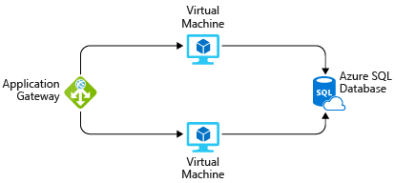

In practice, you would define your requirements in greater detail. But here are some basic facts and requirements that came up during the meeting:

* The app is used by Tailwind employees at their retail stores. It's not accessible to customers.
* This application doesn't require a massive amount of computing power.
* The virtual machines and the database run all the time (730 hours per month).
* The network processes about 1 TB of data per month.
* The database doesn't need to be configured for high-performance workloads and requires no more than 32 GB of storage.

## Explore the Pricing calculator

1. Go to the [Pricing calculator](https://azure.microsoft.com/pricing/calculator/).
2. Notice the following tabs:

* **Products:** This is where you choose the Azure services that you want to include in your estimate. You'll likely spend most of your time here.
* **Example Scenarios:** Here you'll find several reference architectures, or common cloud-based solutions that you can use as a starting point.
* **Saved Estimates:** Here you'll find your previously saved estimates.
* **FAQ:** Here you'll discover answers to frequently asked questions.

### Estimate your solution

Here you add each Azure service that you need to the calculator. Then you configure each service to fit your needs. Make sure you have a clean calculator with nothing listed in the estimate. You can reset the estimate by selecting the trash can icon next to each item.

### Add services to the estimate

1. On the **Products** tab, select the service from each of these categories:

| **Category** | **Service** |
| --- | --- |
| Compute | **Virtual Machines** |
| Databases | **Azure SQL Database** |
| Networking | **Application Gateway** |

1. Scroll to the bottom of the page. You see that each service is listed with its default configuration.

### Configure services to match your requirements

1. Under **Virtual Machines**, set these values:

| **Setting** | **Value** |
| --- | --- |
| Region | **West US** |
| Operating system | **Windows** |
| Type | **(OS Only)** |
| Tier | **Standard** |
| Instance | **D2 v3** |
| Virtual machines | **2** x **730 Hours** |

1. Leave the remaining settings at their current values.
2. Under **Azure SQL Database**, set these values: .. img
3. Leave the remaining settings at their current values.
4. Under **Application Gateway**, set these values: .. img
5. Leave the remaining settings at their current values.

### Review, share, and save your estimate

At the bottom of the page, you see the total estimated cost of running the solution. You can change the currency type if you want. At this point, you have a few options:

* Select **Export** to save your estimate as an Excel document.
* Select **Save** or **Save as** to save your estimate to the **Saved Estimates** tab for later.
* Select **Share** to generate a URL so you can share the estimate with your team.

You now have a cost estimate that you can share with your team. You can make adjustments as you discover any changes to your requirements.

Experiment with some of the options you worked with here, or create a purchase plan for a workload you want to run on Azure.

## Manage and minimize total cost on Azure

As a home improvement retailer, the proverb "measure twice, cut once" is fitting for the team at Tailwind Traders. Here are some recommended practices that can help you minimize your costs.

### Understand estimated costs before you deploy

To help you plan your solution on Azure, carefully consider the products, services, and resources you need. Read the relevant documentation to understand how each of your choices is metered and billed.

Calculate your projected costs by using the Pricing calculator and the Total Cost of Ownership (TCO) Calculator. Only add the products, services, and resources that you need for your solution.

### Use Azure Advisor to monitor your usage

Ideally, you want your provisioned resources to match your actual usage.

Azure Advisor identifies unused or underutilized resources and recommends unused resources that you can remove. This information helps you configure your resources to match your actual workload. The following image shows some example recommendations from Azure Advisor:

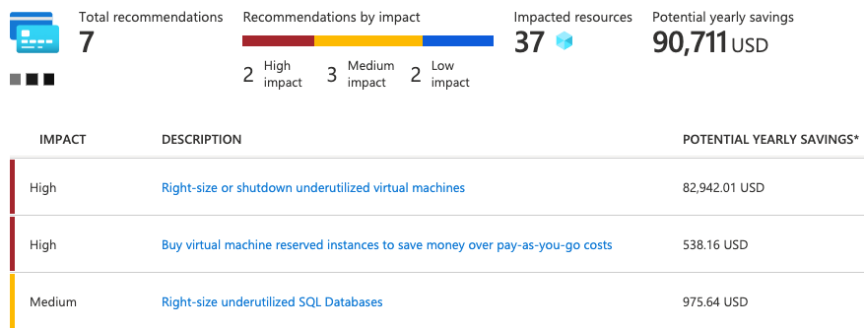

Recommendations are sorted by impact: high, medium, or low. In some cases, Azure Advisor can automatically remediate, or fix, the underlying problem. Other issues, such as the two that are listed as high impact, require human intervention.

### Use spending limits to restrict your spending

If you have a free trial or a credit-based Azure subscription, you can use spending limits to prevent accidental overrun.

Ex. when you spend all credit included with your Azure free account, Azure resources you deployed are removed from production and AVMs are stopped and deallocated. Data in your storage accounts is available as read-only. You can upgrade your free trial subscription to pay-as-you-go subscription.

If you have a credit-based subscription and you reach your configured spending limit, Azure suspends your subscription until a new billing period begins.

A related concept is quotas, or limits on the number of similar resources you can provision within your subscription. For example, you can allocate up to 25,000 VMs per region. These limits mainly help Microsoft plan its datacenter capacity.

### Use Azure Reservations to prepay

Azure Reservations offers discounted prices on certain Azure services. Azure Reservations can save you up to 72 percent as compared to pay-as-you-go prices. To receive a discount, you reserve services and resources by paying in advance.

Ex. you can prepay for one year or three years of use of VMs, database compute capacity, database throughput, and other Azure resources.

Azure Reservations are available to customers with an Enterprise Agreement, Cloud Solution Providers, and pay-as-you-go subscriptions.

### Choose low-cost locations and regions

The cost of Azure products, services, and resources can vary across locations and regions. If possible, you should use them in those locations and regions where they cost less.

But remember, some resources are metered and billed according to how much outgoing (egress) network bandwidth they consume. You should provision connected resources that are metered by bandwidth in the same Azure region to reduce egress traffic between them.

### Research available cost-saving offers

Keep up to date with the latest Azure customer and subscription offers, and switch to offers that provide the greatest cost-saving benefit.

### Use Azure Cost Management + Billing to control spending

Azure Cost Management + Billing is a free service that helps you understand your Azure bill, manage your account and subscriptions, monitor and control Azure spending, and optimize resource use.

The following image shows current usage broken down by service:

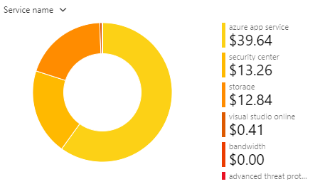

In this example, Azure App Service, a web application hosting service, generates the greatest cost.

Azure Cost Management + Billing features include:

* **Reporting:** Use historical data to generate reports and forecast future usage and expenditure.
* **Data enrichment:** Improve accountability by categorizing resources with tags that correspond to real-world business and organizational units.
* **Budgets:** Create and manage cost and usage budgets by monitoring resource demand trends, consumption rates, and cost patterns.
* **Alerting:** Get alerts based on your cost and usage budgets.
* **Recommendations:** Receive recommendations to eliminate idle resources and to optimize the Azure resources you provision.

### Apply tags to identify cost owners

Tags help you manage costs associated with the different groups of Azure products and resources. You can apply tags to groups of Azure resources to organize billing data.

Ex. if you run several VMs for different teams, you can use tags to categorize costs by department, such as Human Resources, Marketing, or Finance, or by environment, such as Test or Production.

Tags make it easier to identify groups that generate the biggest Azure costs, which can help you adjust your spending accordingly.

The following image shows a year's worth of usage broken down by tags on the Azure Cost Management + Billing page:

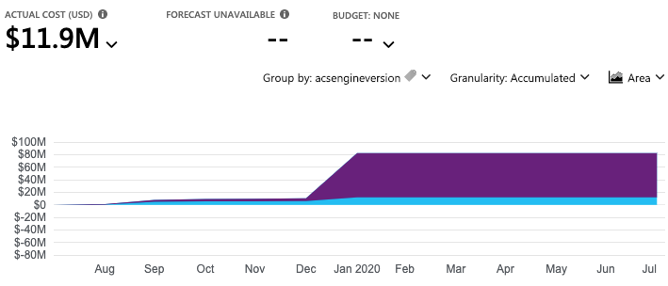

### Resize underutilized virtual machines

A common recommendation that you'll find from Azure Cost Management + Billing and Azure Advisor is to resize or shut down VMs that are underutilized or idle.

As an example, say you have a VM whose size is **Standard_D4_v4**, a general-purpose VM type with four vCPUs and 16 GB of memory. You might discover that this VM is idle 90 percent of the time.

VM costs are linear and double for each size larger in same series. In this case, if you reduce VM's size from **Standard_D4_v4** to **Standard_D2_v4**, which is next size lower, you reduce compute cost by 50 percent. The following image shows this idea:

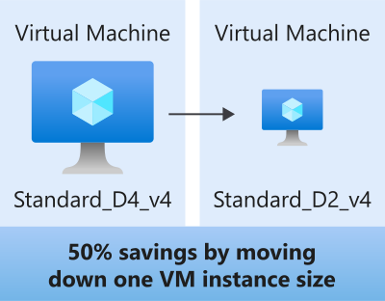

Keep in mind that resizing a VM requires it to be stopped, resized, and then restarted. This process might take a few minutes depending on how significant the size change is. Be sure to properly plan for an outage, or shift your traffic to another instance while you perform resize operations.

### Deallocate virtual machines during off hours

Recall that to deallocate a VM means to no longer run the VM, but preserve the associated hard disks and data in Azure. If you have VM workloads that are only used during certain periods, but you're running them every hour of every day, you're wasting money. These VMs are great candidates to shut down when not in use and start back when you need them, saving you compute costs while the VM is deallocated.

This approach is excellent strategy for development & testing envs, where the VMs are needed only during business hours. Azure even provides way to automatically start & stop your VMs on schedule.

### Delete unused resources

This recommendation might sound obvious, but if you aren't using a resource, you should shut it down. It's not uncommon to find nonproduction or proof-of-concept systems that are no longer needed following the completion of a project.

Regularly review your environment, and work to identify these systems. Shutting down these systems can have a dual benefit by saving you on infrastructure costs and potential savings on licensing and operating costs.

### Migrate from IaaS to PaaS services

As you move your workloads to the cloud, a natural evolution is to start with IaaS services because they map more directly to concepts and operations you're already familiar with.

Over time, one way to reduce costs is to gradually move IaaS workloads to run on PaaS services. While you can think of IaaS as direct access to compute infrastructure, PaaS provides ready-made development and deployment environments that are managed for you.

As an example, say you run SQL Server on a VM running on Azure. This configuration requires you to manage the underlying operating system, set up a SQL Server license, manage software and security updates, and so on. You also pay for the VM whether or not the database is processing queries. One way to potentially save costs is to move your database from SQL Server on a VM to Azure SQL Database. Azure SQL Database is based on SQL Server.

Not only are PaaS services such as Azure SQL Database often less expensive to run, but because they're managed for you, you don't need to worry about software updates, security patches, or optimizing physical storage for read and write operations.

### Save on licensing costs

Licensing is another area that can dramatically impact your cloud spending. Let's look at some ways you can reduce your licensing costs.

### Choose cost-effective operating systems

Many Azure services provide a choice of running on Windows or Linux. In some cases, the cost depends on which you choose. When you have a choice, and your application doesn't depend on the underlying operating system, it's useful to compare pricing to see whether you can save money.

### Use Azure Hybrid Benefit to repurpose software licenses on Azure

If you've purchased licenses for Windows Server or SQL Server, and your licenses are covered by [Software Assurance](https://www.microsoft.com/licensing/licensing-programs/software-assurance-default), you might be able to repurpose those licenses on VMs on Azure.

Some of the details vary between Windows Server or SQL Server. We'll provide resources at the end of this module where you can learn more.

## Summary

While proof-of-concept projects can help demonstrate technical feasibility, having a clear picture of the total cost of running in the cloud will further help the team validate its approach.

To start, the Tailwind team used the Total Cost of Ownership Calculator to estimate the cost savings of operating its solution on Azure instead of in its on-premises datacenter. From there, the team used the Pricing calculator to get a more detailed estimate for running a typical workload on Azure each month.

The team also created a checklist of cost-saving measures that it can use to help keep down costs. This list includes:

* Perform cost analysis before you deploy.
* Use Azure Advisor to monitor your usage.
* Use spending limits to prevent accidental spending.
* Use Azure Reservations to prepay.
* Choose low-cost locations and regions.
* Research available cost-saving offers.
* Apply tags to identify cost owners.

## Choose the right Azure services by examining SLAs and service lifecycle

In this module, you'll learn about service-level agreements (SLAs) in Azure and how they can affect your application design decisions. You'll also learn about the lifecycle of new Azure services, from preview to general availability.

### How will moving to the cloud affect availability agreements?

Moving to the cloud removes the burden of supporting IT infrastructure. When network connectivity is lost or a hard drive fails, you rely on the cloud provider to restore service.

Tailwind Traders' IT department hosts applications and services in its datacenter for the rest of the company. The IT department has agreements with other teams in place that state how available those services will be, which includes when and how planned maintenance can happen. As Tailwind Traders moves its workloads to Azure, it no longer has full control over the hardware and networks. How will its agreements around availability be affected?

### What are service-level agreements (SLAs)?

As mentioned in the video, a service-level agreement (SLA) is a formal agreement between a service company and the customer. For Azure, this agreement defines the performance standards that Microsoft commits to for you, the customer.

### Why are SLAs important?

Understanding the SLA for each Azure service you use helps you understand what guarantees you can expect. When you build applications on Azure, the availability of the services that you use affect your application's performance. Understanding the SLAs involved can help you establish the SLA you set with your customers.

### Where can I access SLAs for Azure services?

You can access SLAs from [Service Level Agreements](https://azure.microsoft.com/support/legal/sla/).

**Note:** You don't need an Azure subscription to review service SLAs.

Each Azure service defines its own SLA. Azure services are organized by category.

Open the SLA for Azure Database for MySQL, a managed database that makes it easy for developers to work with MySQL databases. You'll refer back to this SLA in a moment. To do so:

1. Go to [Service Level Agreements](https://azure.microsoft.com/support/legal/sla/).
2. From the **Databases** category, select **Azure Database for MySQL**.

### What's in a typical SLA?

A typical SLA breaks down into these sections:

**Introduction:** This section explains what to expect in the SLA, including its scope and how subscription renewals can affect the terms.

**General terms:** This section contains terms that are used throughout the SLA so that both parties (you and Microsoft) have a consistent vocabulary. For example, this section might define what's meant by downtime, incidents, and error codes. This section also defines the general terms of the agreement, including how to submit a claim, receive credit for any performance or availability issues, and limitations of the agreement.

**SLA details:** This section defines the specific guarantees for the service. Performance commitments are commonly measured as a percentage. That percentage typically ranges from 99.9% ("three nines") to 99.99% ("four nines"). The primary performance commitment typically focuses on uptime, or the percentage of time that a product or service is successfully operational. Some SLAs focus on other factors as well, including latency, or how fast the service must respond to a request.

This section also defines any additional terms that are specific to this service.

Take a moment to review the SLA for Azure Database for MySQL.

You see that this SLA focuses mainly on uptime. Azure Database for MySQL guarantees 99.99 percent, or "four nines", uptime. This means that the service is guaranteed to be running and available to process requests 99.99 percent of the time.

### How do percentages relate to total downtime?

Downtime refers to the time duration that the service is unavailable.

The difference between 99.9 percent and 99.99 percent might seem minor, but it's important to understand what these numbers mean in terms of total downtime.

Here's a table to give you a sense of how total downtime decreases as the SLA percentage increases from 99 percent to 99.999 percent:

| **HOW DO PERCENTAGES RELATE TO TOTAL DOWNTIME?** | | | |
| --- | --- | --- | --- |
| **SLA percentage** | **Downtime per week** | **Downtime per month** | **Downtime per year** |
| 99 | 1.68 hours | 7.2 hours | 3.65 days |
| 99.9 | 10.1 minutes | 43.2 minutes | 8.76 hours |
| 99.95 | 5 minutes | 21.6 minutes | 4.38 hours |
| 99.99 | 1.01 minutes | 4.32 minutes | 52.56 minutes |
| 99.999 | 6 seconds | 25.9 seconds | 5.26 minutes |

These amounts are cumulative, which means that the duration of multiple different service outages would be combined, or added together.

### What are service credits?

A service credit is the percentage of the fees you paid that are credited back to you according to the claim approval process.

An SLA describes how Microsoft responds when an Azure service fails to perform to its specification. For example, you might receive a discount on your Azure bill as compensation when a service fails to perform according to its SLA.

Credits typically increase as uptime decreases. Here's how credits are applied for Azure Database for MySQL according to uptime:

| **WHAT ARE SERVICE CREDITS?** | |
| --- | --- |
| **Monthly uptime percentage** | **Service credit percentage** |
| < 99.99 | 10 |
| < 99 | 25 |
| < 95 | 100 |

### What's the SLA for free services?

Free products typically don't have an SLA.

For example, many Azure services provide a free or shared tier that provides more limited functionality. Services like Azure Advisor are always free. The [SLA for Azure Advisor](https://azure.microsoft.com/support/legal/sla/advisor/) states that because it's free, it doesn't have a financially backed SLA.

### How do I know when there's an outage?

[Azure status](https://status.azure.com/status) provides a global view of the health of Azure services and regions. If you suspect there's an outage, this is often a good place to start your investigation.

Azure status provides an RSS feed of changes to the health of Azure services that you can subscribe to. You can connect this feed to communication software such as Microsoft Teams or Slack.

From the Azure status page, you can also access Azure Service Health. This provides a personalized view of the health of the Azure services and regions that you're using, directly from the Azure portal.

### How can I request a service credit from Microsoft?

Typically, you need to file a claim with MS to receive a service credit. If you purchase Azure services from a Cloud Solution Provider (CSP) partner, your CSP typically manages the claims process.

Each SLA specifies the timeline by which you must submit your claim and when Microsoft processes your claim. For many services, you must submit your claim by the end of the calendar month following the month in which the incident occurred.

### Define your application SLA

An application SLA defines the SLA requirements for a specific application. This term typically refers to an application that you build on Azure.

Tailwind runs an application that it built on Azure called "Special Orders." The application tracks special orders that customers have placed in the company's retail stores. A special order includes an item and any customizations the customer needs. For example, a folding door might include customizations such as dimension and hinge placement. Bcs customizations typically require special handling, the customized item needs to be ordered from the supplier when a customer needs it.

There are many design decisions you can make to improve the availability and resiliency of the applications and services you build on Azure. These decisions extend beyond just the SLA for a specific service. In this part, you'll explore a few of these considerations.

A good place to start is to have a discussion with your team about how important the availability of each application is to business. The following sections cover few factors Tailwind might consider.

#### Business impact

If the Special Orders application goes down, what would the business impact be? In this case, customers can't place new orders through the store and staff can't check the status of existing orders. Customers will either need to try again later or possibly go to a competitor.

#### Effect on other business operations

The Special Orders application doesn't affect other operations. So the majority of the Tailwind Traders business will continue to function normally if the Special Orders application went down.

#### Usage patterns

Usage patterns define when and how users access your application.

One question to consider is whether the availability requirement differs between critical and non-critical time periods. For example, a tax-filing application can't fail during a filing deadline.

For Tailwind Traders, retail stores aren't open 24 hours a day, so if the application were down in the middle of the night, the impact would be minimal. However, because Tailwind Traders has retail locations all over the world, it will need to ensure that each location has access to the service during its retail hours.

### What does the team decide?

Let's say that Tailwind Traders decides that an SLA of 99.9 percent is acceptable for the Special Orders application. This gives the company an estimated downtime of 10.1 minutes per week. But how will it ensure that its technology choices support its application SLA?

In the next part, you'll see how the team maps its application requirements to specific Azure services. You'll learn about some of the techniques you can use to help ensure that your technology choices meet your application SLA.

### Design your application to meet your SLA

Tailwind Traders decides that an SLA of 99.9 percent is acceptable for the Special Orders application. Recall that this gives the company an estimated downtime of 10.1 minutes per week.

Now you need to design an efficient and reliable solution for this application on Azure, keeping that application SLA in mind. You'll select the Azure products and services you need, and provision your cloud resources according to those requirements.

In reality, failures will happen. Hardware can fail. The network can have intermittent timeout periods. While it's rare for an entire service or region to experience a disruption, you still need to plan for such events.

### Identify your workloads

A workload is a distinct capability or task that's logically separated from other tasks, in terms of business logic and data storage requirements. Each workload defines a set of requirements for availability, scalability, data consistency, and disaster recovery.

On Azure, the Special Orders application will require:

* Two virtual machines.
* One instance of Azure SQL Database.
* One instance of Azure Load Balancer.

## Combine SLAs to compute the composite SLA

After you've identified the SLA for the individual workloads in the Special Orders application, you might notice that those SLAs are not all the same. How does this affect our overall application SLA requirement of 99.9 percent? To work that out, you'll need to do some math.

The process of combining SLAs helps you compute the composite SLA for a set of services. Computing the composite SLA requires that you multiply the SLA of each individual service.

From [S](https://azure.microsoft.com/support/legal/sla/)LA, you discover the SLA for each Azure service that you need. They are:

| **COMBINE SLAS TO COMPUTE THE COMPOSITE SLA** | |
| --- | --- |
| **Service** | **SLA** |
| Azure Virtual Machines | 99.9 percent |
| Azure SQL Database | 99.99 percent |
| Azure Load Balancer | 99.99 percent |

Therefore, for the Special Orders application, the composite SLA would be:

99.9%×99.9%×99.99%×99.99%99.9%×99.9%×99.99%×99.99%=0.999×0.999×0.9999×0.9999=0.999×0.999×0.9999×0.9999=0.9978=0.9978=99.78%=99.78%

Recall that you need two virtual machines. Therefore, you include the Virtual Machines SLA of 99.9 percent two times in the formula.

Note that even though all of the individual services have SLAs equal to or better than the application SLA, combining them results in an overall number that's lower than the 99.9 percent you need. Why? Because using multiple services adds an extra level of complexity and slightly increases the risk of failure.

You see here that the composite SLA of 99.78 percent doesn't meet the required SLA of 99.9 percent. You might go back to your team and ask whether this is acceptable. Or you might implement some other strategies into your design to improve this SLA.

### What happens when the composite SLA doesn't meet your needs?

For the Special Orders application, the composite SLA doesn't meet the required SLA of 99.9 percent. Let's look at a few strategies that Tailwind Traders might consider.

#### Choose customization options that fit your required SLA

Each of the workloads defined previously has its own SLA, and the customization choices you make when you provision each workload affects that SLA. For example:

* **Disks:** With Virtual Machines, you can choose from a Standard HDD Managed Disk, a Standard SSD Managed Disk, or a Premium SSD or Ultra Disk. The SLA for a single VM would be either 95 percent, 99.5 percent or 99.9 percent, depending on the disk choice.
* **Tiers:** Some Azure services are offered as both a free tier product and as a standard paid service. Ex. Azure Automation provides 500 minutes of job runtime in an Azure free account, but is not backed by an SLA. The standard tier SLA for Azure Automation is 99.9 percent.

Make sure that your purchasing decisions take into account the impact on the SLA for the Azure services that you choose. Doing so ensures that the SLA supports your required application SLA.

Here, Tailwind Traders might choose the Ultra Disk option for its virtual machines to help guarantee greater uptime.

#### Build availability requirements into your design

There are application design considerations you can use that relate to the underlying cloud infrastructure.

For example, to improve the availability of the application, avoid having any single points of failure. So instead of adding more virtual machines, you can deploy one or more extra instances of the same virtual machine across the different availability zones in the same Azure region.

An availability zone is a unique physical location within an Azure region. Each zone is made up of one or more datacenters equipped with independent power, cooling, and networking. These zones use different schedules for maintenance, so if one zone is affected, your virtual machine instance in the other zone is unaffected.

Deploying two or more instances of an Azure virtual machine across two or more availability zones raises the virtual machine SLA to 99.99 percent. Recalculating your composite SLA above with this Virtual Machines SLA gives you an application SLA of:

99.99%×99.99%×99.99%×99.99%99.99%×99.99%×99.99%×99.99%=99.96%=99.96%

This revised SLA of 99.96 percent exceeds your target of 99.9 percent.

#### Include redundancy to increase availability

To ensure high availability, you might plan for your application to have duplicate components across several regions, known as redundancy. Conversely, to minimize costs during non-critical periods, you might run your application only in a single region. Tailwind Traders might consider this if there's a trend that the special order rates are much higher during certain months or seasons.

To achieve maximum availability in your application, add redundancy to every single part of the application. This redundancy includes the application itself, as well as the underlying services and infrastructure. Be aware, however, that doing so can be difficult and expensive, and often results in solutions that are more complex than they need to be.

Consider how critical high availability is to your requirements before you add redundancy. There may be simpler ways to meet your application SLA.

### Very high performance is difficult to achieve

Performance targets above 99.99 percent are very difficult to achieve. An SLA of 99.99 percent means 1 minute of downtime per week. It's difficult for humans to respond to failures quickly enough to meet SLA performance targets above 99.99 percent. Instead, your application must be able to self-diagnose and self-heal during an outage.

### Access preview services and preview features

Now that the Tailwind company has its apps up and running in Azure, it wants to start looking into new Azure capabilities. One option is to look at preview services. In this module, you'll learn how Azure services go from the preview phase to being generally available product integrated into Azure.

For Tailwind Traders, migration from the datacenter to Azure is more about operational efficiency. The research and development team is looking into new, cloud-based features that will keep them ahead of the competition.

Tailwind is in the development stages of creating a drone delivery system for rural customers. The company needs real-time storm tracking in drone guidance system, but the feature isn't available yet. An AI Storm Analyzer service has recently been released in the public preview phase. Tailwind R&D team has decided to incorporate the preview service into the early stages of application testing.

**Note:** AI Storm Analyzer is a fictitious Azure service, introduced here for illustrative purposes only.

Before the team moves forward, it wants a better understanding of how preview services affect its SLA. Let's begin by defining the Azure service lifecycle.

### What is the service lifecycle?

The service lifecycle defines how every Azure service is released for public use.

Every Azure service starts in the development phase. In this phase, the Azure team collects and defines its requirements, and begins to build the service.

Next, the service is released to the public preview phase. During this phase, the public can access and experiment with it and provide real-world feedback. Your feedback helps Microsoft improve services. More importantly, providing feedback gives you the opportunity to request new or different capabilities so that services better meet your needs.

After a new Azure service has been validated and tested, it's released to all customers as a production-ready service. This is known as general availability (GA).

### What terms and conditions can I expect?

Each Azure preview defines its own terms and conditions. All [preview-specific terms and conditions are excluded from the service level agreements and limited warranty](https://azure.microsoft.com/support/legal/preview-supplemental-terms/).

Some previews may not be covered by customer support, and may be subject to reduced or different security, compliance, and privacy commitments. For these reasons, previews are not recommended for business-critical workloads.

### How can I access preview services?

You can access preview services from the Azure portal. Here's how to see what preview services are available. You can follow along if you have an Azure subscription.

1. Go to the [Azure portal](https://portal.azure.com/) and sign in.
2. Select **Create a resource**.
3. Enter preview in the search box, and select **Enter**.
4. Select a preview service to learn more about it. You can also launch the service if you'd like to try it out.

### How can I access new features for an existing service?

Some preview features relate to a specific area of an existing Azure service. For example, a compute or database service that you use daily might provide enhanced functionality. These preview features are accessible when you deploy, configure, and manage the service.

Although you can use an Azure preview feature in production, make sure you're aware of any limitations before you deploy it to a production environment.

### How can I access preview features for the Azure portal?

You can access preview features that are specific to the Azure portal from [Microsoft Azure (Preview)](https://preview.portal.azure.com/).

Typical portal preview features provide performance, navigation, and accessibility improvements to the Azure portal interface.

When you're using the preview version of the Azure portal, **Microsoft Azure (Preview)** displays in the page header to remind you what version of the Azure portal you're using. Public preview features that are optionally available are also labeled with (preview) on Azure pages.

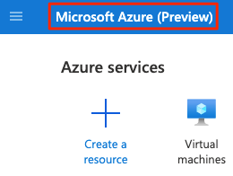

### How can I provide feedback on the Azure portal?

You can provide feedback:

* From any of the 124 forums for Azure services, go to the [Azure feedback community ideas page](https://feedback.azure.com/d365community)
* From the **Feedback** tab in the Azure portal.

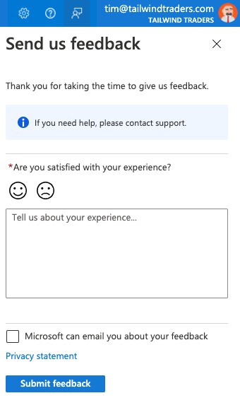

### How can I stay updated on the latest announcements?

The [Azure updates](https://azure.microsoft.com/updates) page provides information about the latest updates to Azure products, services, and features, and product roadmaps and announcements.

From the Azure updates page, you can:

* View details about all Azure updates.
* See which updates are now available, in preview, or in development.
* Browse updates by product category or update type.
* Search for updates by keyword.
* Subscribe to an RSS feed to receive notifications.
* Access the Microsoft Connect page to read Azure product news and announcements.

### Summary

A service-level agreement (SLA) is the formal agreement between a service company and the customer. For Azure, this agreement defines the performance standards that Microsoft commits to for its customers.

For example, the main website must be available as close to 100 percent of the time as possible. To accomplish that, Tailwind Traders might deploy extra instances of the same virtual machine across different availability zones in the same Azure region. Doing so helps ensure that if one zone is affected, virtual machine instances in the other zone can pick up the load.

The Special Orders application might have more flexible tolerances. As long as retail employees don't lose data and can quickly regain network access, the Special Orders application might have a lower SLA. Here, the team can choose to include less redundancy in its design.

When defining your SLA requirements, be sure to consider both your business needs and the time it takes to restore a component after a failure. Also consider how the use of preview services and preview features might affect your systems in production.

# Sources

YouTube tutorial

[azure fundamentals az-900 exam questions - YouTube](https://www.youtube.com/results?search_query=azure+fundamentals+az-900+exam+questions)

MS Azure fundamentals Certificate:

[Microsoft Certified: Azure Fundamentals - Learn | Microsoft Docs](https://docs.microsoft.com/en-us/learn/certifications/azure-fundamentals/)